

WAY4 Issuing Product

Configuration

|  |  |
| --- | --- |
| Prepared for : | OCB |
| Version of Document : | 0.1 |
| Status : | Initial Draft |
| Release Date : | 9 April 2018 |
| Prepared by : | Openway Asia |
| Author : | Nguyen Hoang Hiep |
| Owner : | Openway Asia |

Contents

1.1 Country Table 3

1.2 Currency Table 3

1.3 Financial Institutions 3

1.4 FX Scheme 4

1.5 Accounting contract type 4

1.6 Card contract type 5

1.7 Account type 5

1.8 Behavior Type 7

1.9 Production Event 7

1.10 Fee type 7

1.11 Transaction All 8

1.12 Balance Type 9

1.13 Contract Status 10

1.14 Event Type 12

1.15 Issuing Event State 15

1.16 Bank Service Pack 16

1.17 Bank Account Scheme 16

1.18 Issuing Account Scheme 19

1.18.1 Detail 19

1.18.2 Definition 20

1.18.3 Interest 23

1.18.4 Ageing 23

1.18.5 Tiers 24

1.18.6 Event 24

1.19 Private Card Service Package 24

1.20 Account Service Package 28

1.21 Classifier 29

1.22 Classifier Actions 32

1.23 Product 32

1.24 Tariff 33

1.25 Instalment 35

1.25.1 Global Parameter 35

1.25.2 Configuring "Contract Add Info Types" Classifiers 36

1.25.3 Balance Type 36

1.25.4 Instalment Scheme 36

1.25.5 Instalment Account Template 38

1.25.6 Instalment Fee Types 40

1.25.7 Instalment Transaction Type 40

1.25.8 Instalment Events 40

1.25.9 Instalment Fee 42

1.25.10 Instalment Groups, Available Instalment Trans Type, Available Instalment Schemes 42

1.25.11 Account scheme 43

1.25.12 Account Service Pack 43

1.25.13 Standing order 44

1.25.14 Reverse Transaction 64

1.25.15 OVD Instalment 64

1.26 Followed debt 67

1.27 Account T60 configuration 77

1.28 Account T30 configuration 79

1.29 Balance type changes 81

1.30 Country restrictions 82

1.30.1 Restrict our cards in other country devices (e.g. devices in China) 82

1.30.2 Restrict foreign cards in our devices (e.g. cards from Canada) 84

1.31 Usage limiter without considering fee 86

1.32 Fee for Balance Inquiry 87

1.33 Cash limit 89

1.34 Additional Hold 90

1.35 Limitation of Off us card at Our devices 91

1.36 Change Instalment scheme effective date and due date 92

1.37 Disable Expire Check for Local Cards 93

1.38 Notification Event Configuration 93

## Country Table

Menu: OpenWay\Full\Configuration Setup\Main Tables\Country Table

Purpose: setup currency which we want to use in WAY4

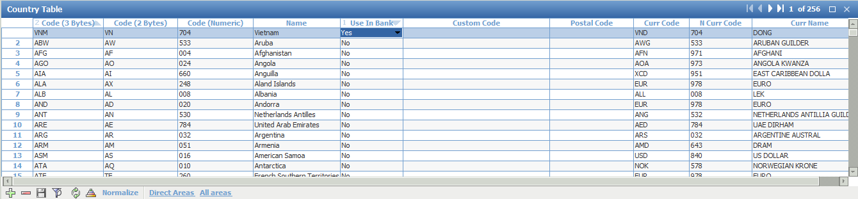

## Currency Table

Menu: OpenWay\Full\Configuration Setup\Main Tables\Currency Table

Purpose: setup the currency we use in way4

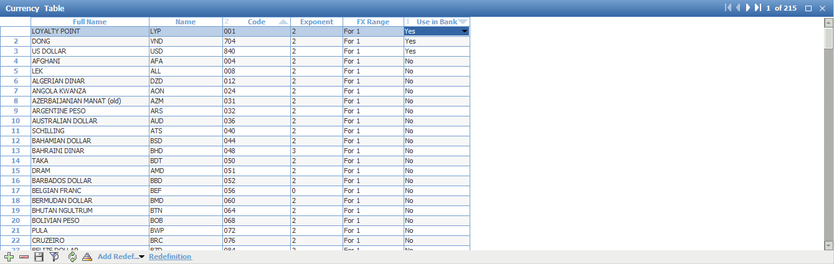

## Financial Institutions

Menu: OpenWay\Full\Configuration Setup\Main Tables\Financial Institutions

Case 1: Change Currency of F_I, and then we can change Country, interest scheme and Name

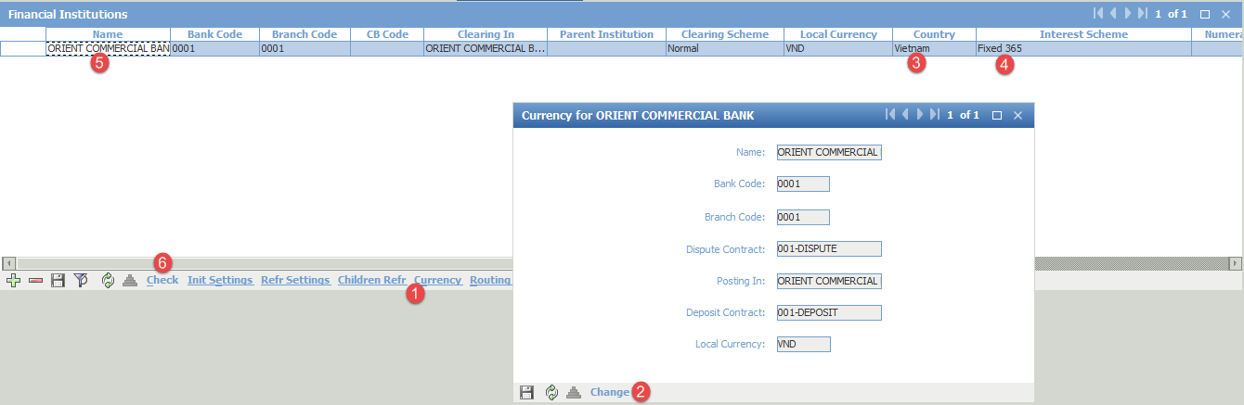

Case 2: Delete un-necessary financial institution

Menu: OpenWay\Full\DB Administrator Utilities\!!! STAFF ONLY !!!\Purge Utilities\Clear Financial Institution

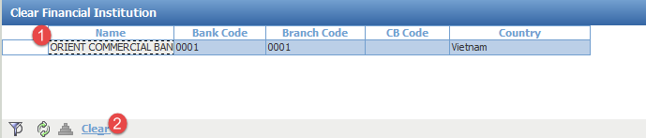

Choose the F_I which you want to delete

Click on the button to Clear

Go back menu: OpenWay\Full\Configuration Setup\Main Tables\Financial Institutions

Click on delete button to delete un-necessary financial institution

Finally, we run the menu OpenWay\Full\Configuration Setup\Main Tables\Renew All For Institution

## FX Scheme

Menu: OpenWay\Full\Configuration Setup\Accounting Setup\FX Scheme

Purpose: In case you want to add new currency as foreign currency

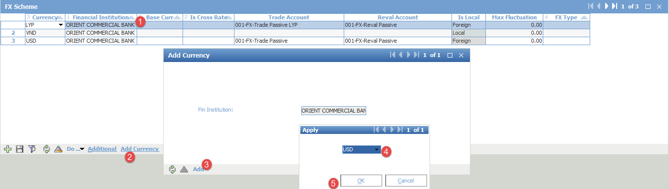

## Accounting contract type

Menu: Menu: [OpenWay\Full\Configuration Setup\Contract Types\Accounting Contract Types]y

Purpose: define range of Account contract type

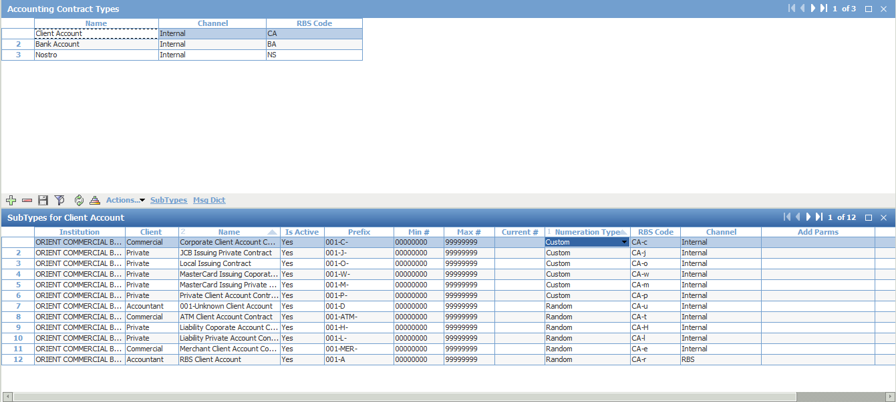

## Card contract type

Menu: [OpenWay\Full\Configuration Setup\Contract Types\Card Contract Types]

Purpose: setup BIN range, expiry period

For example: Name = MASTERCARD EMV CR STANDARD; BIN = 530572;

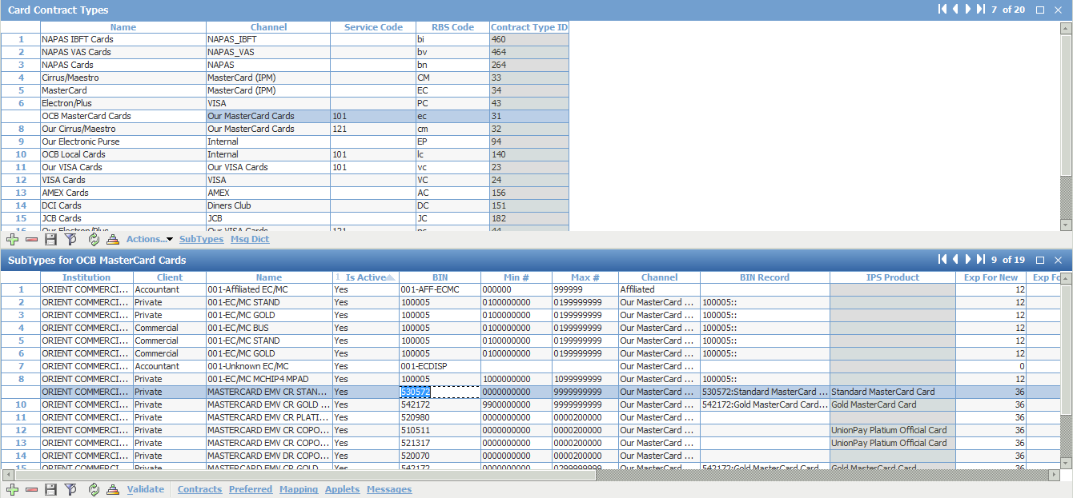

## Account type

Menu: [OpenWay\Full\Configuration Setup\Accounting Setup\Account Types]

Purpose: define account which will be used in WAY4

Cardholder account

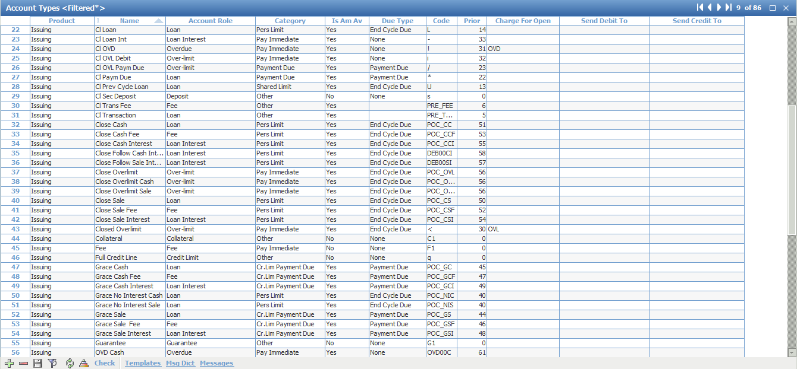

Shadow account

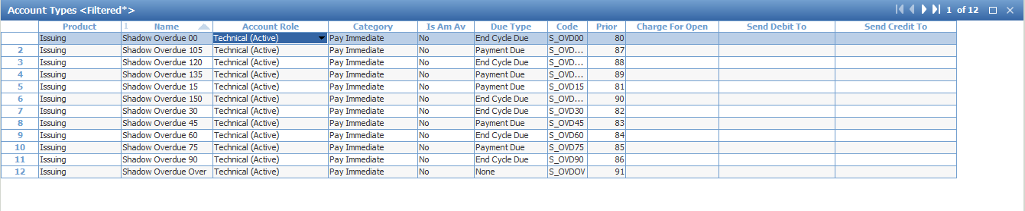

Bank Accounting

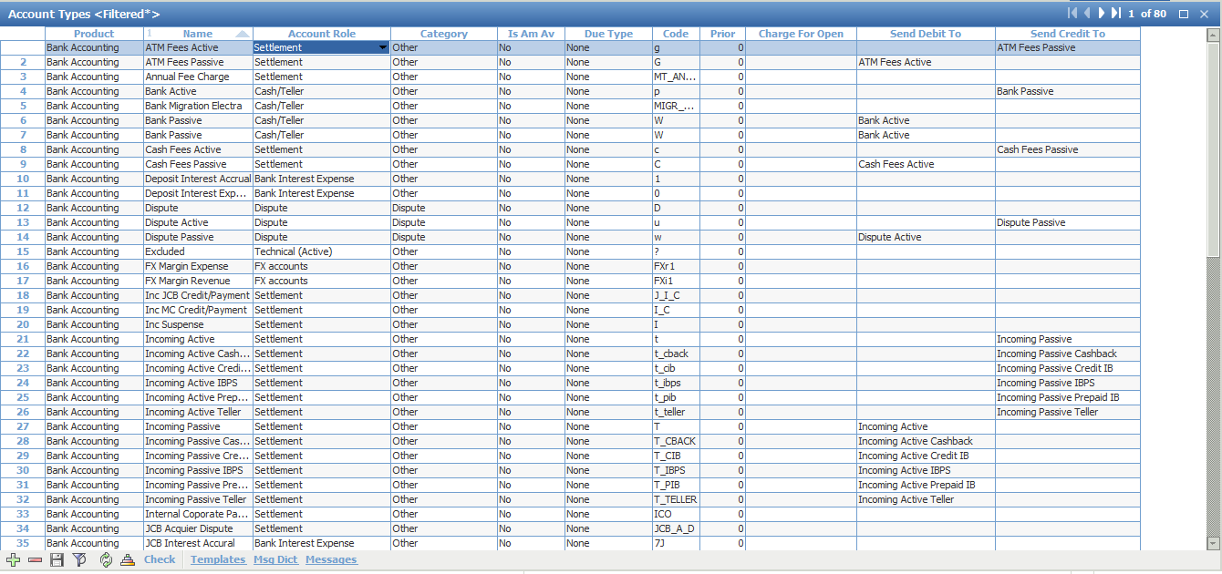

## Behavior Type

Menu: [OpenWay\Full\Configuration Setup\Behavior Scoring Setup\Behavior Types]

Purpose: to set up Behavior Types for Accounting Credit Scheme

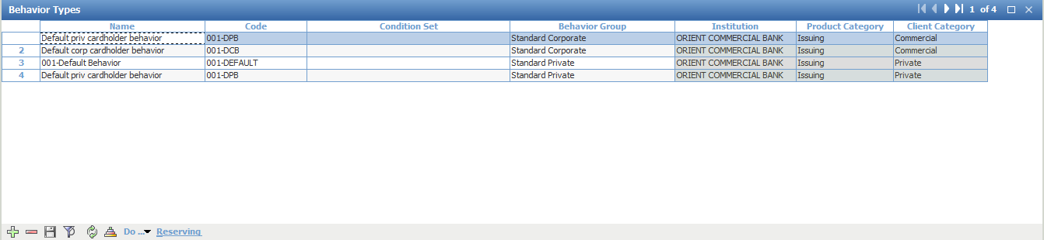

## Production Event

Menu: [OpenWay\Full\Configuration Setup\Transaction Types\Production Events]

Purpose: Define Event for Card Production/Replacement

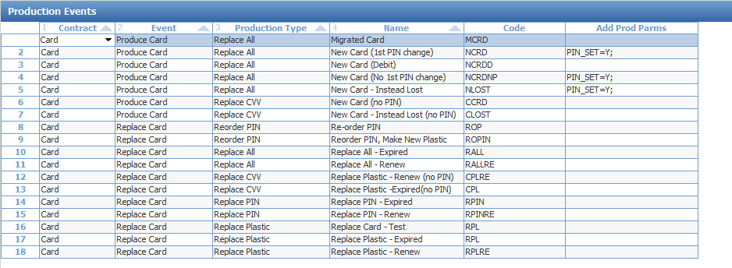

## Fee type

Menu: [OpenWay\Full\Configuration Setup\Transaction Types\Fee Types]

Purpose: setup new fee type as Bank’s requirement

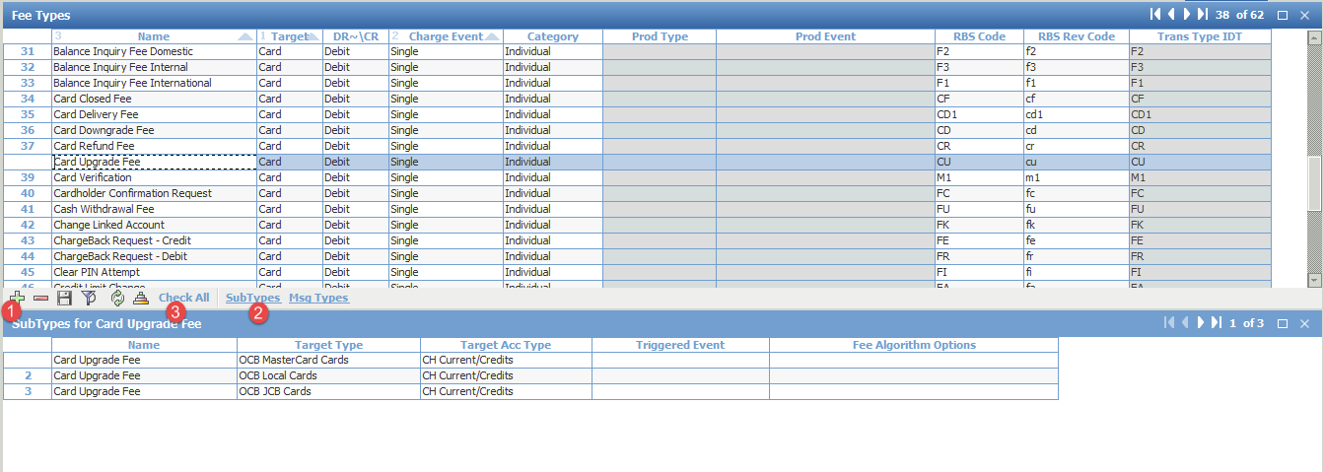

Late payment fee

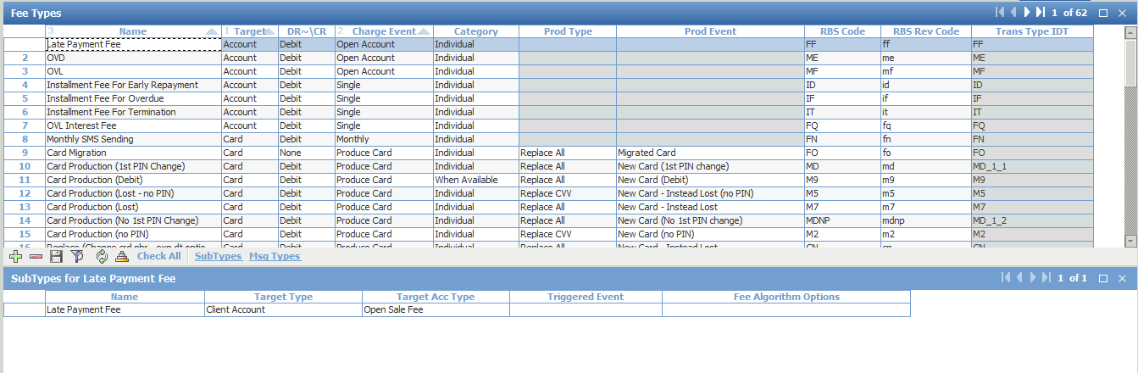

## Transaction All

Menu: OpenWay\Full\Configuration Setup\Transaction Types\Transactions – All

Purpose: setup transaction for migration

**Migration Balance -Debit**

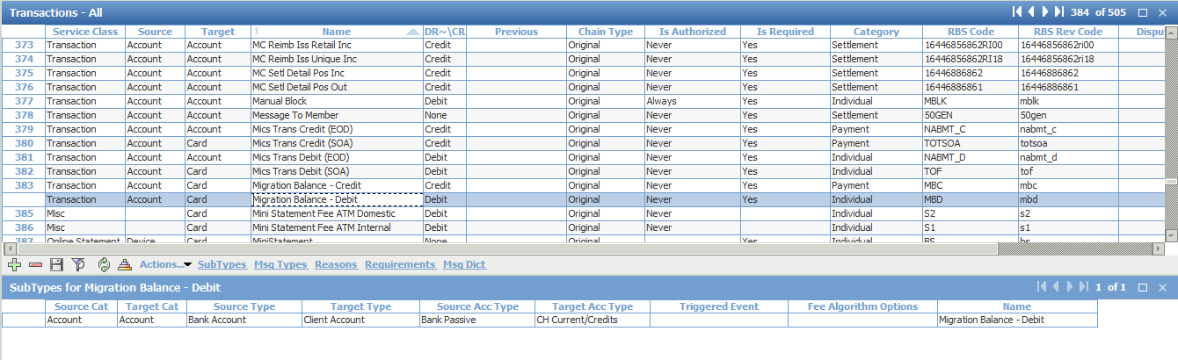

**Migration Balance -Credit**

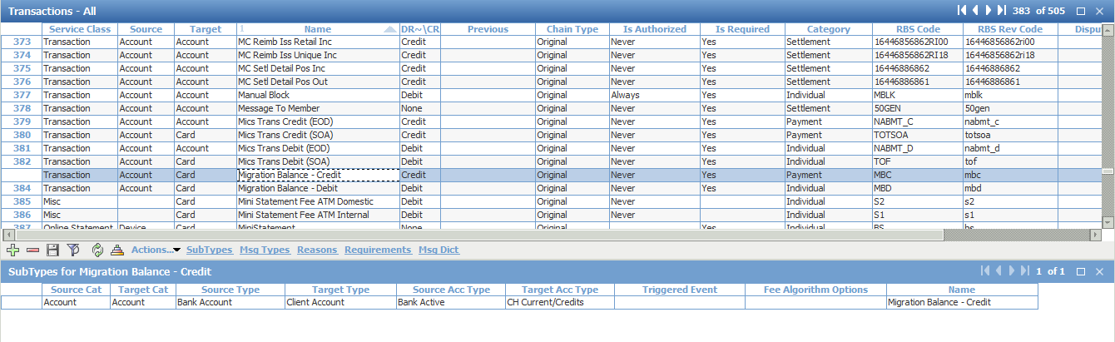

## Balance Type

Menu: [OpenWay\Full\Configuration Setup\Accounting Setup\Balance Types]

Purpose: to create the Balance Type to handle calculation of Minimum Payment.

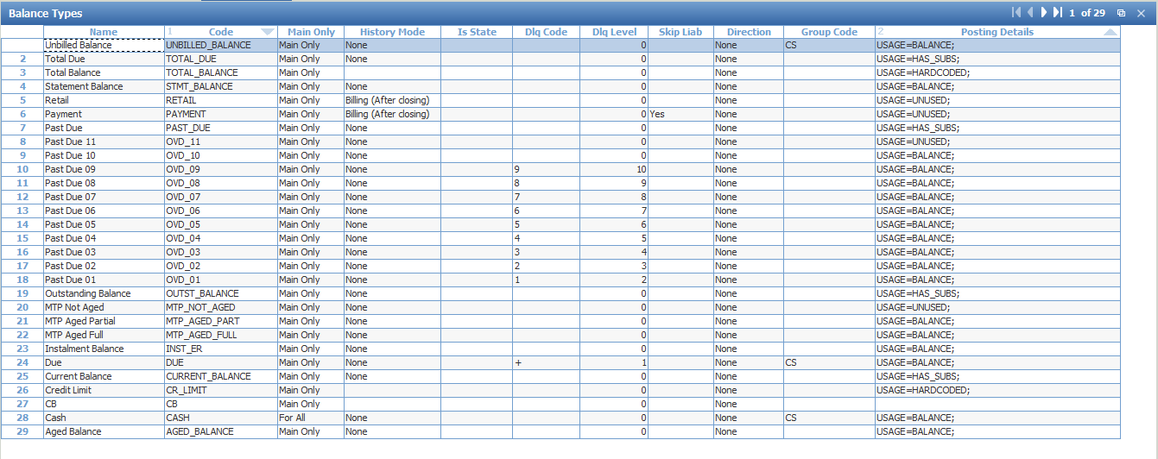

Sub-balance of

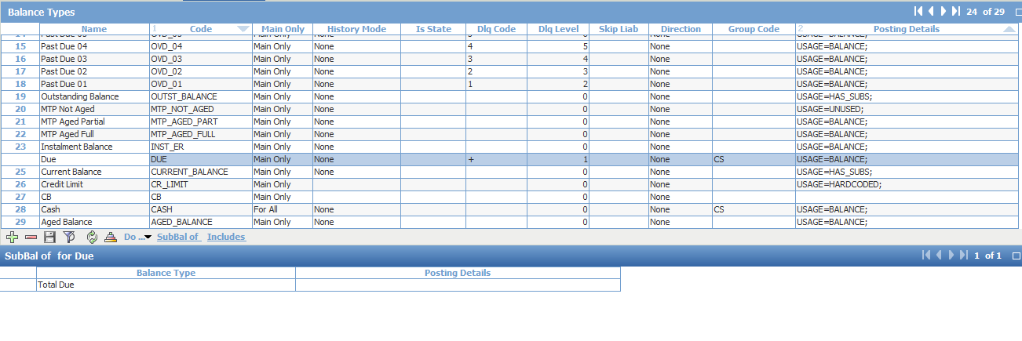

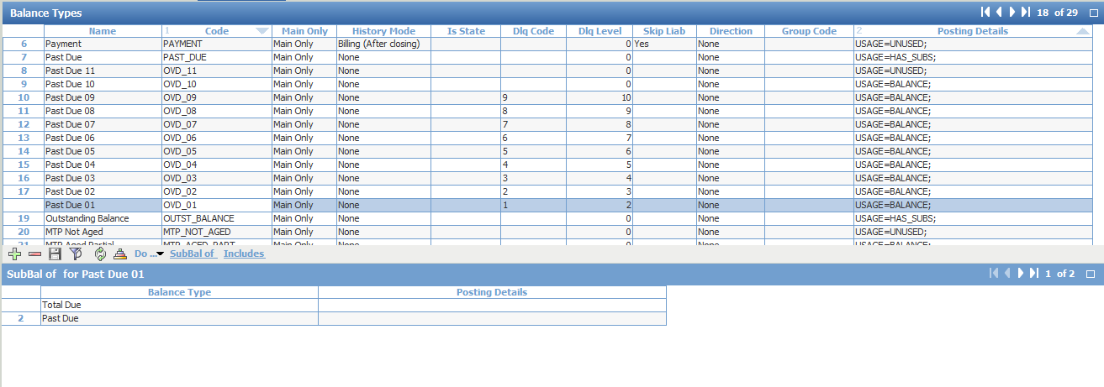

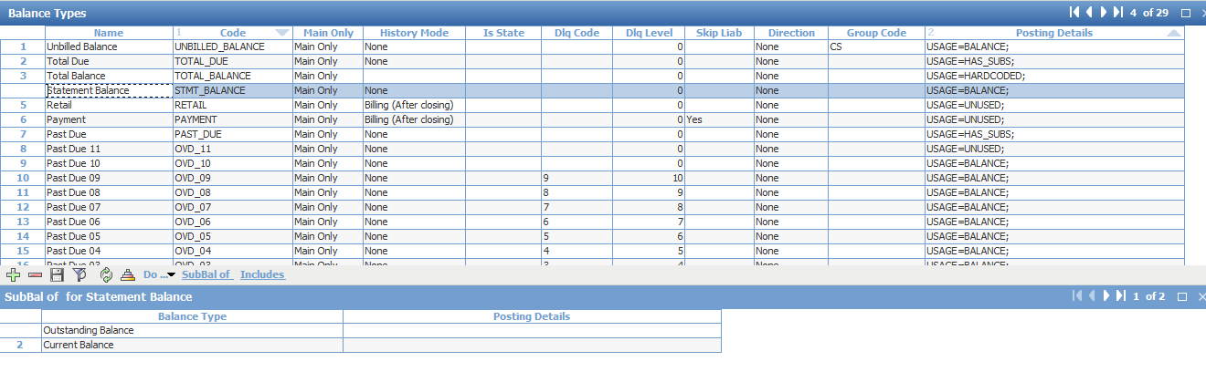

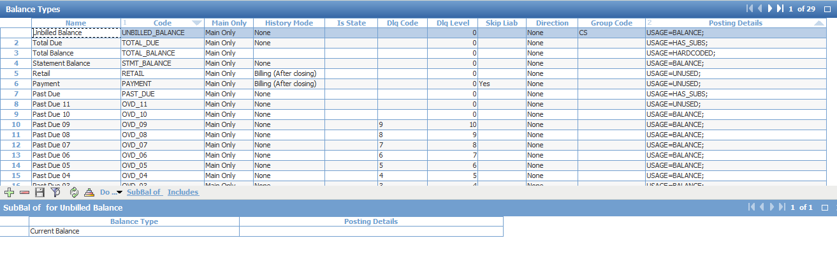

## Contract Status

Menu: [OpenWay\Full\Configuration Setup\Contract Types\Contract Statuses]

Purpose: using existing code and change name to use for customize requirement

Card Contract

|  |  |  |
| --- | --- | --- |
| **Contract Status** | **Legacy** | **WAY4** |
| Normal (bình thường) | 0 | Card OK |
| Cancelled (thẻ đóng) | 3 | Card Close |
| Replaced (thẻ bị thay thế) | 4 | Card Replaced |
| Lost (thất lạc) | 5 | Pick Up L41 |
| Stolen (mất cắp) | 6 | Pick Up S43 |
| Counterfeit (thẻ giao xuống chi nhánh nhưng không kích hoạt) | 7 | Card Branch |
| Returned (tạm khóa) | 8 | Do not honor |
| Upgrade (chuyển thẻ từ lên thẻ chip) | 9 | Card Upgrade |
| Returned Card Renewal (áp thẻ chính ko có nhu cầu sử dụng) | 10 | Card Returned |
| Expired (thẻ hết hạn) | 12 | Card Expired |

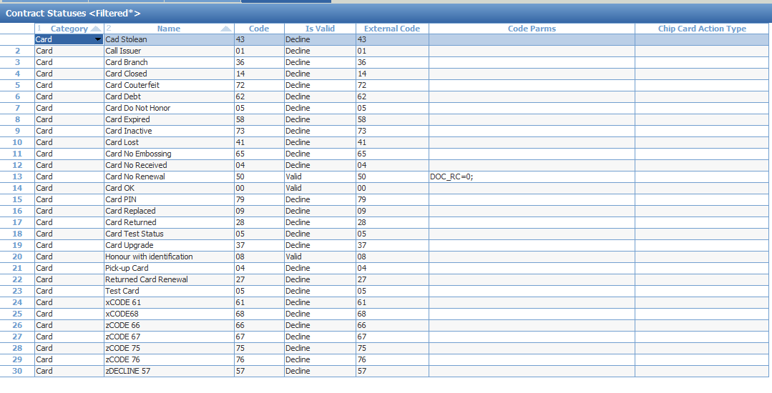

Account contract

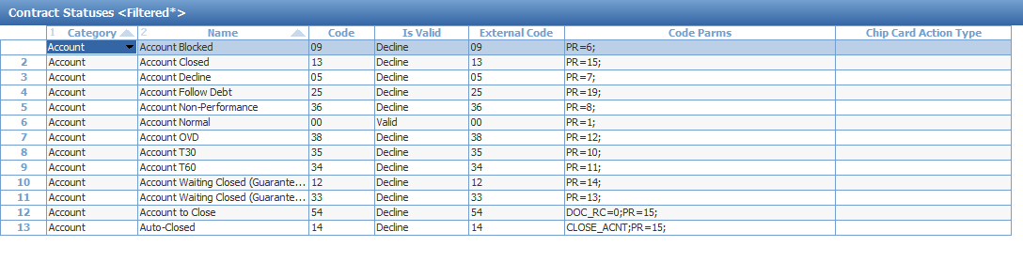

|  |  |  |
| --- | --- | --- |
| **Contract Status** | **Legacy** | **WAY4** |
| NORMAL (bình thường) | 0 | Account OK |
| Transferred (đóng thẻ có tài sản bảo đảm nhưng giải chấp ngay) | 2 | Account Transfer |
| CLOSED | 3 | Account Close |
| RESERVE (chậm thanh toán T60) | 5 | Account T60 |
| LEGAL (đóng thẻ ko thế chấp) | 6 | Account Legal |
| NON PERFORMING (ngân hàng chủ động khóa) | 8 | Account Non-Perform |

## Event Type

Menu: [OpenWay\Full\Configuration Setup\Products\Issuing Private Products\Issuing Event Types]

**For Account**

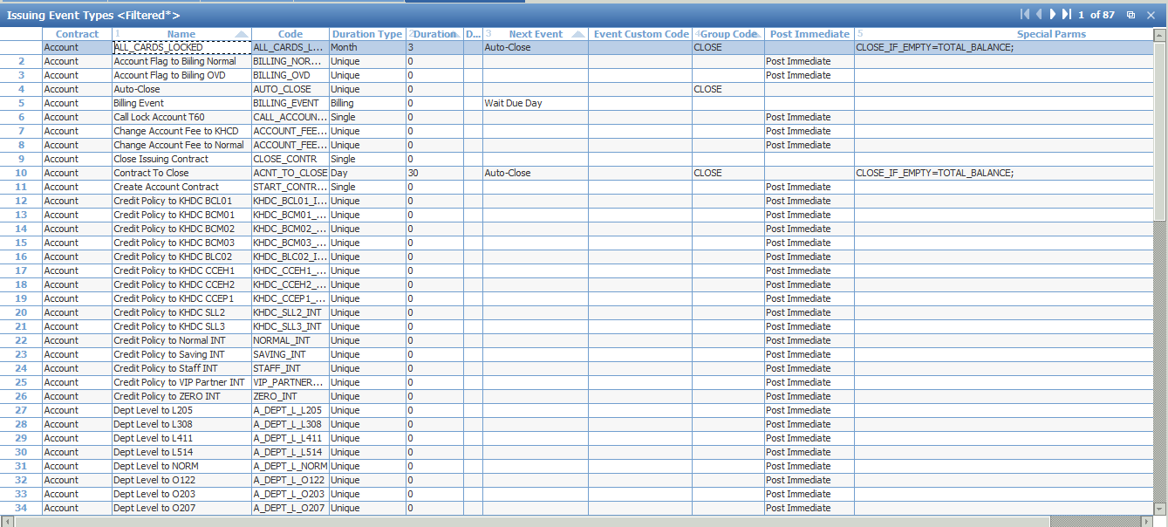

Lock Account T60: Lock Account after 2 late payment cycles

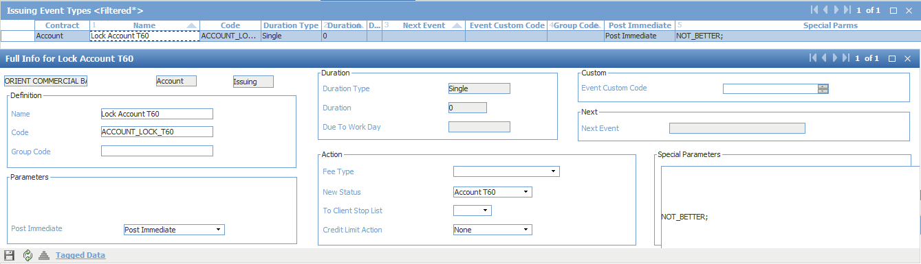

Contract To Close: auto-close if balance is empty once all cards were closed

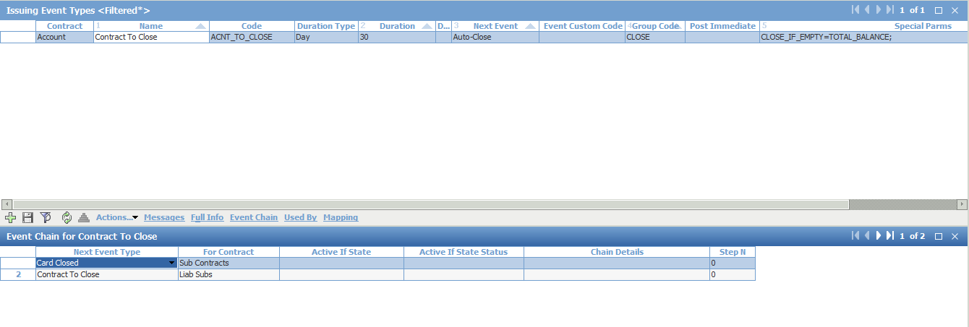

OVD: Lock all cards under issuing contract

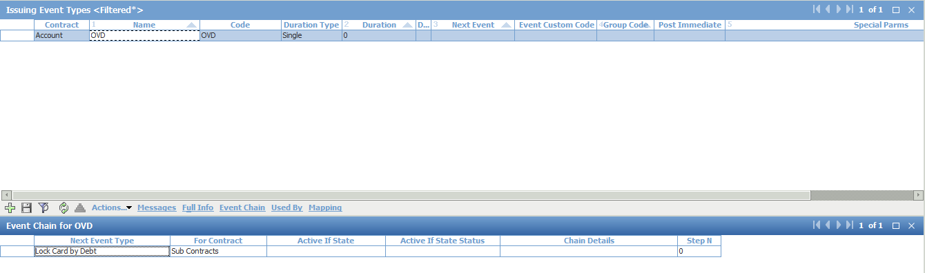

Event to change Classifier value

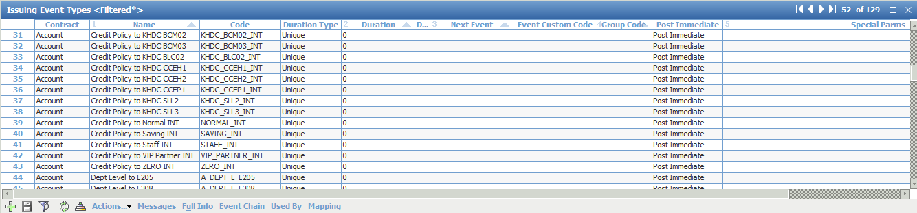

Call Full Payment event once issuing contract is created

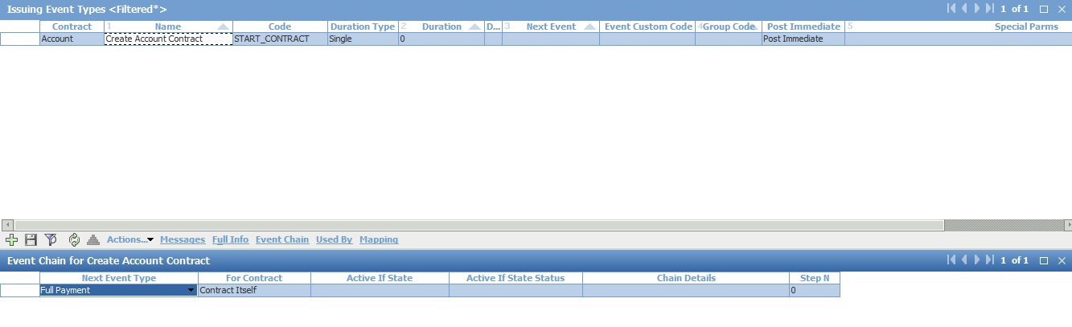

Waiting Card Block

Purpose: ‘Waiting Card Block’ Event has duration of 1 month for Bank’s requirement of blocking the card by the next Due Date.

Late payment

Purpose: The ‘Late Payment’ Event will be set up at Account Scheme’s Special Parms. A custom procedure will open this event on Due Date and calculate the Late Payment Fee.

Close Issuing Contract

Purpose: ‘Close Issuing Contract’ Event is to be manually triggered when customer closes the contract. This will switch the Issuing Contract to a Closed Scheme and move the accumulated Secured Deposit Interest Extra back to Bank’s Interest Contract so that it will not be posted to customer’s contract.

Full payment

Purpose: In the event when a Full Statement Balance Payment is made, on Due Date, this Event is posted. With this ‘Full Payment’ Event posted, Retail Interests from those Account Types with Calc When Credit = ‘Waive Interest’ in Account Scheme would have their interests waived.

Total Due

Purpose: This Event is opened when there is an amount in ‘Total Due’ Balance Type.

Wait Due Day

Purpose: call due day after 15 days

Billing Event

Purpose: Time to perform billing

**For Card**

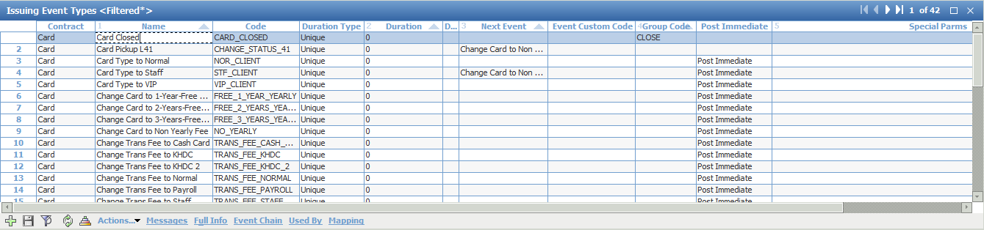

Lock Card by Debt

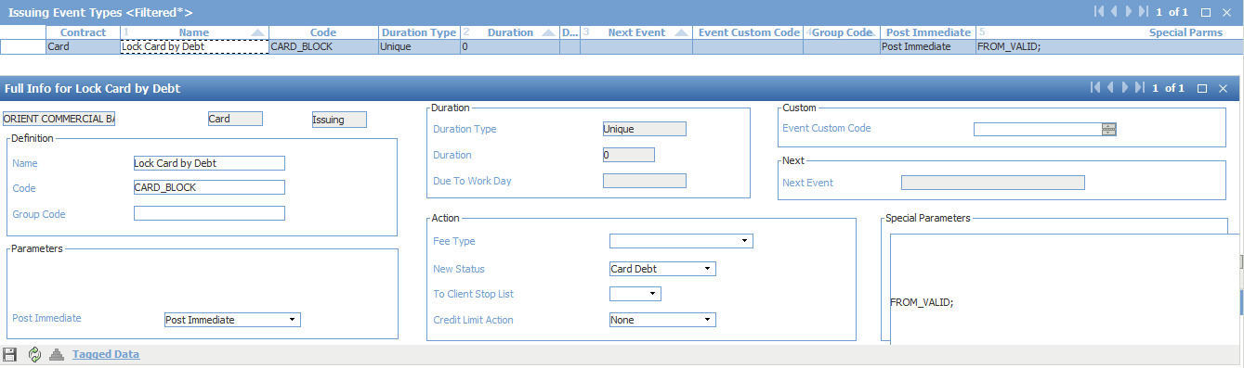

Event to change Classifier value

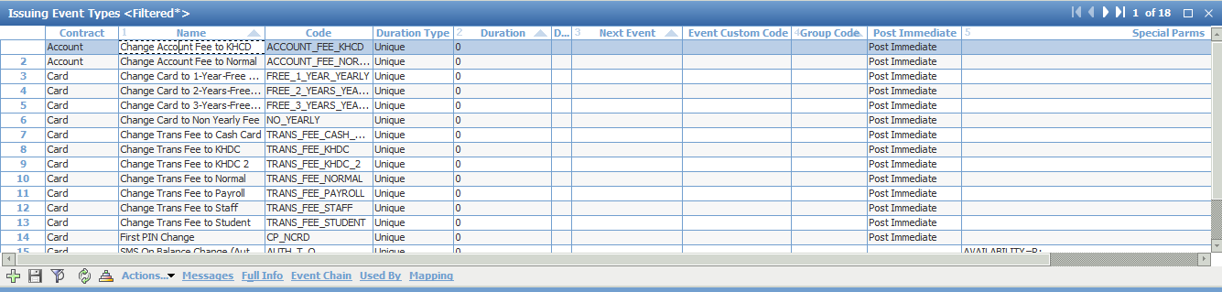

## Issuing Event State

Menu: [OpenWay\Full\Configuration Setup\Products\Issuing Private Products\Issuing Event States]

ADD the following Event State with [Condition] and [Full Info]: Full Due Paid -

* + ‘Full Due Paid’ is opened when ‘Total Due’ Event is NOT ACTIVE (i.e. Active if Status = ‘No’)
  + This means that when there is an amount in ‘Total Due’ Balance Type, the ‘Total Due’ EVENT will be opened and this ‘Full Due Paid’ Event State is NOT ACTIVE.
  + But when there is a Full/Minimum Payment made, thereby clearing the ‘Total Due’ Balance Type to 0.00, the ‘Total Due’ EVENT will be closed and this ‘Full Due Paid’ Event State will be ACTIVE.

‘CLOSE_EVENT=DELQ%;’ in Special Parameters will close all Events with the starting Code ‘DELQ’ when ‘Full Due Paid’ Event State is opened.

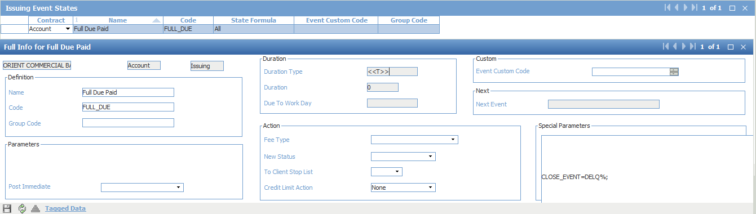

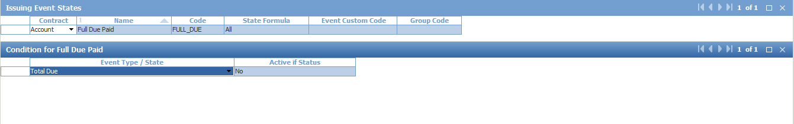

## Bank Service Pack

Menu: [OpenWay\Full\Configuration Setup\Accounting Setup\Bank Service Packs]

Purpose: Setup Fee of transaction type in service pack which bank want to charge merchant.

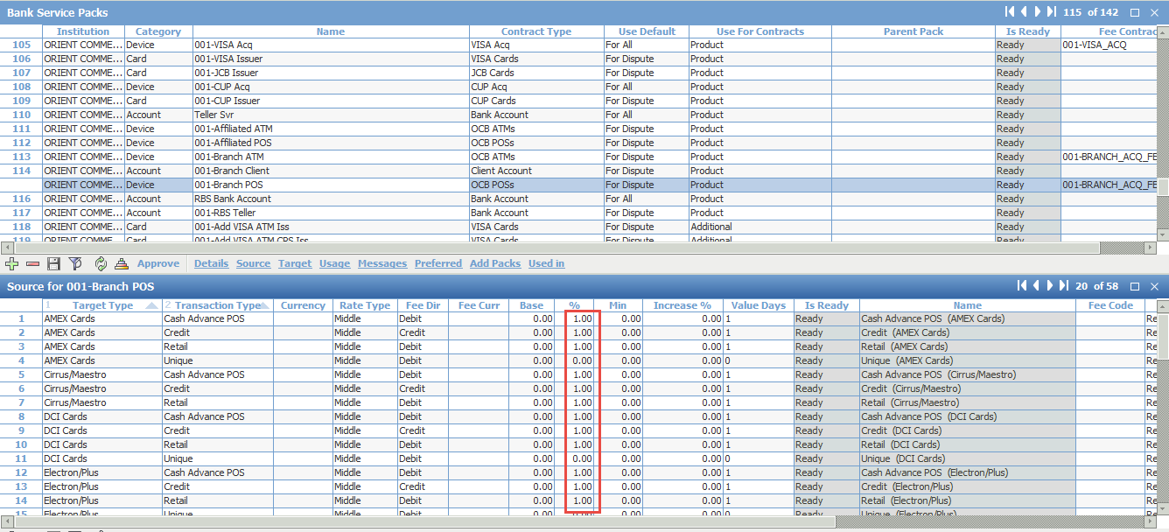

## Bank Account Scheme

Menu: [OpenWay\Full\Configuration Setup\Accounting Setup\Bank Account Schemes]

Purpose: to create the counter-party Account Types at Bank’s Interest Contract to handle the tracking of Due and Aged Amounts and Retail Interest Grace.

* + **Select 00N-Interests** (where 00N is the last 3-digit of Financial Institution’s Branch Code), click [Definition].
  + Insert the following Account Types in Local Currency and USD:
    - Shadow Payment Due
    - Shadow Deposit
    - Shadow Recovered

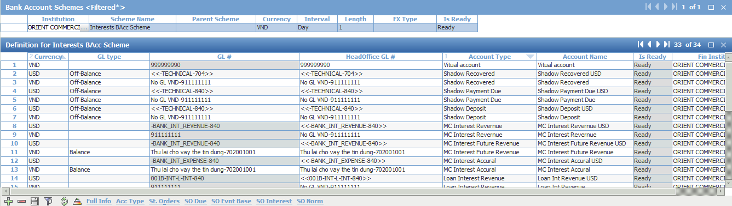

* For each of the record, click [Full Info]
* Input the following values in all the Account Types:

*GL Type*: ‘Off-Balance’ and Aggregate GL For: ‘Consolidated GL’

(This is to prevent movement of money between Real Account Types and Shadow Account Types)



* + Insert interest accounts for 2 currencies (VND; USD):
    - MC/JCB interest Accural
    - MC/JCB interest Future Revenue
    - MC/JCB interest Revenue

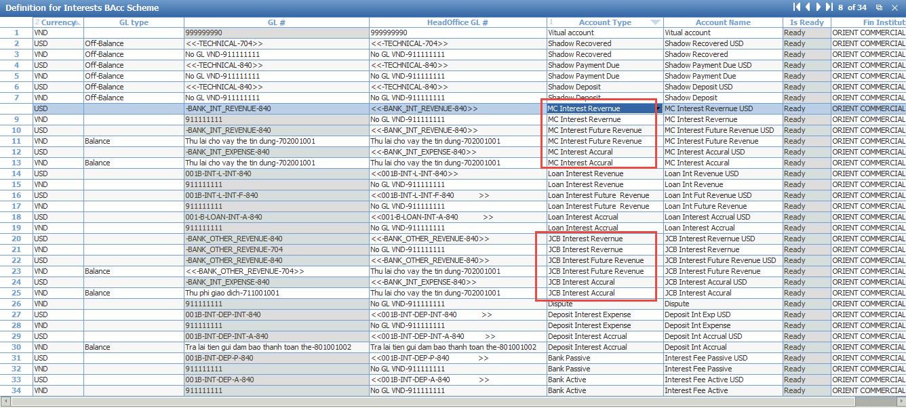

* **Select 00N-Teller** (where 00N is the last 3-digit of Financial Institution’s Branch Code), click [Definition].

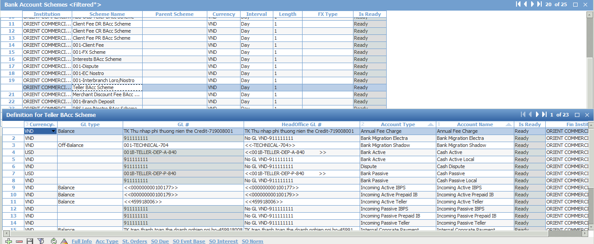

* **Select 00N-** **RBS Loro/Nostro** (where 00N is the last 3-digit of Financial Institution’s Branch Code), click [Definition].

Insert “MC/JCB Bank Active/Passive” for VND currency.

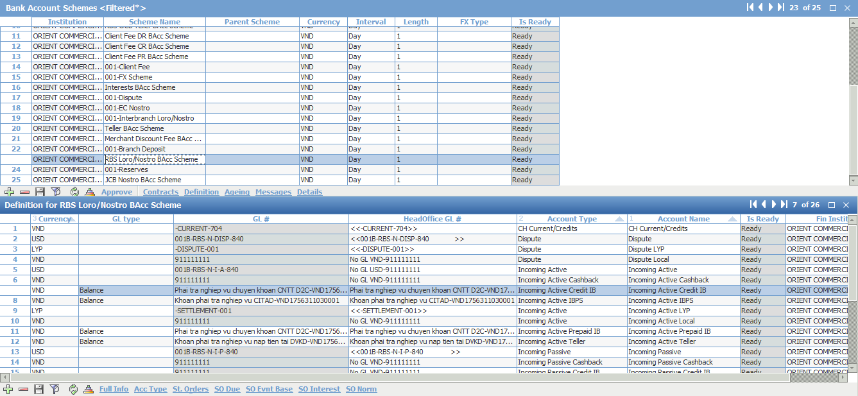

* **Select 00N-FX Scheme** (where 00N is the last 3-digit of Financial Institution’s Branch Code), click [Definition].

Insert GL # and HeadOffice GL#

## Issuing Account Scheme

Menu: [OpenWay\Full\Configuration Setup\Products\Issuing Private Products\Private Issuing Account Schemes]

Purpose: setup basic accounts in accounting scheme for prepaid/debit/credit card (JCB/Master and Local)

### Detail

* Input the fields as stated below:
  + *Currency* = ‘VND’
  + *Interval* = ‘Month’
  + *Length* = ‘1’
  + *Special Billing* = ‘Fixed Day of Month’
  + *Behav Group* = ‘Standard Private’
  + *Int Beh Type* = ‘001-Default behavior’
  + *SpecParms*= USE_AGED;REV_NORM;LOAN_BAL_TYPE=STMT_BALANCE;SH_DUE_MODE=BT_SIMPLE;SPLIT_MONTHLY;MTP_ROUND=0;EFF_PAST_DUE=NULL;EFF_DUE=NULL;EFF_TOTAL_DUE=DUE;
  + *Tariff Domain* = ‘MasterCard Credit Card’
  + *Billing Tariff* = ‘Billing Cycle’
  + *Statement Tariff* = ‘Statement Ageing’

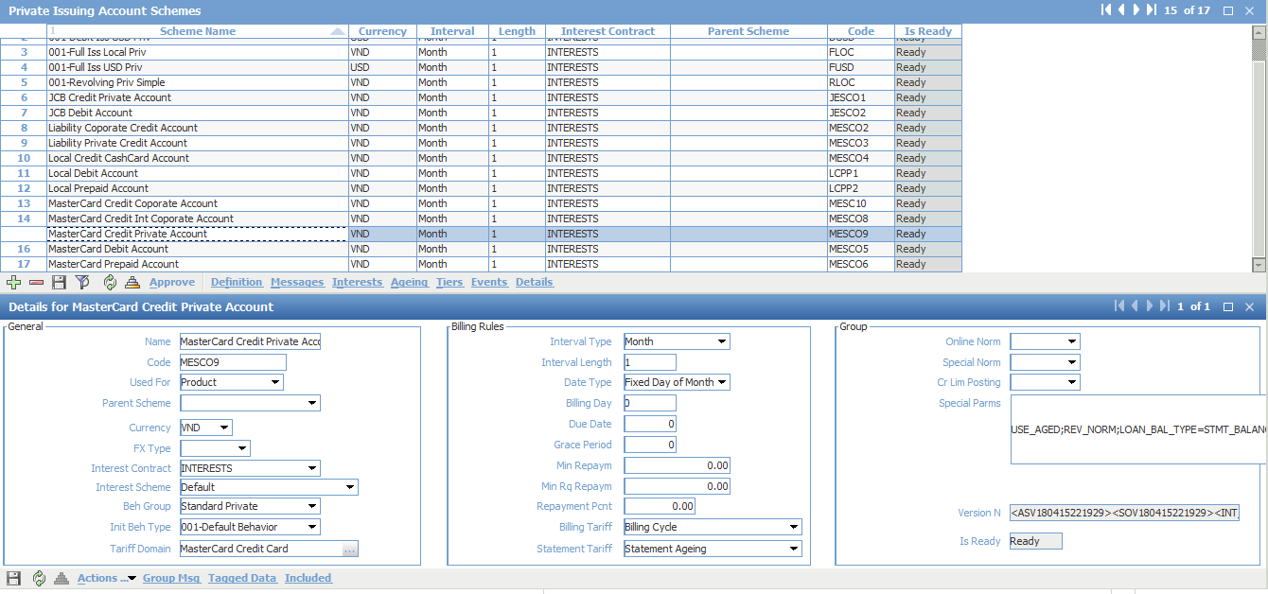

### Definition

Cardholder Accounts

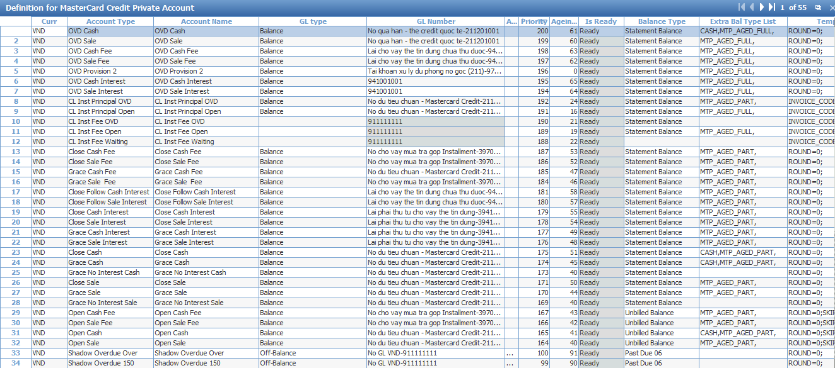

Shadow Accounts

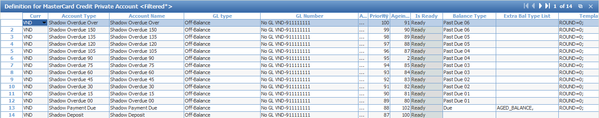

Standing Order

Move balance to Overdue account

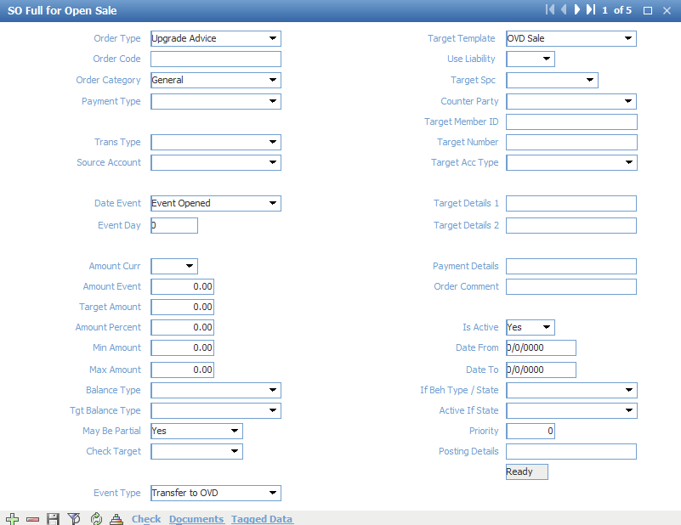

Move interest after Overdue

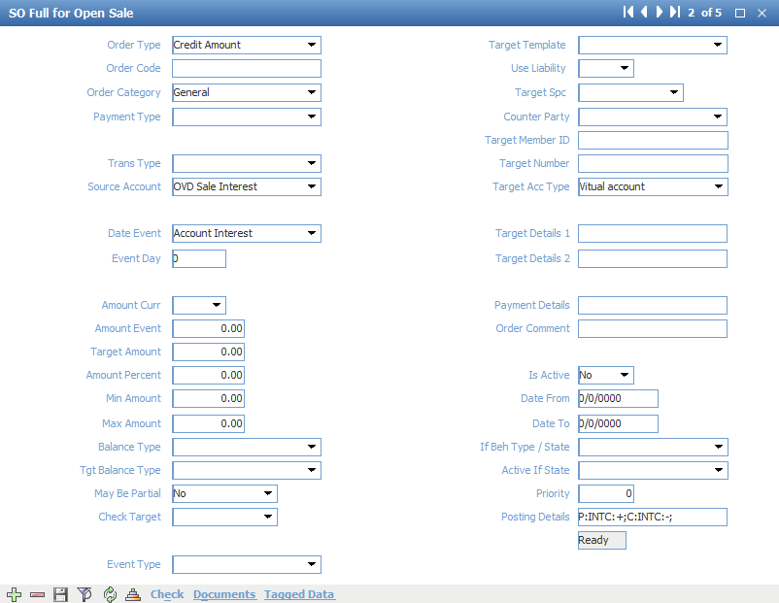

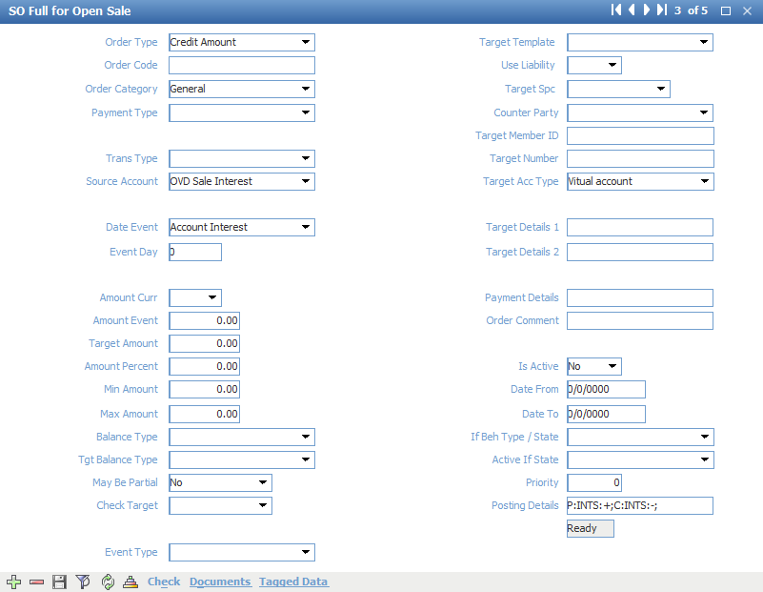

### Interest

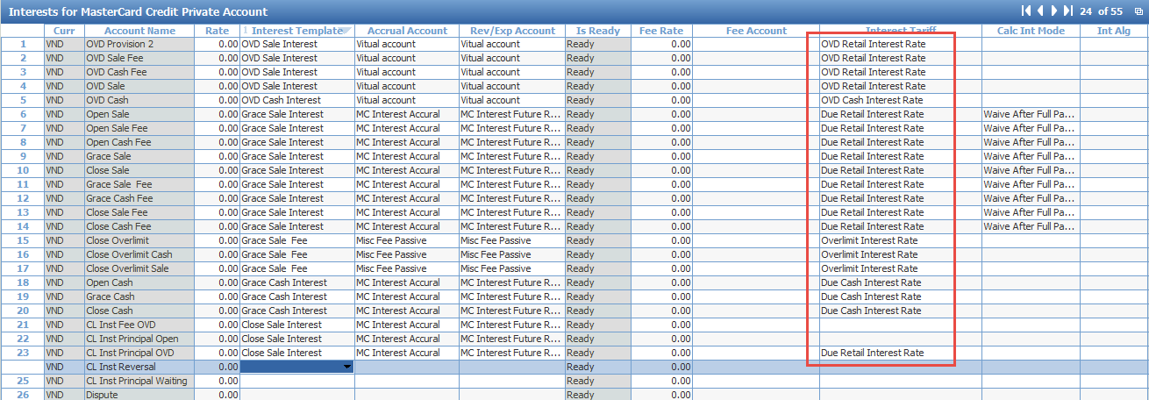

### Ageing

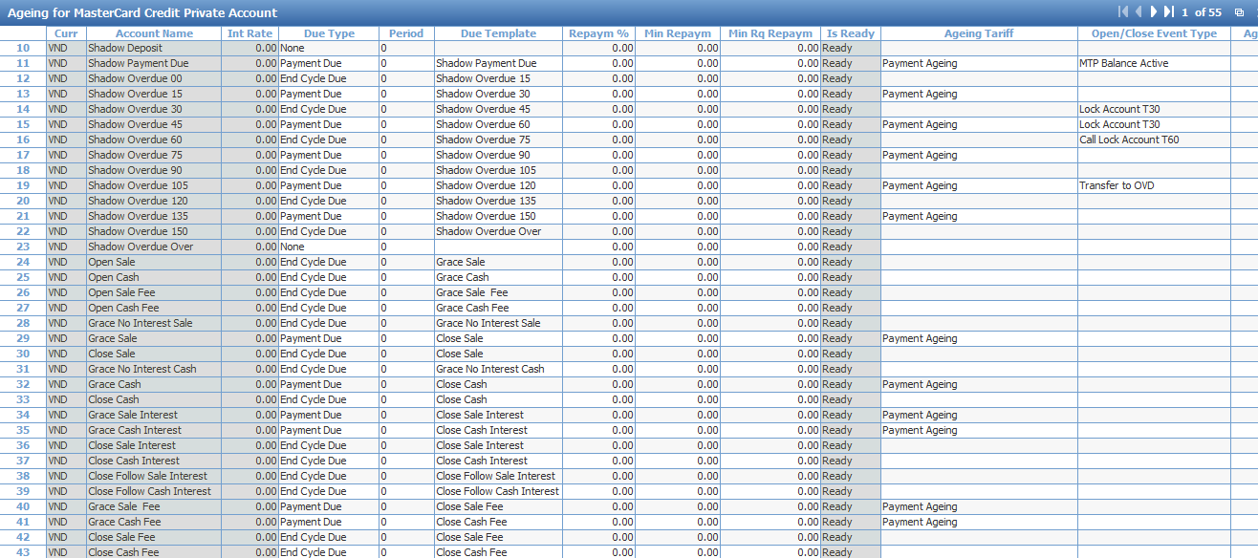

### Tiers

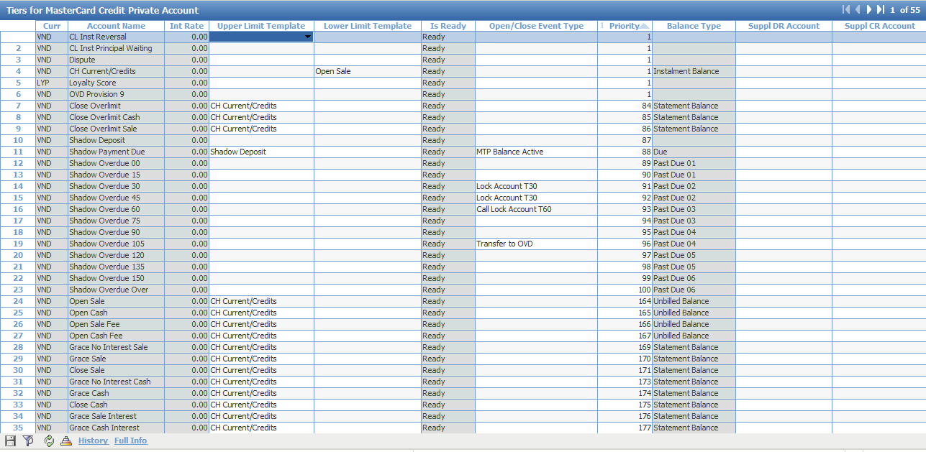

### Event

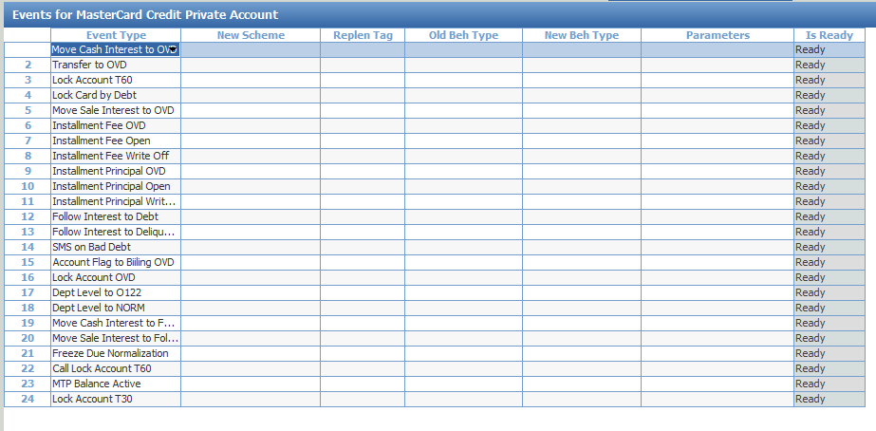

## Private Card Service Package

Menu: [OpenWay\Full\Configuration Setup\Products\Issuing Private Products\Private Card Service Packs]

Purpose: setup basic source and target contract in service pack

In order to adopt with bank requirement, we need to create some additional service. Below is list of basic additional service for each product.

|  |  |
| --- | --- |
| Additional service pack | Meaning |
| 00N-Add MC Standard Usage Limit | Setup ATM/POS limiter for Product |
| 00N-Add MC standard Annual Default | Free yearly charge for first 2 years |
| 00N-Add MC standard Annual Charge | Charge from 2nd year |
| 00N-Add MC Credit MOTO Prevention | Prevent MOTO transaction as default |
| 00N-Add MC Ecommerce Prevention | Prevent Ecommerce transaction |
| 00N-Add MC Annual Usage | Detect the first transaction of year |
| 00N- Add MC Credit Base | All transaction and misc fee |
| 00N-Add MC Credit Fallback Prevention | Prevent Fallback transaction as default |
| 00N-Add MC Credit SMS Service | Setup Notification message |

00N-Add MC Standard Usage Limit

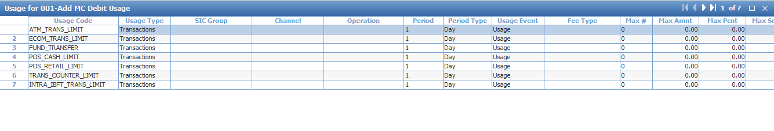

00N-Add MC standard Annual Default



00N- Add MC standard Annual Charge

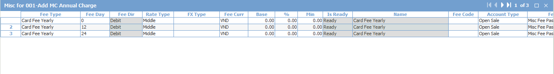

00N-Add MC MOTO Permission

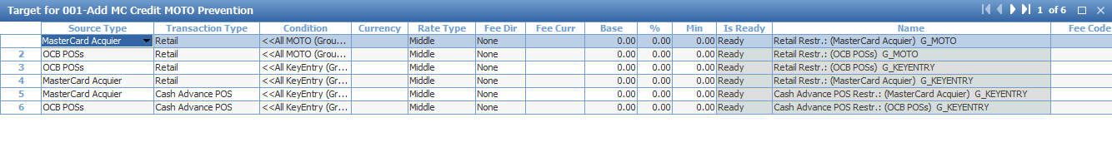

00N-Add MC Ecommerce Permission



00N-Add MC Annual Usage

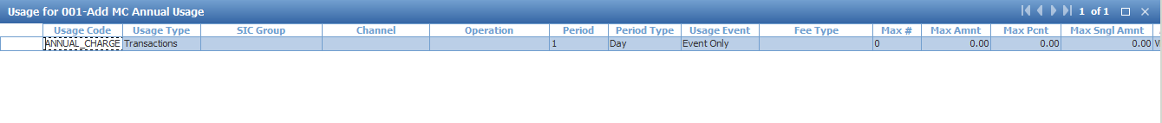

00N-Add MC Credit Base

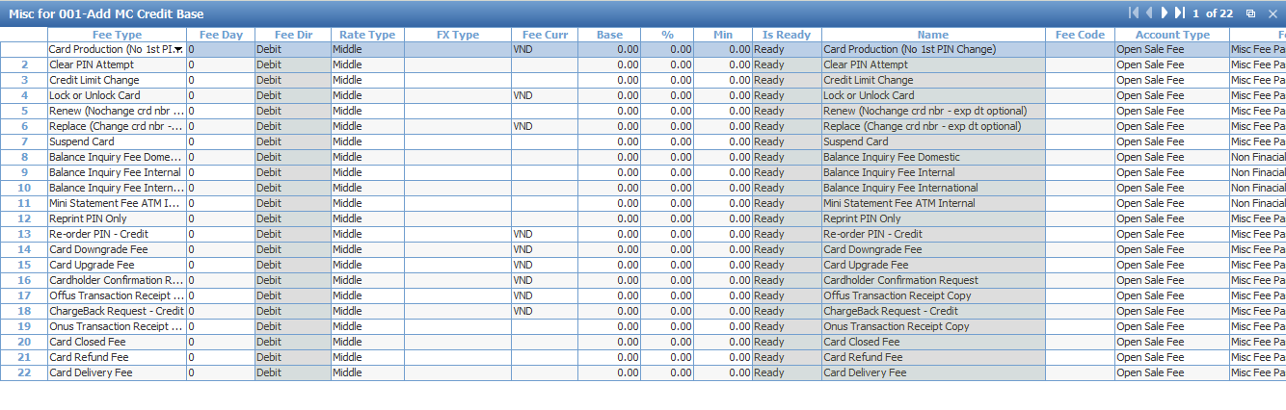



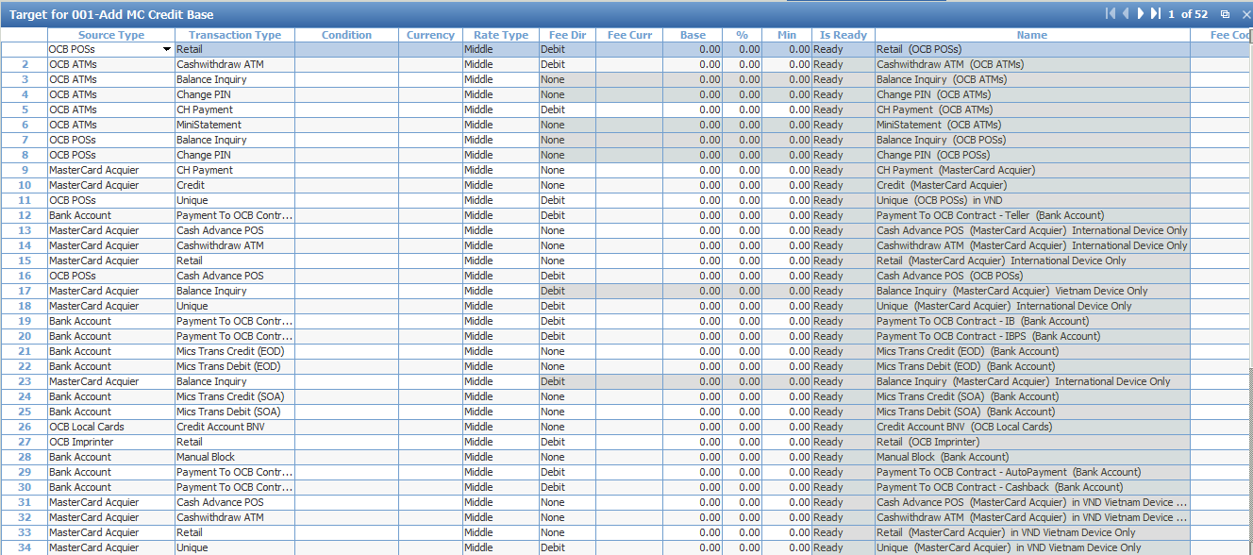

00N-Add MC Credit Fallback Prevention

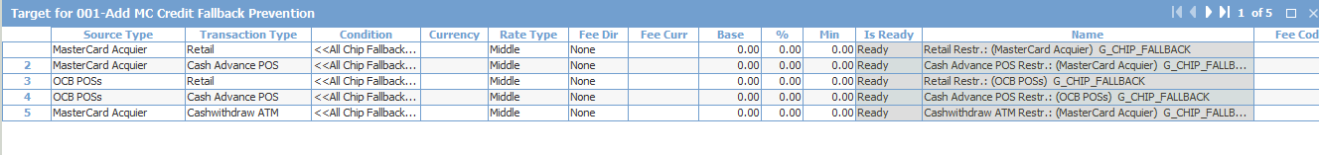

00N-Add MC Credit SMS Service

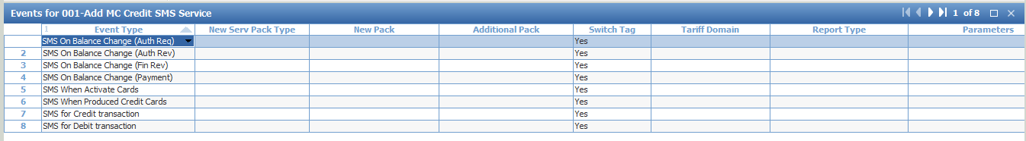

Main service package will refer to additional service package

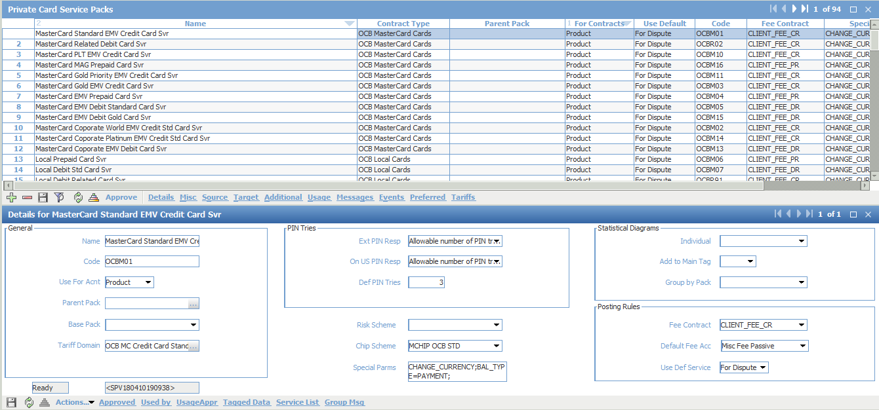

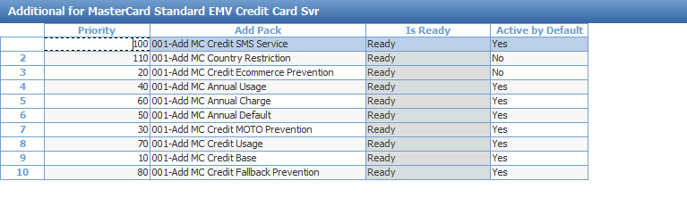

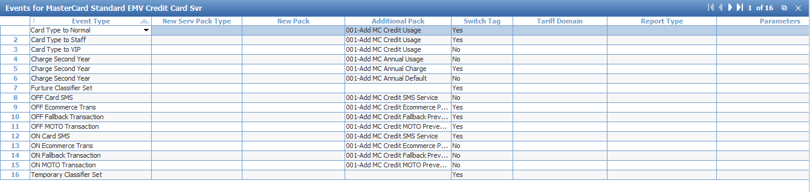

## Account Service Package

Menu: [OpenWay\Full\Configuration Setup\Products\Issuing Private Products\Private Account Service Packs]

Purpose: add new source, target and misc for account service packs

**Issuing Account Service Package**

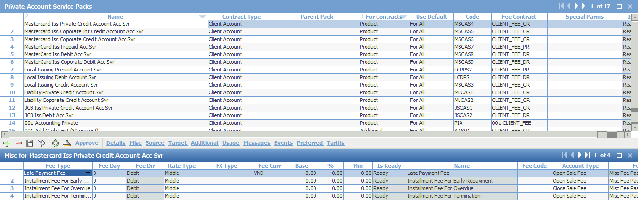



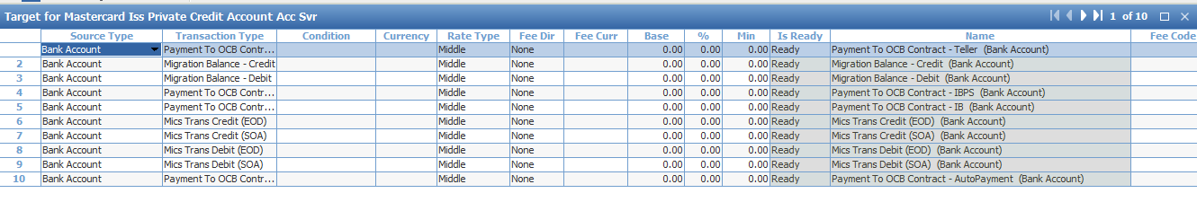

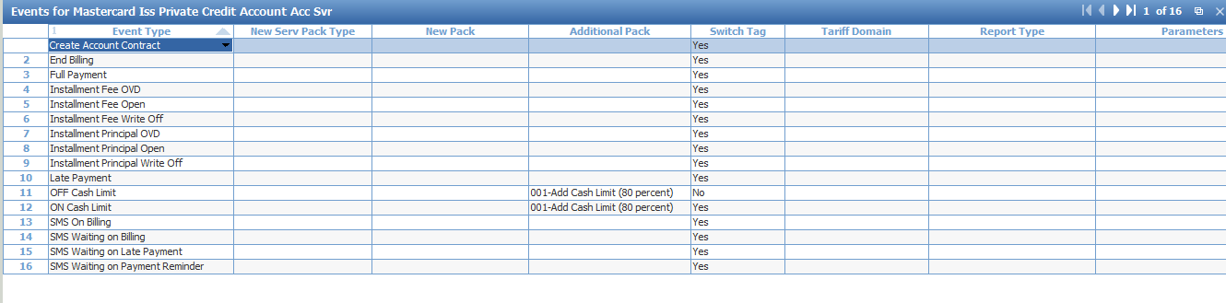

**Liability Account Service Package**

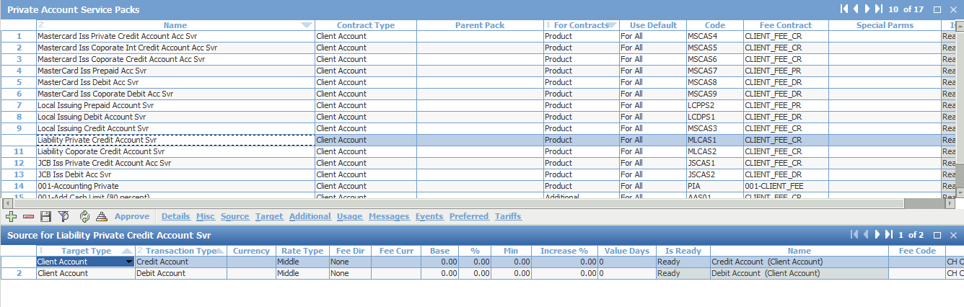

## Classifier

Menu: OpenWay\Full\Configuration Setup\Common Handbooks\User Classifiers

Purpose: define client classifier

Classifier for client categories

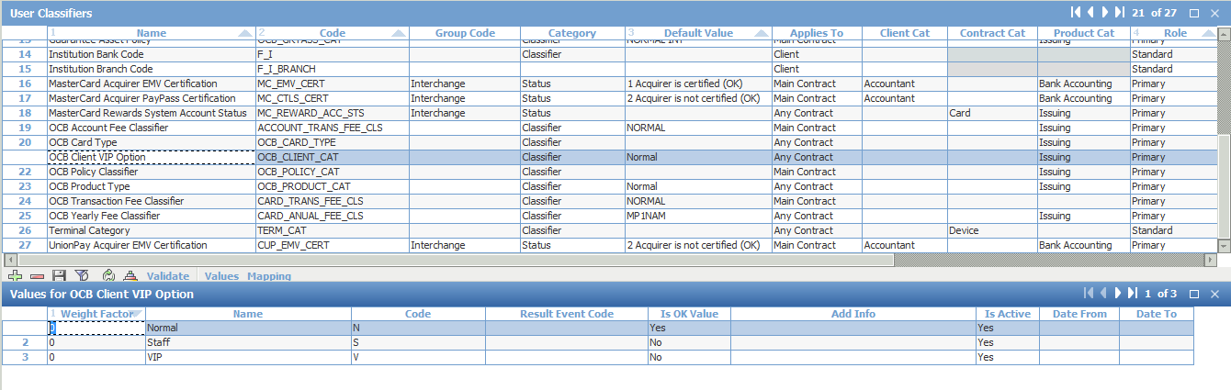

Classifier for Interest type

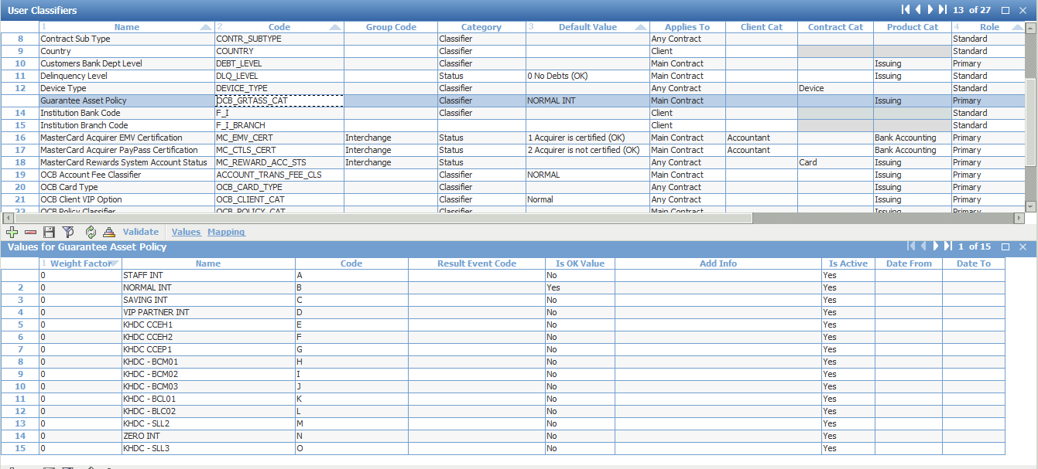

Classifier for Yearly Fee

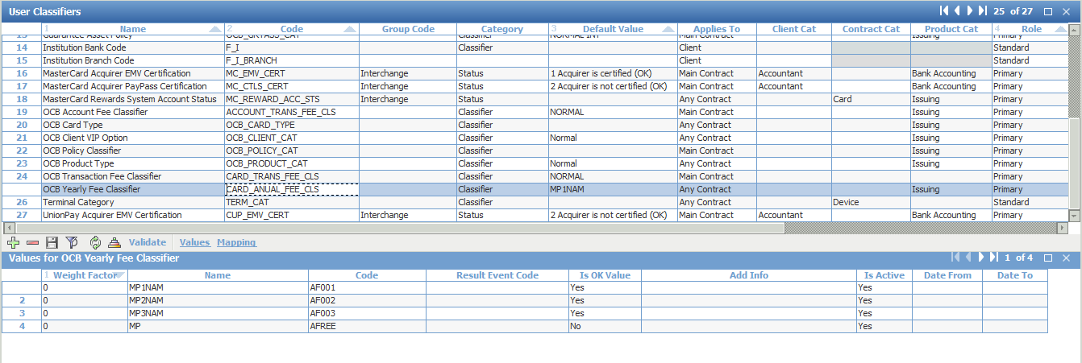

Policy Classifier

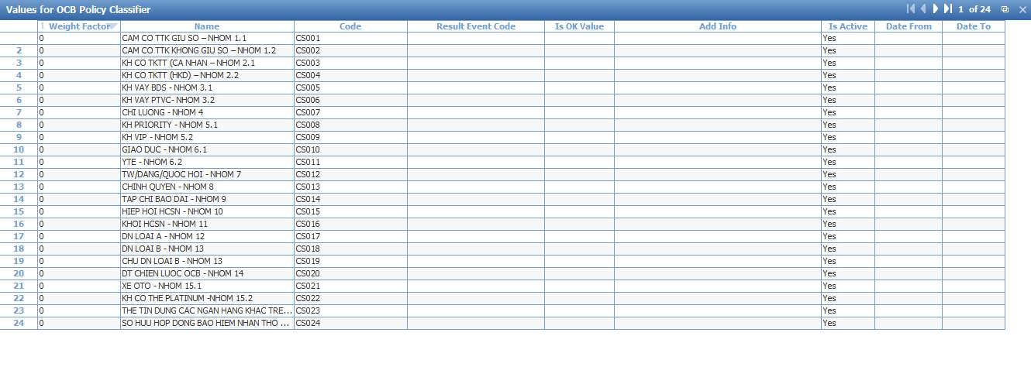

Account Fee Classifier

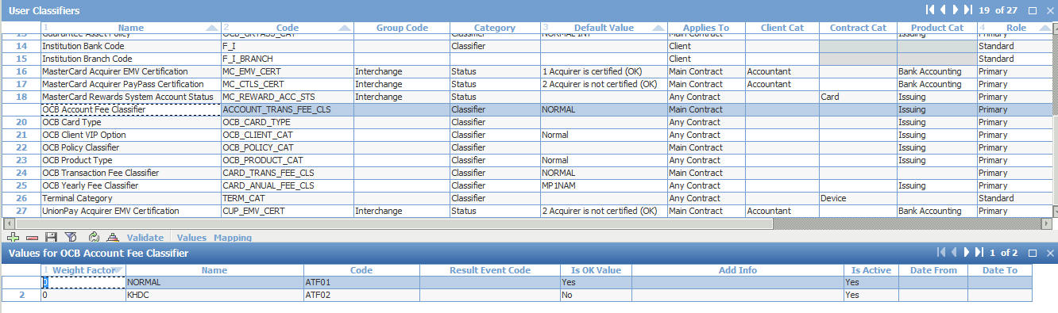

Card Type Classifier

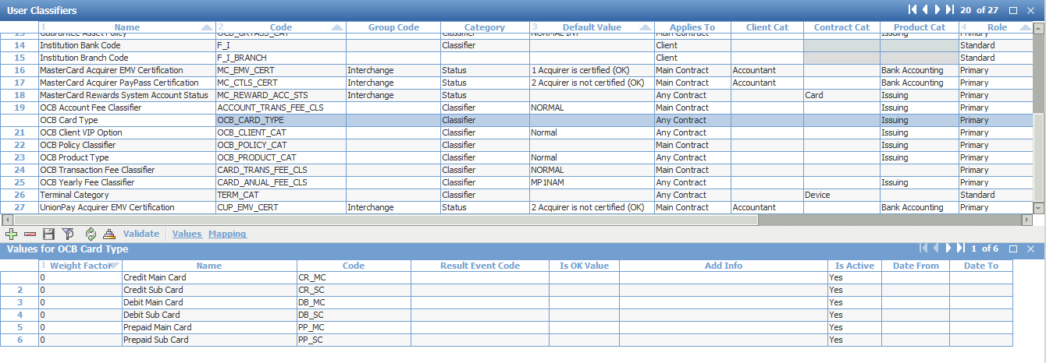

Transaction Fee Classifier

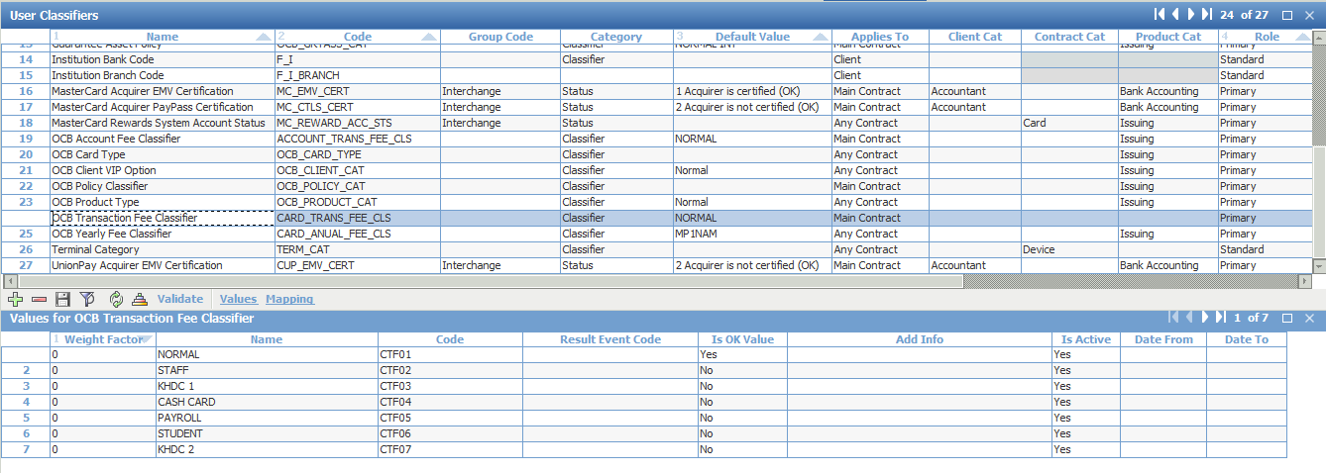

## Classifier Actions

Menu: OpenWay\Full\Configuration Setup\Common Handbooks\Classifier Actions

Purpose: setup event to switch value of classifier

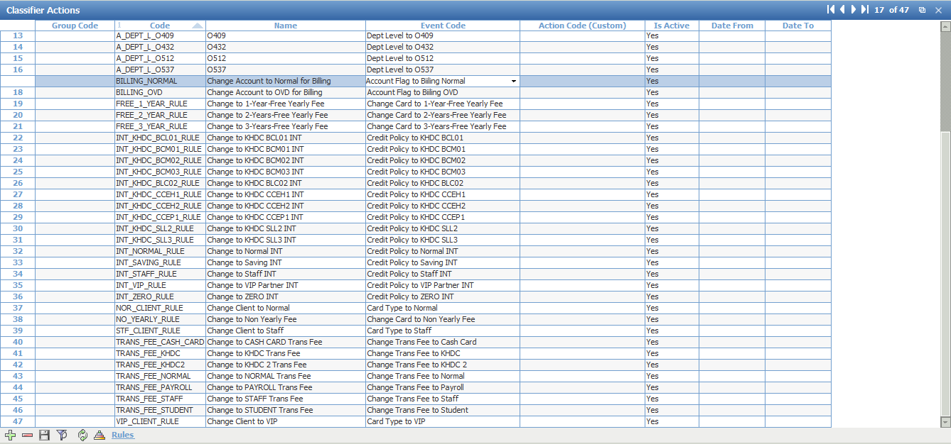

## Product

Menu: [OpenWay\Full\Configuration Setup\Products\Product Definition\Product Groups]

Purpose: to declare product before produce card.



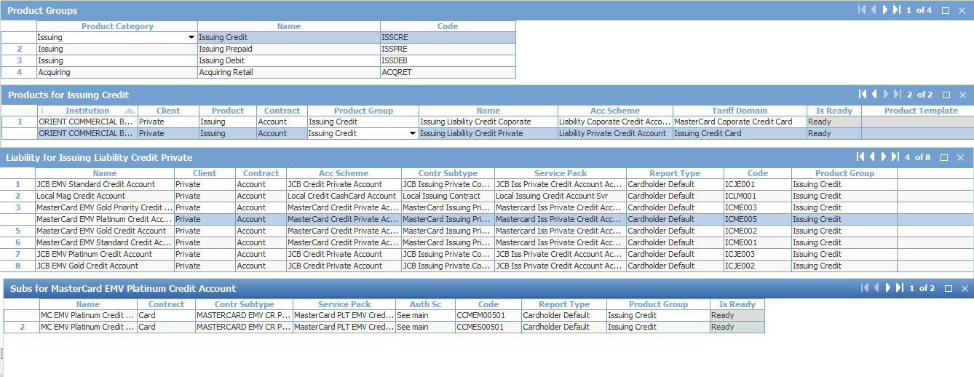

Add Classifier as default

## Tariff

Tariff Groups

Menu: ROOT.OpenWay.Tariffs.Tariff Types & Tariff Domains.Tariff Groups

Purpose: Define tariff group

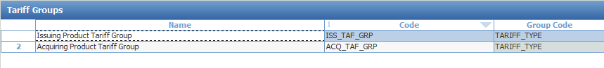

Tariff Types

Menu: ROOT.OpenWay.Tariffs.Tariff Types & Tariff Domains.Tariff Types

Purpose: Create tariff type based on tariff role and tariff type group

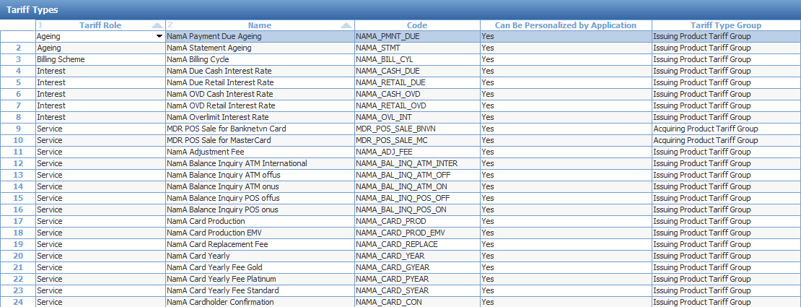

Tariff Domains:

Menu: ROOT.OpenWay.Tariffs.Tariff Types & Tariff Domains.Tariff Domains

Purpose: Create tariff domains, tariffs will be added to tariff domains

To add a tariff in a registered tariff domain, click the [Tariff] button in the "Tariff Domains" form 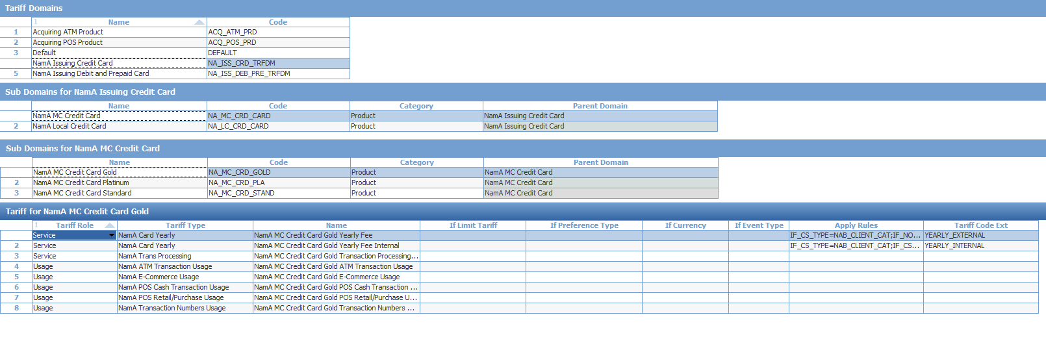

Add data to Tariff

Menu: ROOT.OpenWay.Tariffs.Tariff Data Input By Tariff

Purpose: To specify tariff numeric values

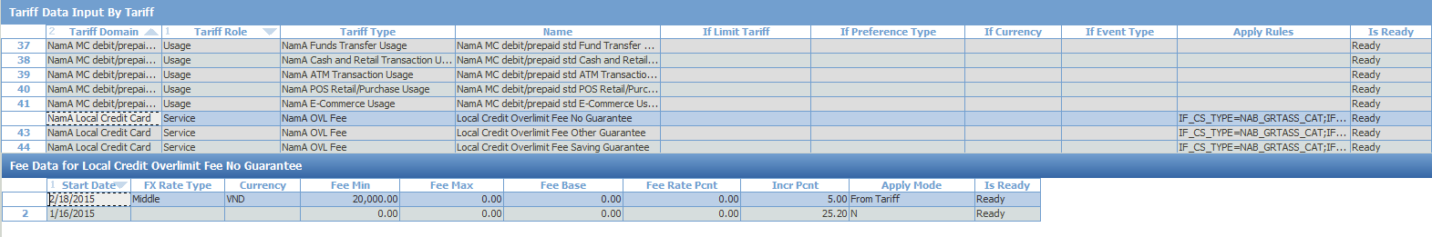

## Instalment

### Global Parameter

Menu: OpenWay\Full\Configuration Setup\Main Tables\Additional Global Parameters

Purpose: Add some parameters for instalment module

|  |  |
| --- | --- |
| Parameters | Values |
| INST_AUTH_ACTION | CHECK – it is default value. Instalment plan is not generated.  CREATE_INACTIVE – Instalment plan is generated in an inactive status based on authorization document. |
| INST_FIN_ACTION | CHECK – it is default value. Instalment plan is not generated.  ACTIVE - when a financial document is received to activate an instalment plan created in an inactive state on the basis of an authorization document.  CREATE_INACTIVE – Instalment plan is generated in an inactive status based on authorization document.  CREATE_ACTIVE – Instalment plan is generated in an active status |



### Configuring "Contract Add Info Types" Classifiers

A record with the INST_INPUT code must be added to the "Contract Add Info Types" classifier



### Balance Type

Add a new Balance type which is used for early repayment, balance code must be INST_ER



### Instalment Scheme

Menu: OpenWay\Instalments\Instalment Configuration\Instalment Schemes

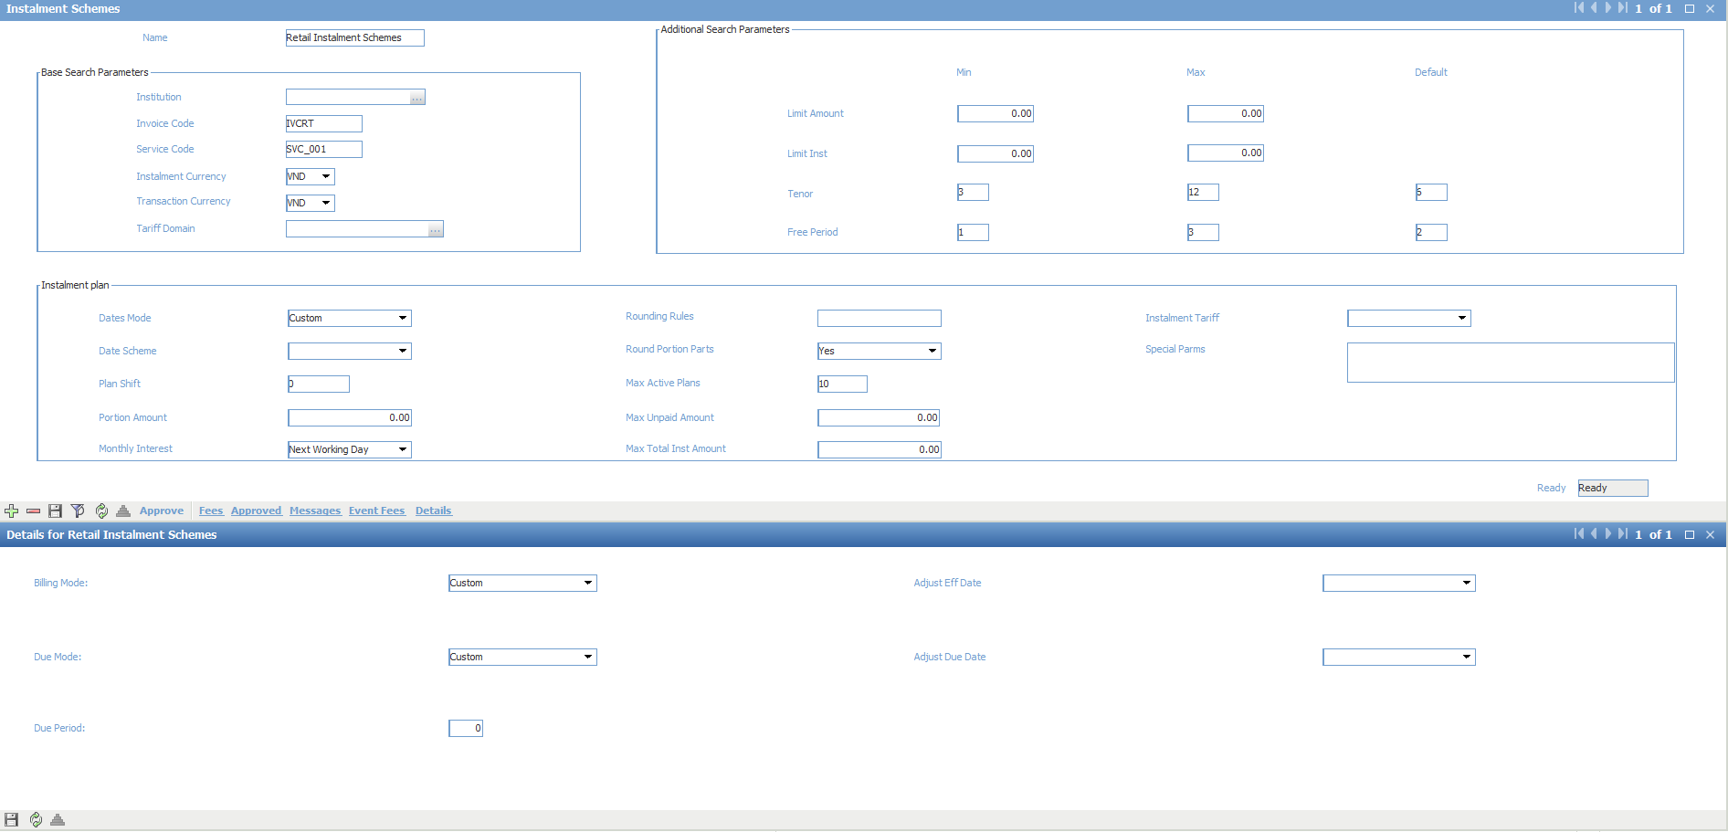

In order to use Date Mode = Custom and Due Mode = Custom, we need to configure two functions: CUST_INSTL_EFF_DATE and CUST_INV_DUE_DATE

In this case, the effective date of instalments is fixed to 15th of each month.

create or replace function CUST_INSTL_EFF_DATE(

ContractID in dtype. RecordID %Type,

InvoiceCode in dtype. Name %Type,

PrevEffDate in dtype. CurrentDate %Type,

StartDate in dtype. CurrentDate %Type,

InstN in dtype. Counter %Type,

BillingMode in dtype. Name %Type,

ShiftN in dtype. Counter %Type

) return dtype. CurrentDate %Type

is

EffDate dtype. CurrentDate %Type;

begin

if (glob.LDATEACNT(ContractID) <= to_date(to_char(glob.LDATEACNT(ContractID),'YYYY-MM')||'-15')) then

if (InstN=1) then

EffDate:= to_date(to_char(glob.LDATEACNT(ContractID),'YYYY-MM')||'-15');

else

EffDate:= sy_convert.PLUS_MONTHS(nvl(StartDate, to_date(to_char(glob.LDATEACNT(ContractID),'YYYY-MM')||'-15')), InstN-1);

end if;

else

EffDate:= sy_convert.PLUS_MONTHS(nvl(StartDate, to_date(to_char(glob.LDATEACNT(ContractID),'YYYY-MM')||'-15')), InstN);

end if;

stnd.process_message('I', 'HELLO EffDate=' ||EffDate);

return EffDate;

*--return sy_convert.PLUS_MONTHS(nvl(StartDate, glob.LDATEACNT(ContractID)), InstN);*

end;

create or replace function CUST_INV_DUE_DATE(

ContractID in dtype. RecordID %Type,

DocRec in doc %RowType,

ServRec in service_approved %RowType,

OrderRec in standing_order %RowType,

InvoiceCode in dtype. Name %Type,

ActionCode in dtype. Name %Type,

EffDate in dtype. CurrentDate %Type,

DueType in dtype. Name %Type,

DuePeriod in dtype. Counter %Type

) return dtype. CurrentDate %Type

is

begin

return sy_convert.PLUS_DAYS(EffDate, 5);

*--return null;*

end;

### Instalment Account Template

Menu: OpenWay\Full\Configuration Setup\Accounting Setup\Account Types

Purpose: define new account template for instalment plan

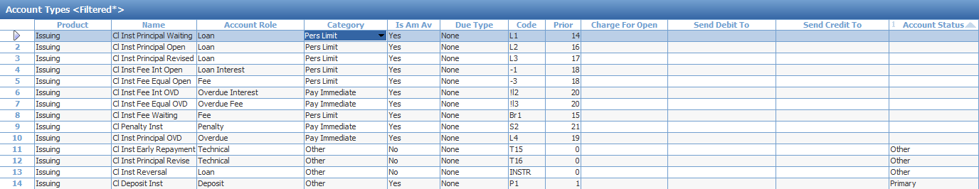

List of new account template

|  |  |  |  |  |  |  |
| --- | --- | --- | --- | --- | --- | --- |
| **Product Category** | **Name** | **Group Name** | **Account Category** | **Code** | **Priority** | **Description** |
| Issuing | Cl Deposit Inst | Deposit | Other | P1 | 1 | This account is used for automatic payment of instalments. The balance from the "Cl Deposit" account remaining after payment is transferred to this account. |
| Issuing | Cl Inst Principal Waiting | Loan | Pers Limit | L1 | 14 | Total amount of debt waiting for payment to become effective |
| Issuing | Cl Inst Principal Open | Loan | Pers Limit | L2 | 16 | Principal effective for payment |
| Issuing | Cl Inst Principal Revised | Loan | Pers Limit | L3 | 17 | Transit account for the principal when restructuring an instalment plan |
| Issuing | Cl Inst Fee Int Open | Loan Interest | Pers Limit | -1 | 18 | Fee with the "Interest" payment method, effective for payment |
| Issuing | Cl Inst Fee Equal Open | Fee | Pers Limit | -3 | 18 | Fee with the "Fee" payment method, effective for payment |
| Issuing | Cl Inst Fee Int OVD | Overdue Interest | Pay Immediate | !l2 | 20 | Fee with the "Interest" payment method, assigned to overdue. |
| Issuing | Cl Inst Fee Equal OVD | Overdue Fee | Pay Immediate | !l3 | 20 | Fee with the "Fee" payment method, assigned to overdue. |
| Issuing | Cl Inst Fee Waiting | Fee | Pers Limit | Br1 | 15 | Total amount of the fee and interest charged as part of an instalment waiting to become effective. Each month instalment fee and interest amounts are transferred from this account to the "Fee Open" and "Interest Open" accounts, respectively. |
| Issuing | Cl Penalty Inst | Penalty | Pay Immediate | S2 | 21 | Penalties charged for overdue principal |
| Issuing | Cl Inst Principal OVD | Overdue | Pay Immediate | L4 | 19 |  |

### Instalment Fee Types

Menu: OpenWay\Full\Configuration Setup\Transaction Types\Fee Types

Purpose: Add new fee type for Instalment module.

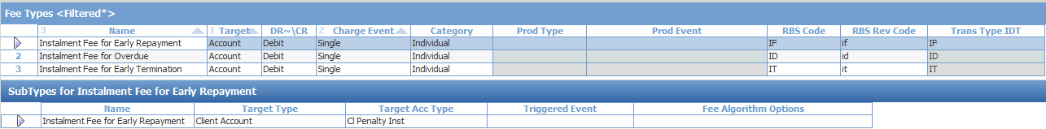

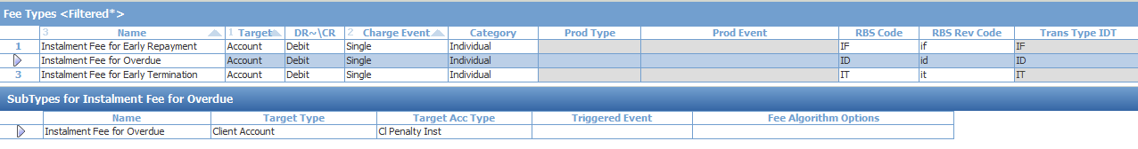



### Instalment Transaction Type

Menu: OpenWay\Full\Configuration Setup\Transaction Types\Transactions – All

Purpose: Add new transaction type for Instalment

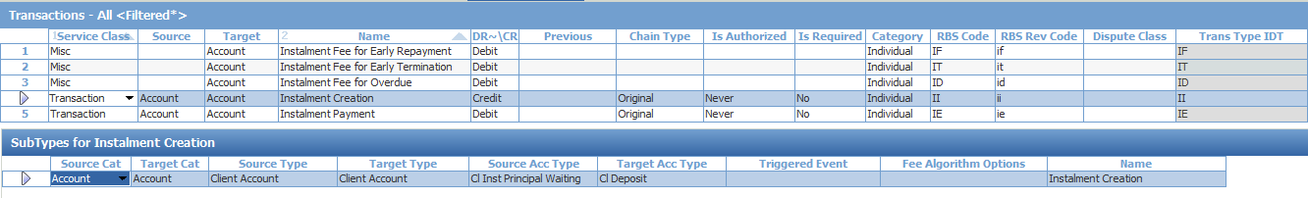

On the transaction sub-type level, account types to record granting the loan are set. For the source contract, a specially configured account type is specified, on which the instalment amount will be recorded.

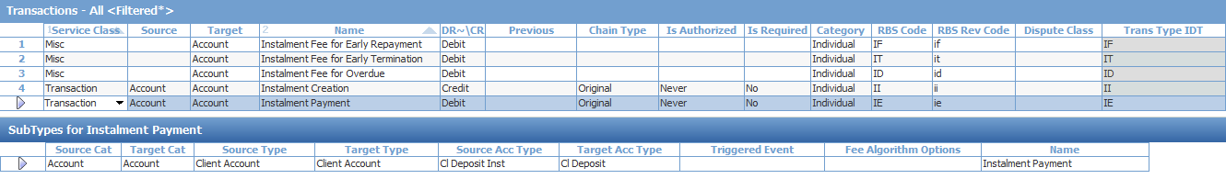

### Instalment Events

Events can be set up for the WAY4 Instalments module in the following ways:

1. Registration of an Event type in the "Issuing Event Types" form.

2. Configuration of conditions for opening the Event in one of the following forms:

"Invoice Events" form.

"Events for <name of instalment scheme> form.

**Set Financial Institution**

Menu: OpenWay\Instalments\Instalment Configuration\ Instalment Events and Fees \Set Financial Institution

Purpose: make sure we choose correct Financial Institution before add instalment Event

**Issuing Event Types**

Menu: OpenWay\Instalments\Instalment Configuration\ Instalment Events and Fees \Issuing Event Types

Purpose: Add new Events

The marker "Post Later" is set for processing the Event in the Contracts Daily Update procedure

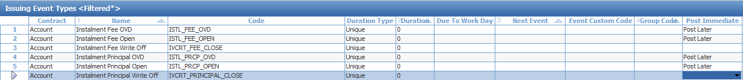

**Invoice Events**

Menu: OpenWay\Instalments\Instalment Configuration\ Instalment Events and Fees \Invoice Events

Purpose: Add condition to open the instalment Event.

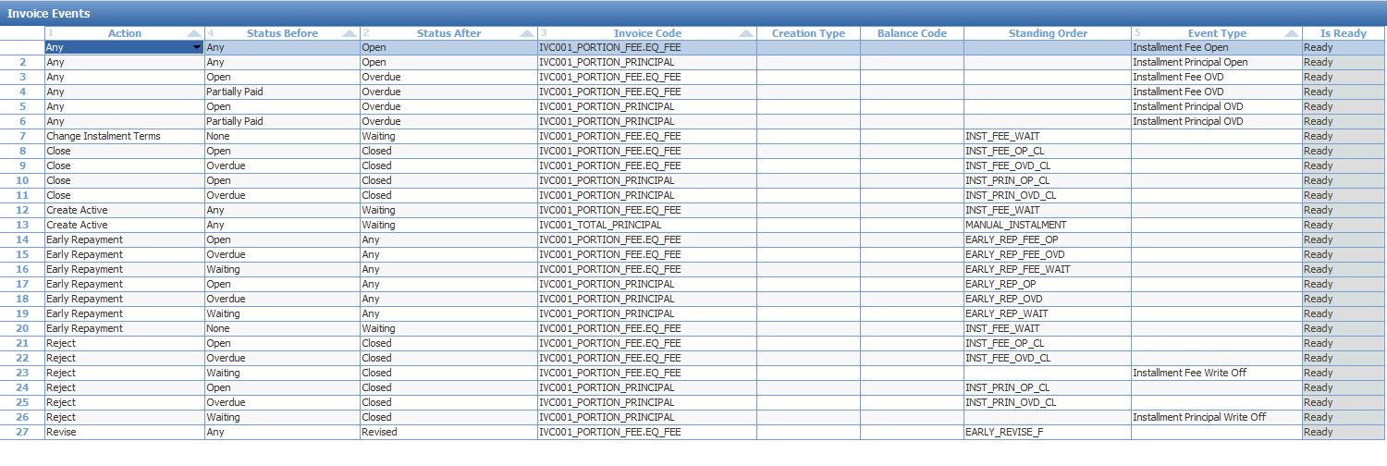

If several fees are set up for an instalment scheme, in order to assign an Event to a particular fee, at the end of the Invoice Code field string add the fee code through a "." character. For example, IVCRT_PORTION_FEE.EQ_FEE (the fee code is taken from the Fee Code field of the fee under the installation scheme



### Instalment Fee

Menu: OpenWay\Instalments\Instalment Configuration\Instalment Events and Fees\Instalment Event Fees

Purpose: Configure fees that are charged at certain times in an instalment plan's lifecycle.



This fee is linked to instalment scheme by the button “Event Fees” in “Instalment Schemes” form

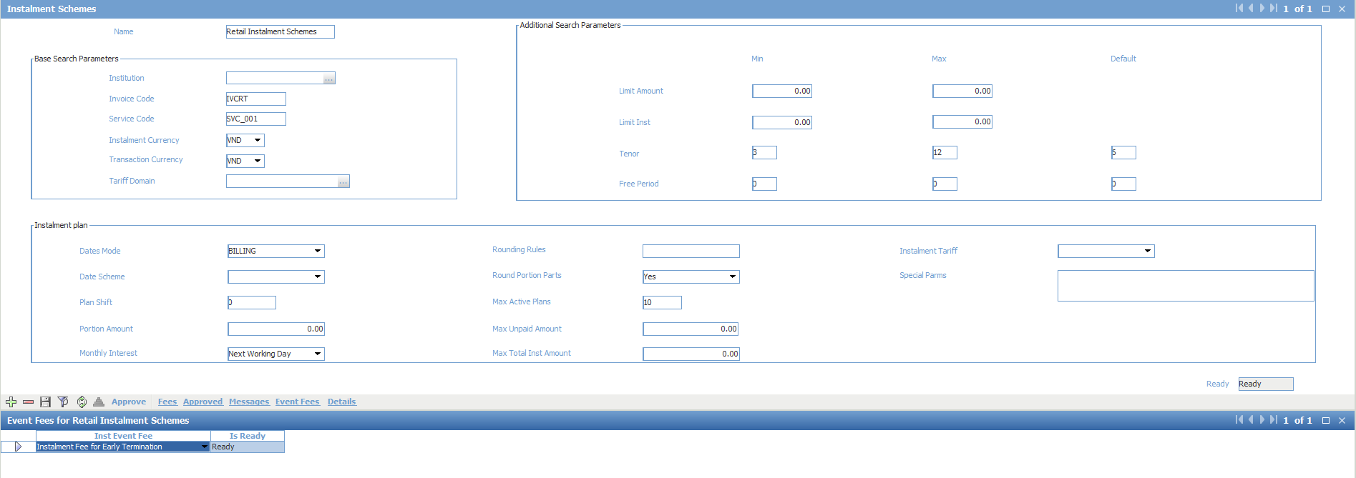

### Instalment Groups, Available Instalment Trans Type, Available Instalment Schemes

Menu: OpenWay\Instalments\Instalment Configuration\Instalment Scheme Group\Instalment Scheme Groups

Purpose: Configure instalment scheme groups.

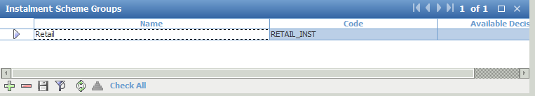

Menu: OpenWay\Instalments\Instalment Configuration\Instalment Scheme Group\Available Instalment Trans Type

Purpose: Configure transactions type which can be converted into instalment within a scheme groups.

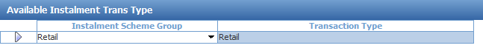

Menu: OpenWay\Instalments\Instalment Configuration\Instalment Scheme Group\Available Instalment Scheme

Purpose: Configure available instalment scheme in a scheme groups.

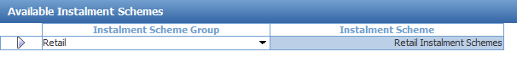

### Account scheme

Menu: OpenWay\Full\Configuration Setup\Products\Issuing Private Products\Private Issuing Account Schemes

Purpose: add account template for Instalment scheme

Definition:

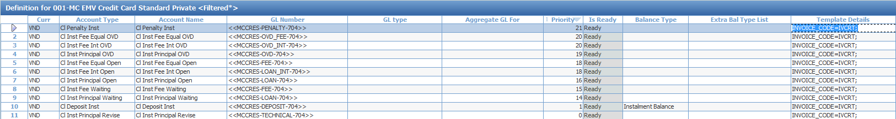

Tiers:

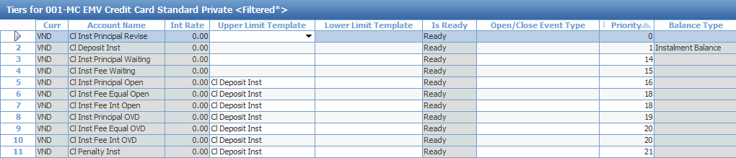

### Account Service Pack

Menu: OpenWay\Full\Configuration Setup\Products\Issuing Private Products\Private Account Service Packs

Purpose: Add Event using for Instalment scheme

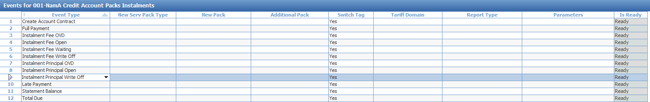

In a Service for an accounting contract, if you want to process instalment loan transactions, specify the INVOICE_ACTION=INSTALMENT; tag in the Service Details field

Misc:

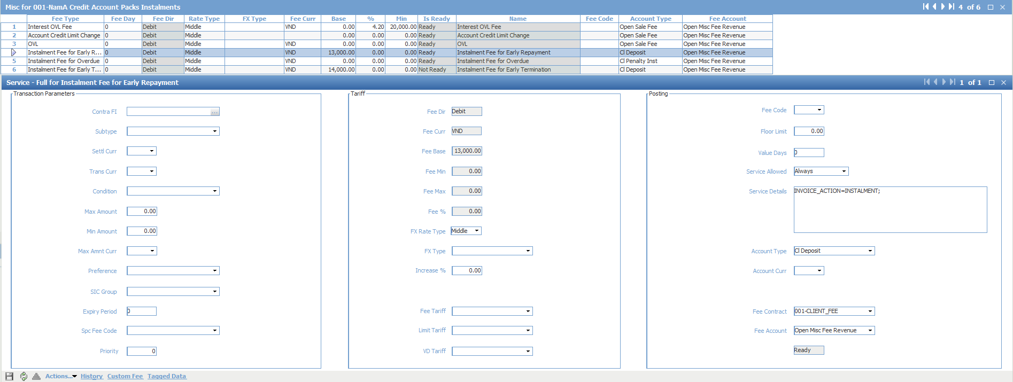

Source:



### Standing order

**CH Current/Credits:**

Purpose: transferring amount for early repayment

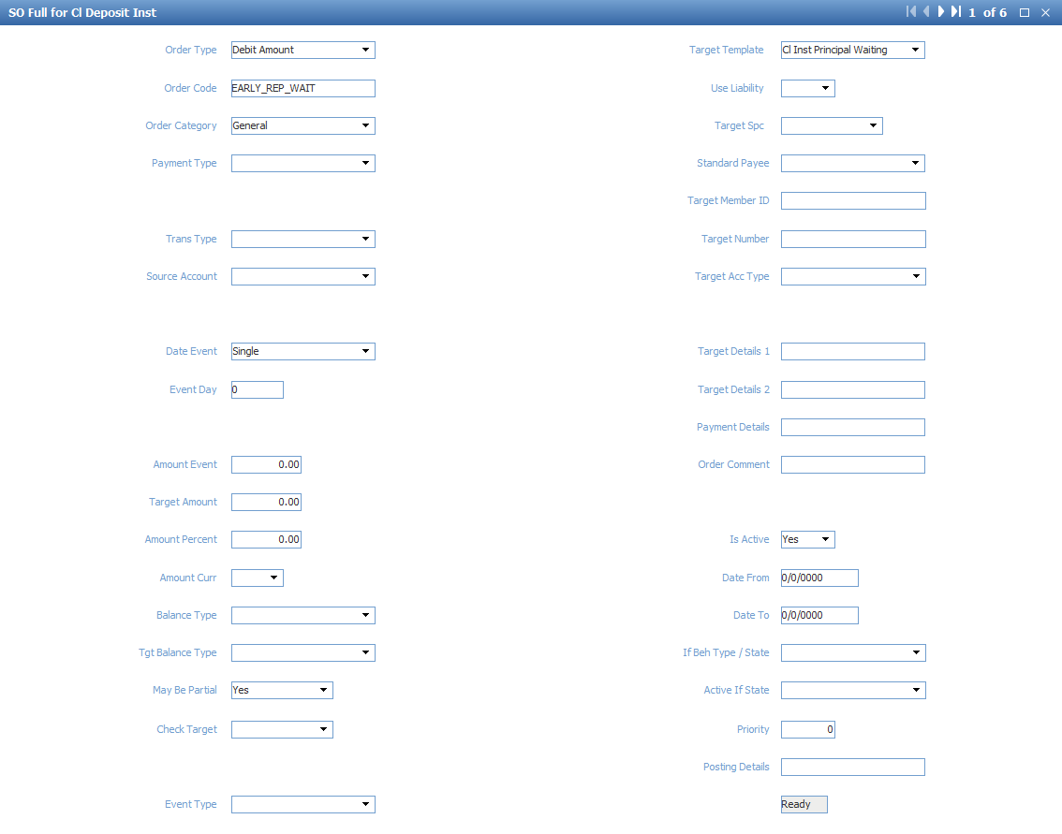

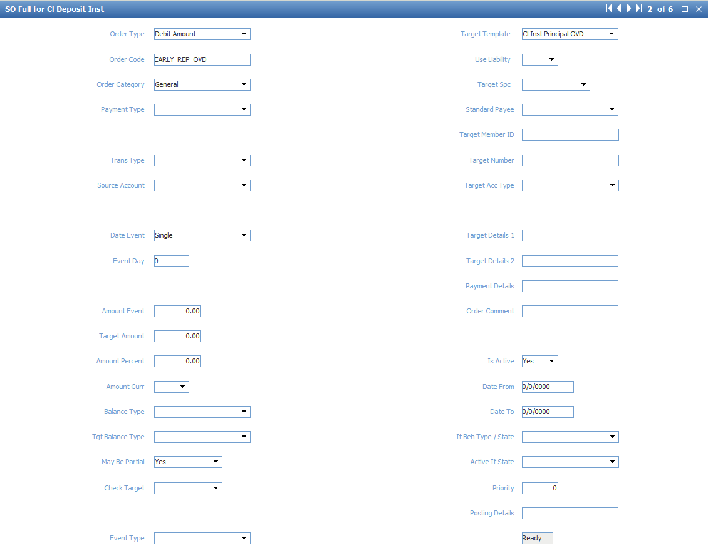

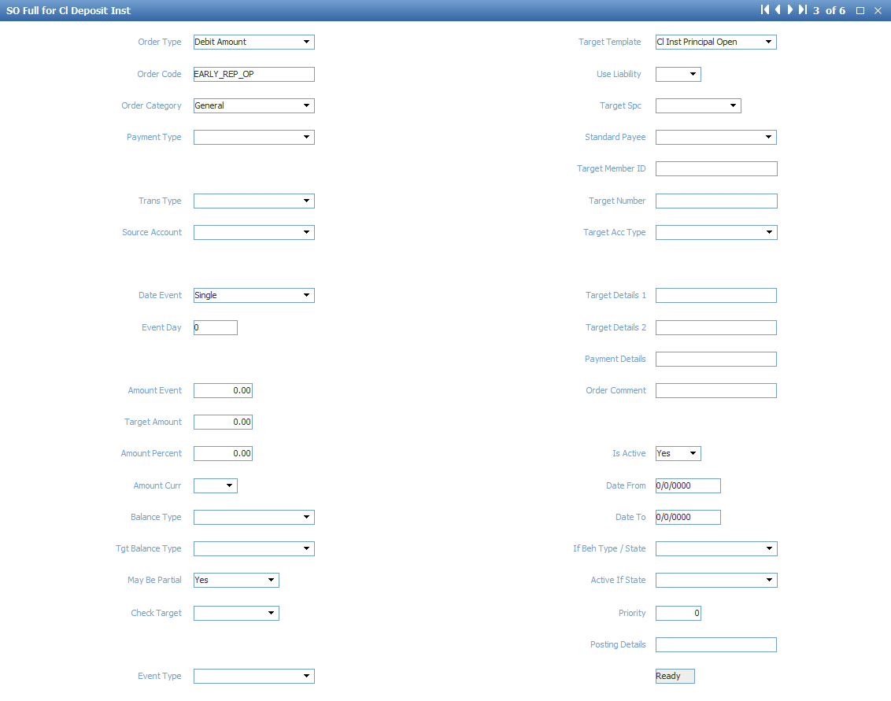

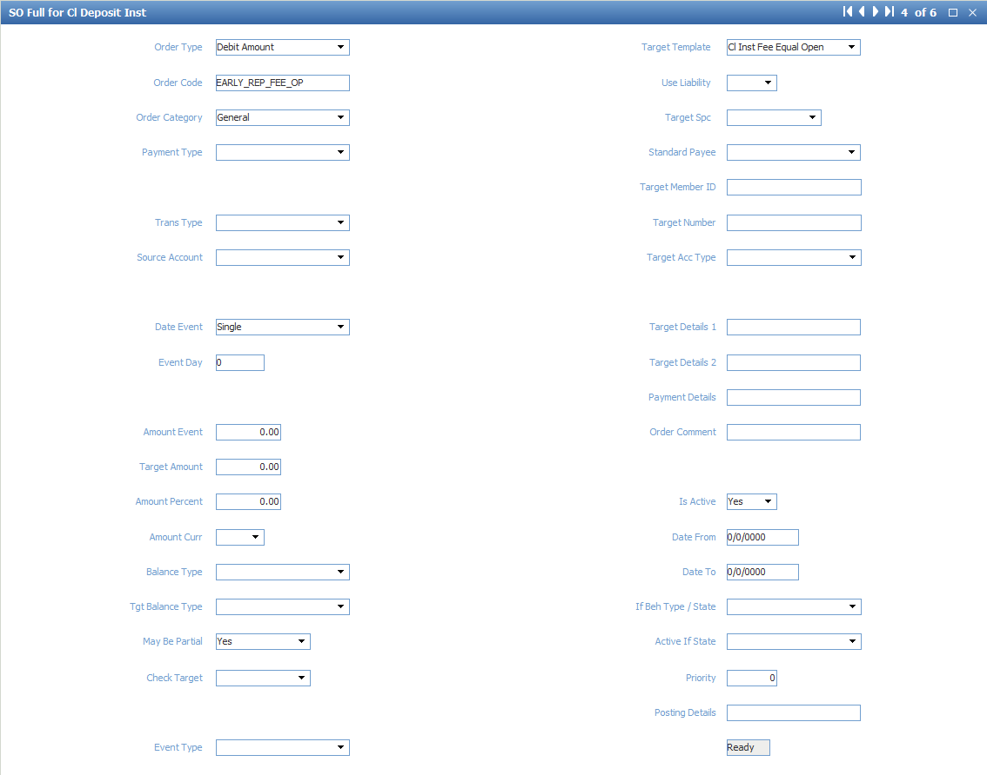

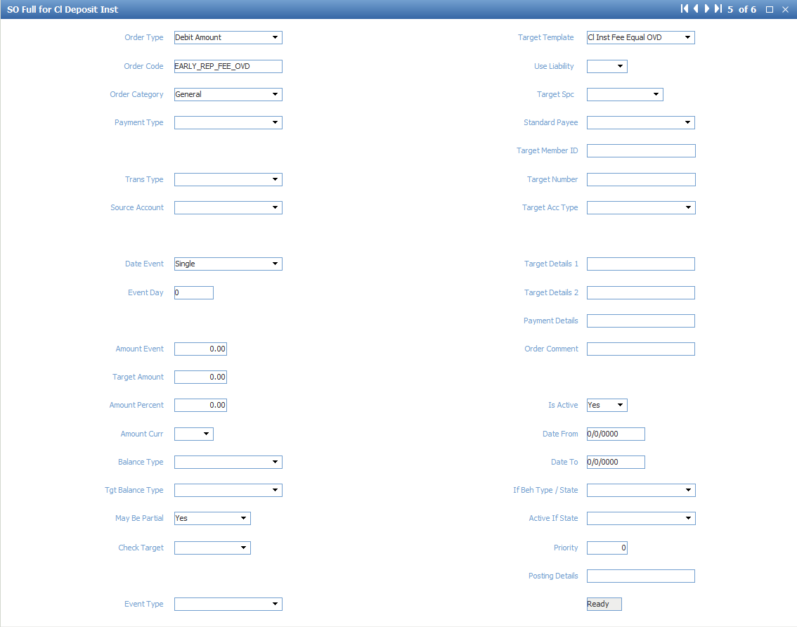

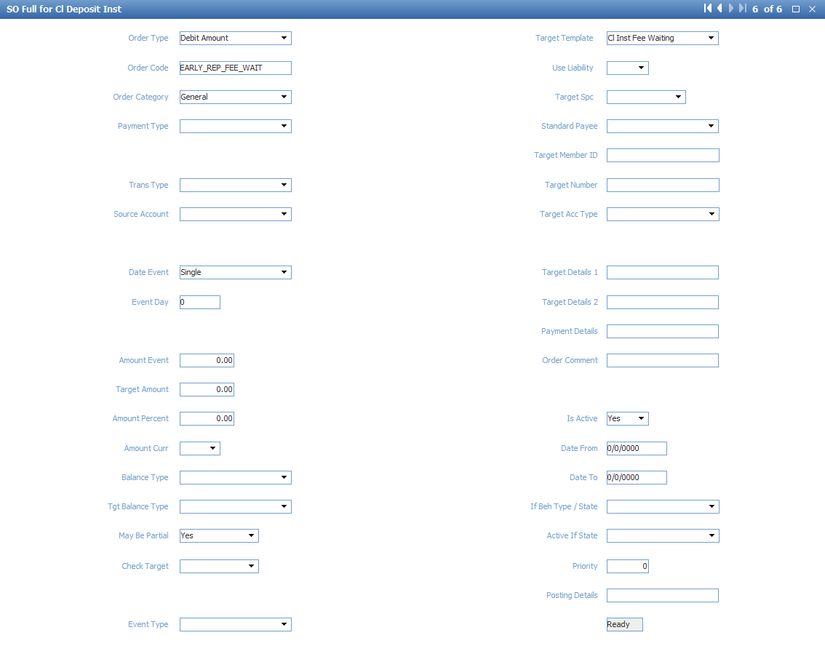

**Cl Inst Principal Waiting**

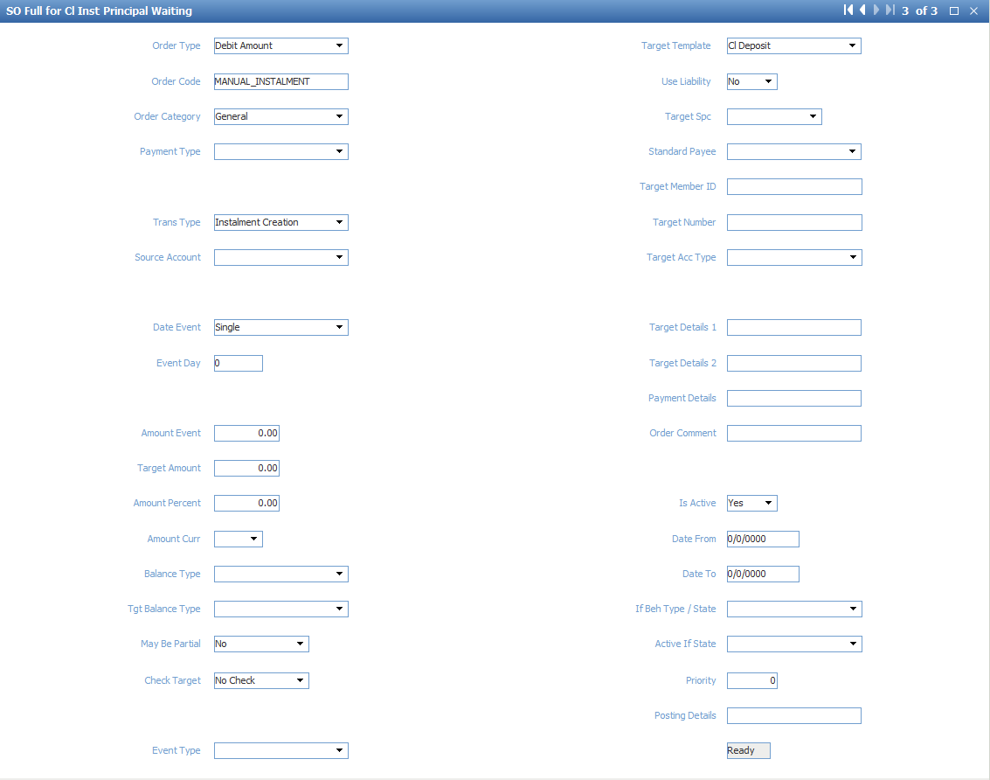

Purpose: transferring from Cl Deposit for manual creation of instalment

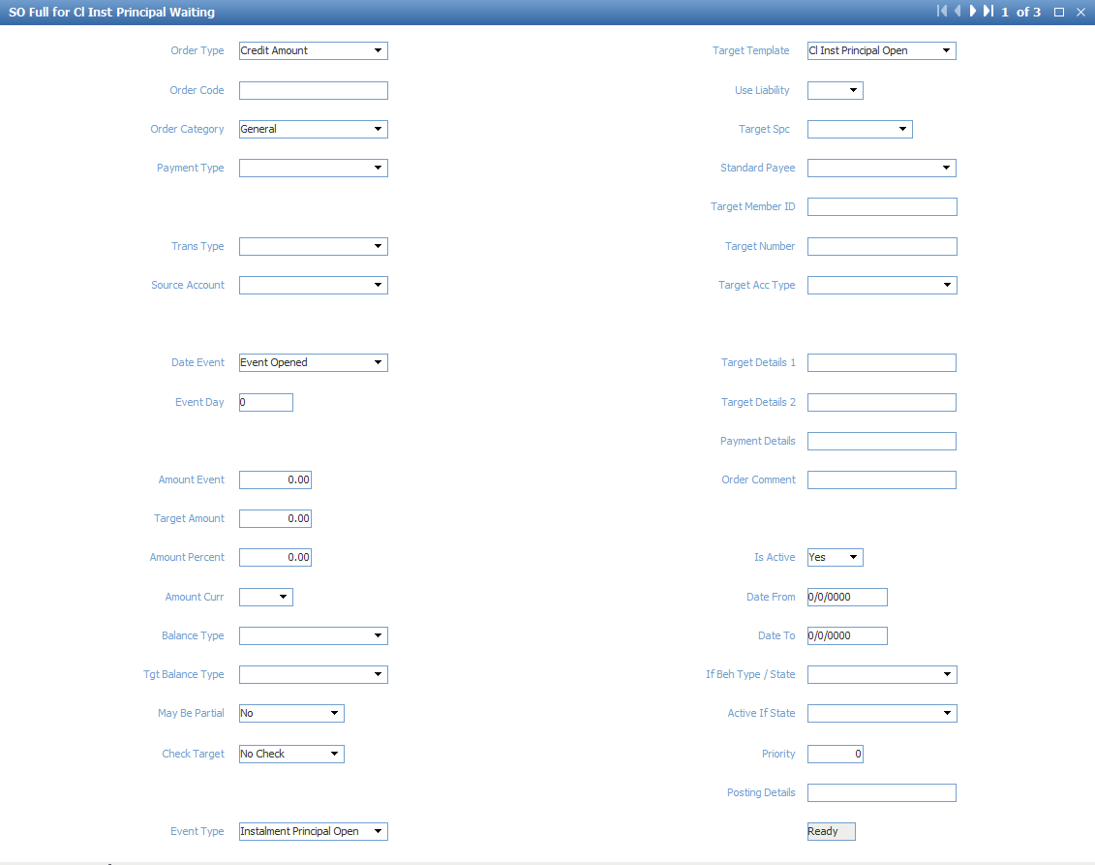

Purpose: transferring Principal Open on effective date

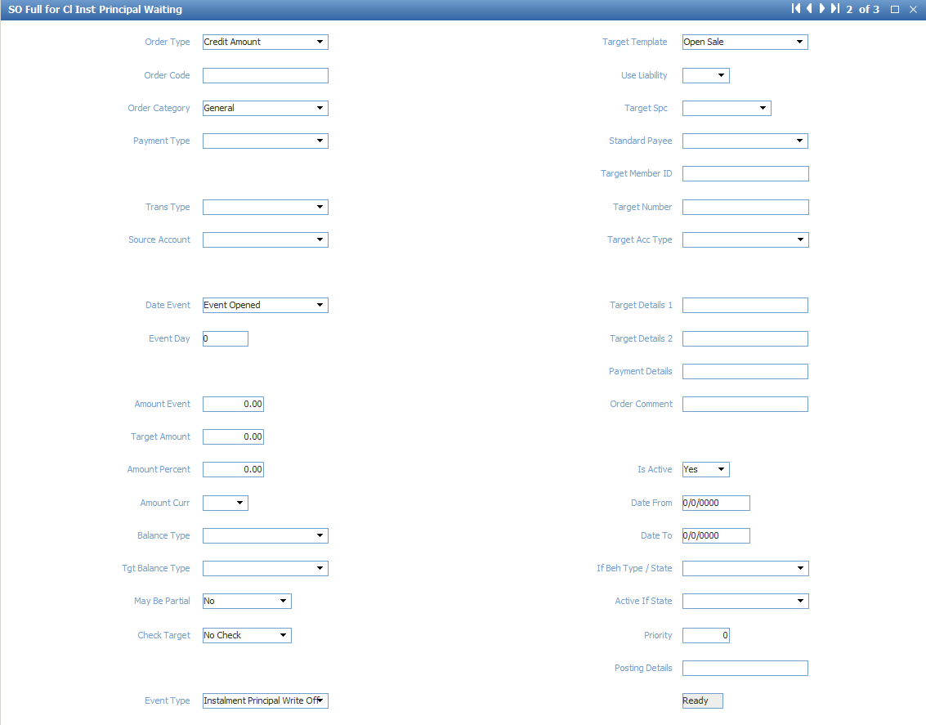

Purpose: Write off Principal Waiting account when the instalments is closed

**Cl Inst Fee Waiting:**

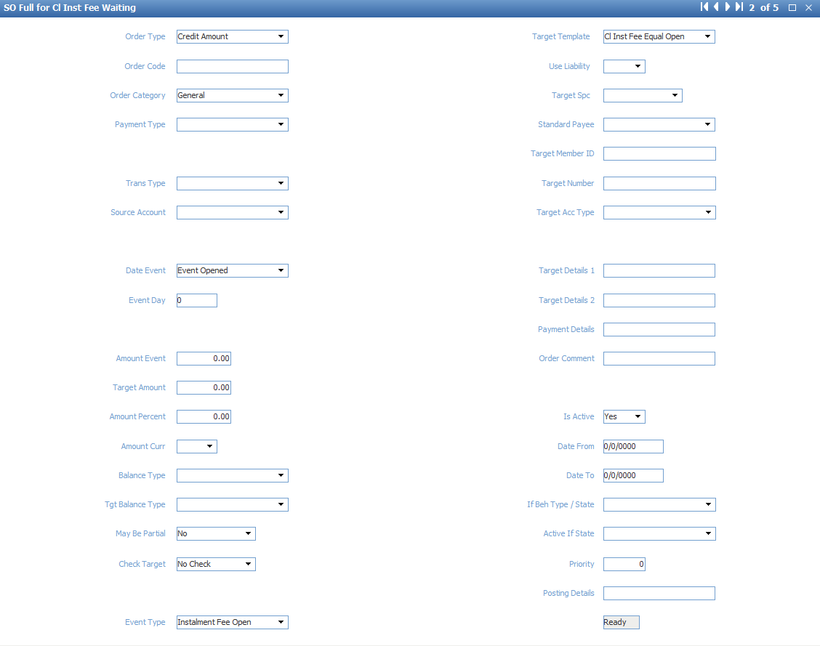

Purpose: Transferring fee to Fee Open account on effective date

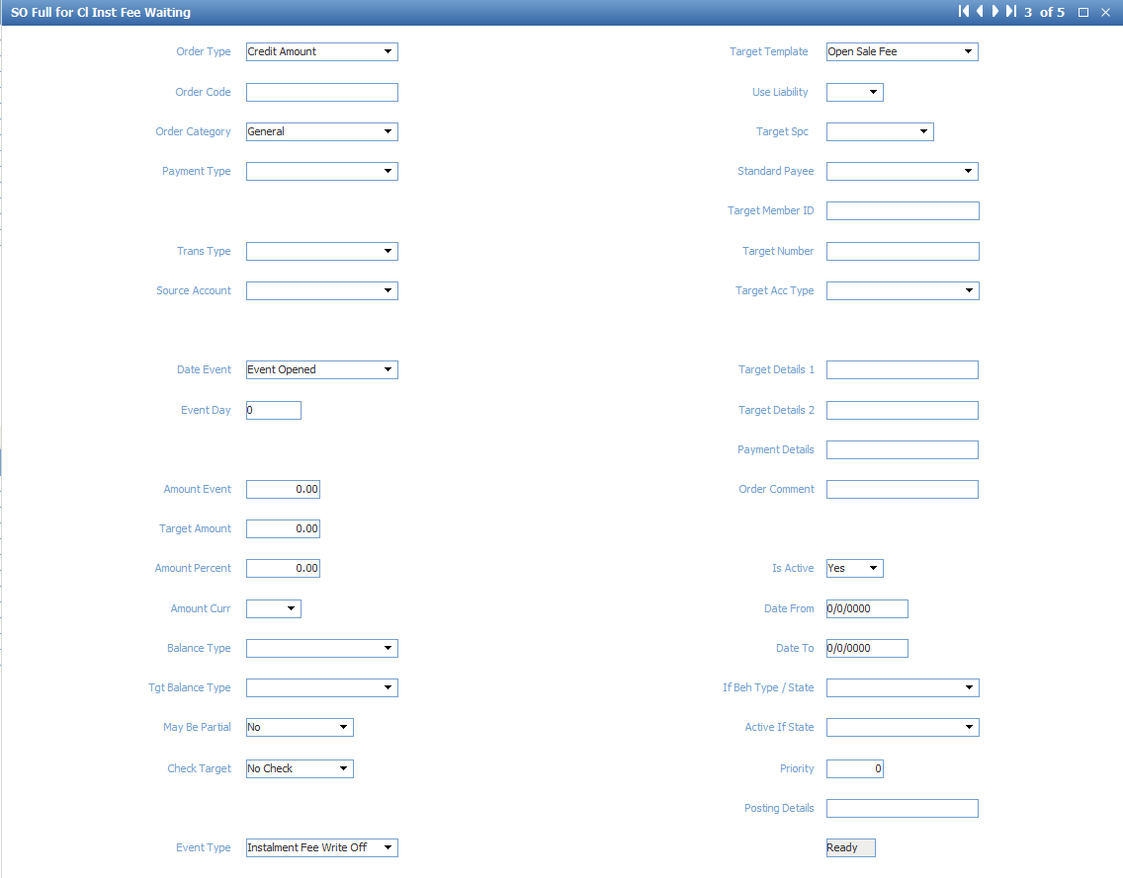

Purpose: Write off Waiting Fee when the instalment is closed

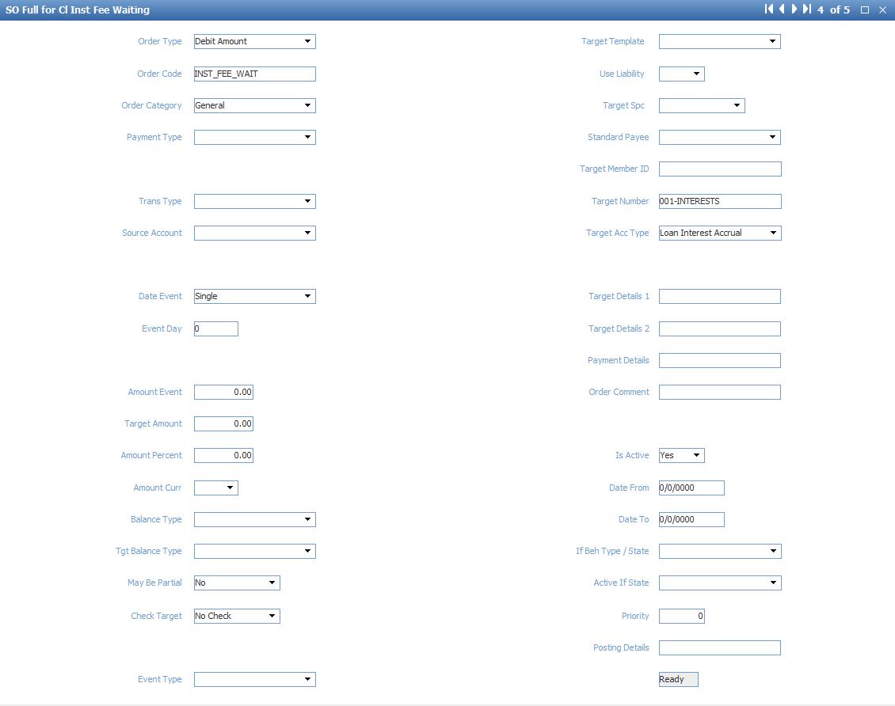

Purpose: create portion fee after creating an instalment plan

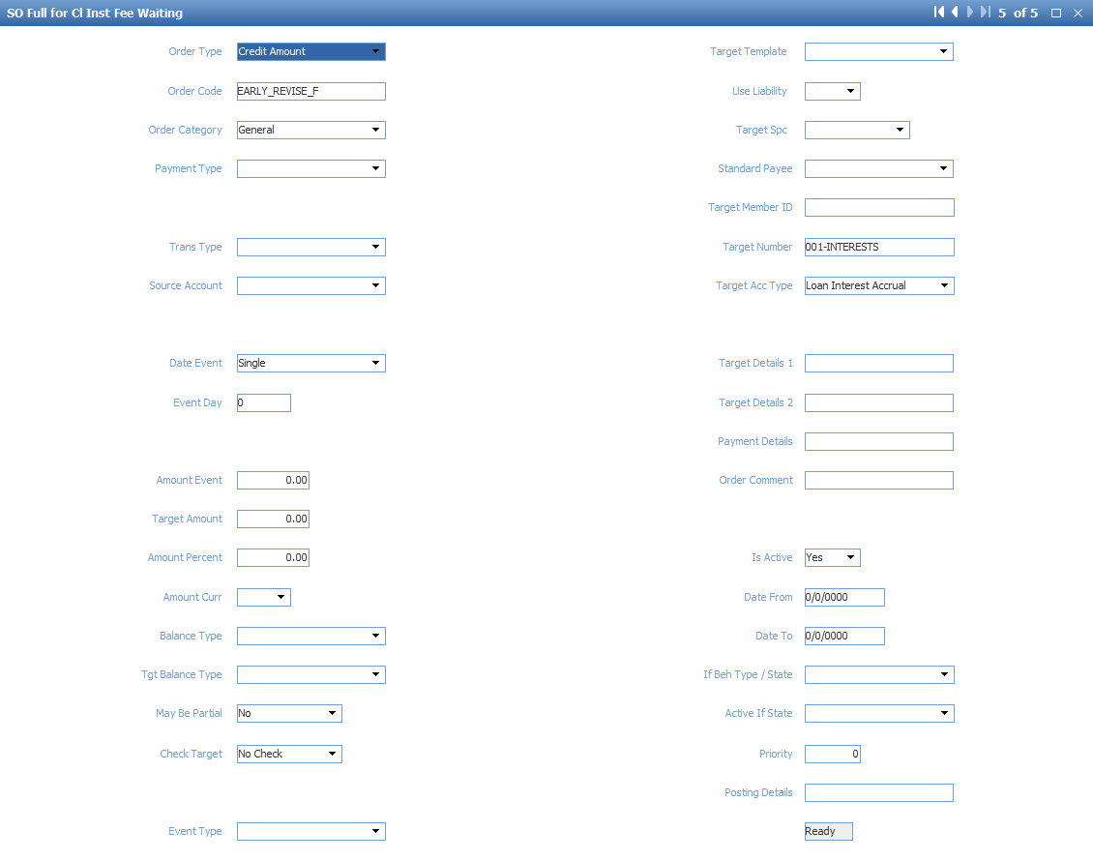

Purpose: Create portion fee after changing an instalment plan

**Cl Inst Principal Open:**

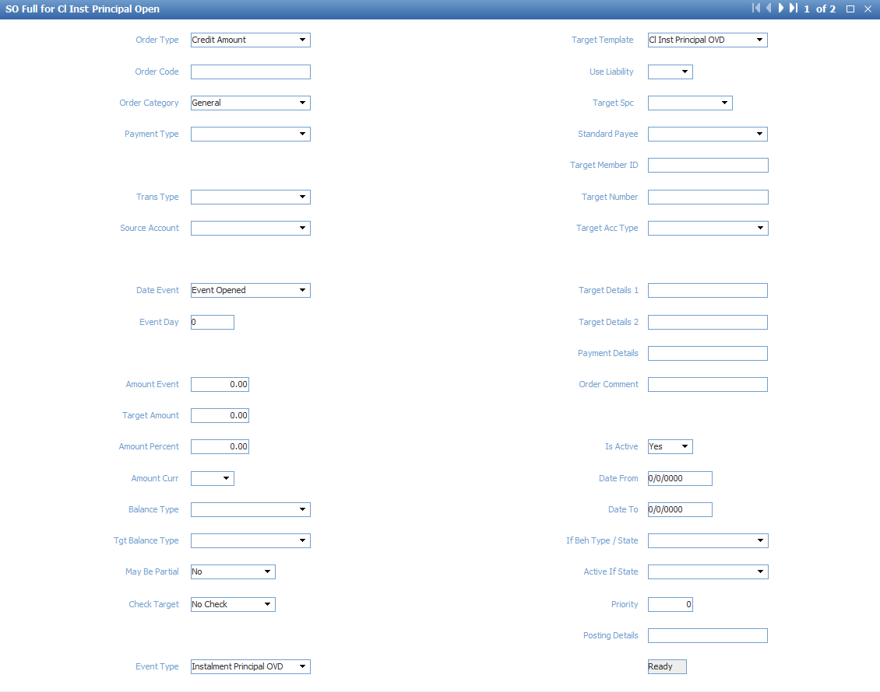

Purpose: transferring to Principal OVD on due date

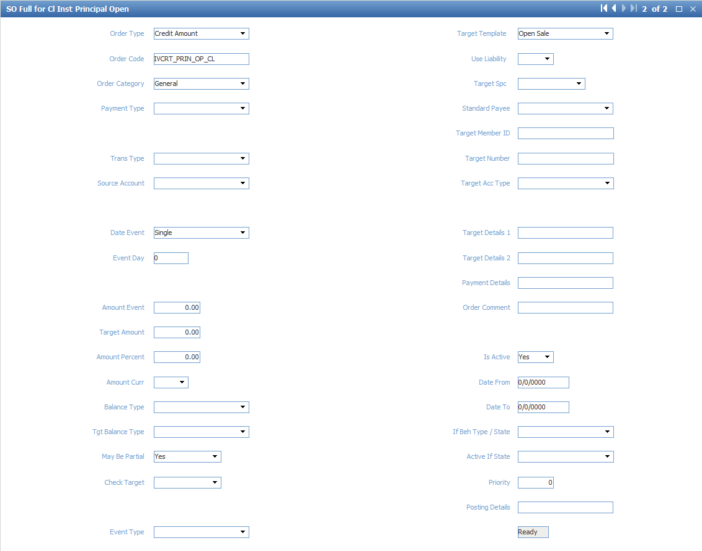

Purpose: transferring when the instalment plan is closed

**Cl Inst Fee Equal Open**

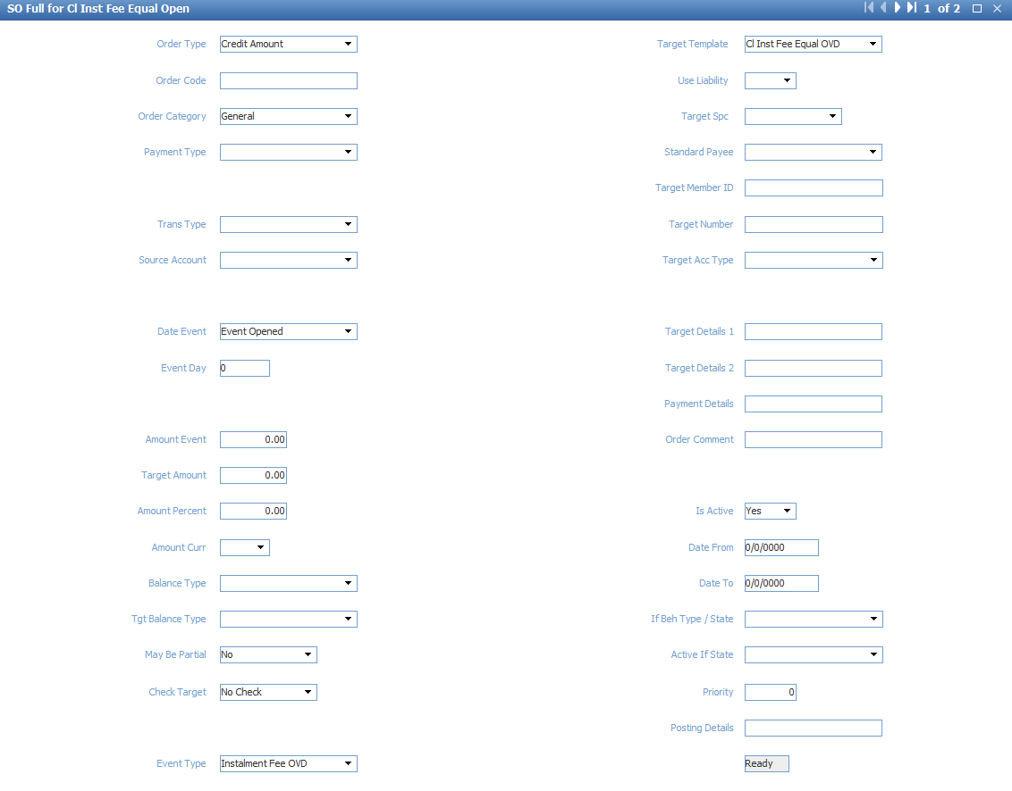

Purpose: transferring to Fee OVD on due date

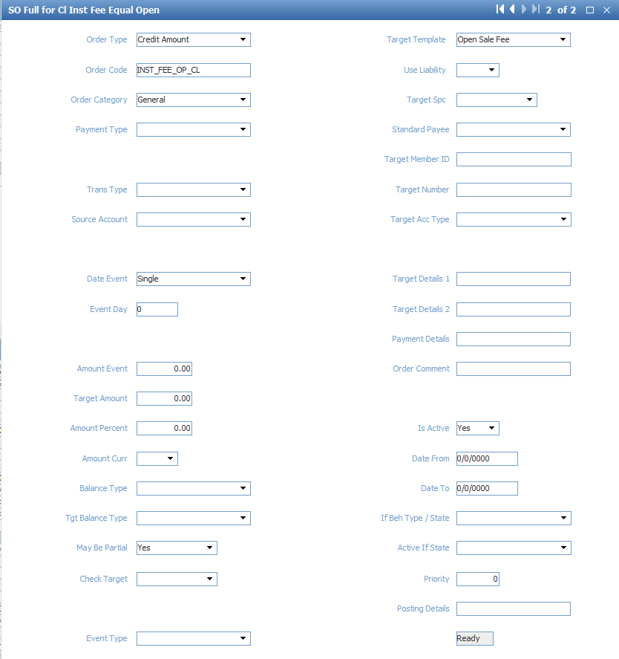

Purpose: Transferring when the instalment plans is closed

**Cl Inst Principal OVD:**

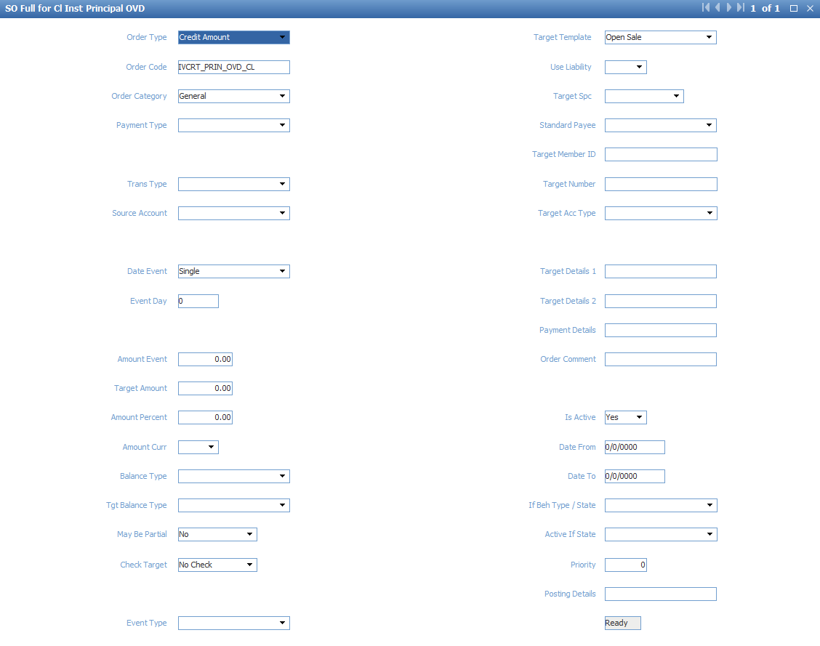

Purpose: Transferring when the instalment plans is closed

**Cl Inst Fee Equal OVD:**

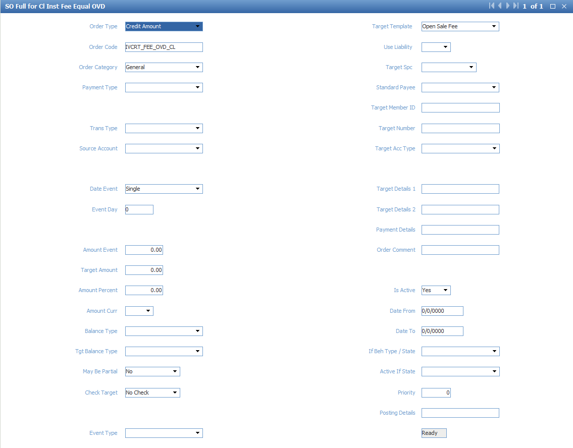

Purpose: Transferring when the instalment plans is closed

### Reverse Transaction

Add the following invoice events with action = “Reject” to transfer loan amount when the original document is reversed

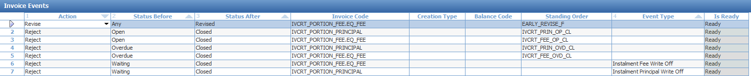

### OVD Instalment

Purpose: Close instalment plan and moving loan to overdue when “Transfer to Overdue” event is posted

Add event custom code to event “Transfer to OVD” to trigger the procedure CUST_EVENT_POST

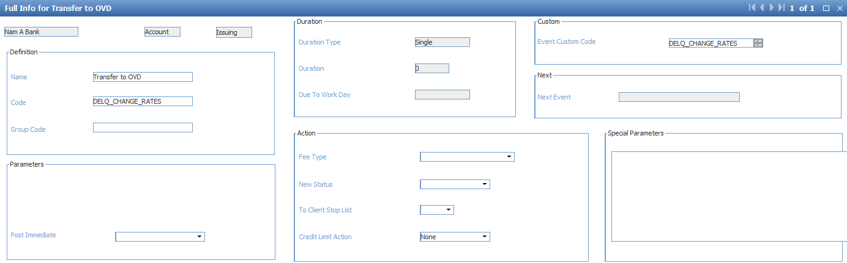

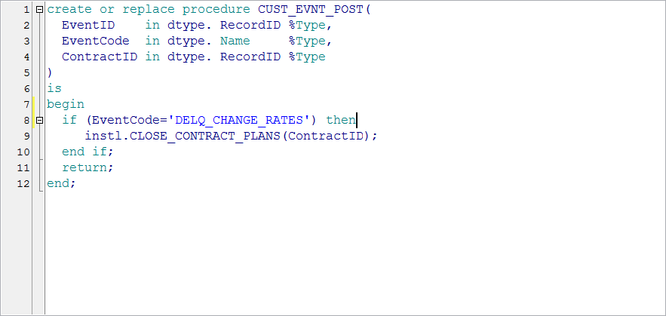

Purpose: Close all contract instalment plans when the event “Transfer to OVD” is posted

Configure the following standing orders

**Open Sale (For closed instalments)**

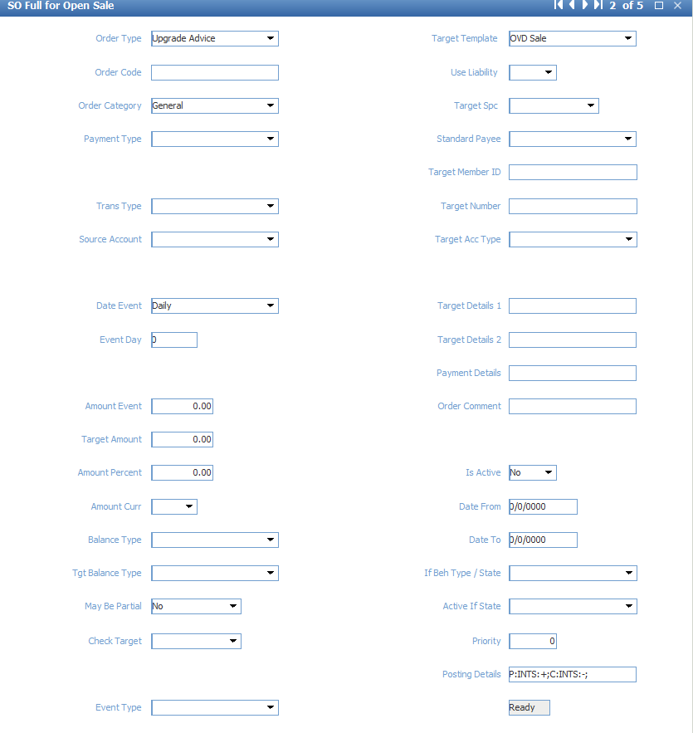

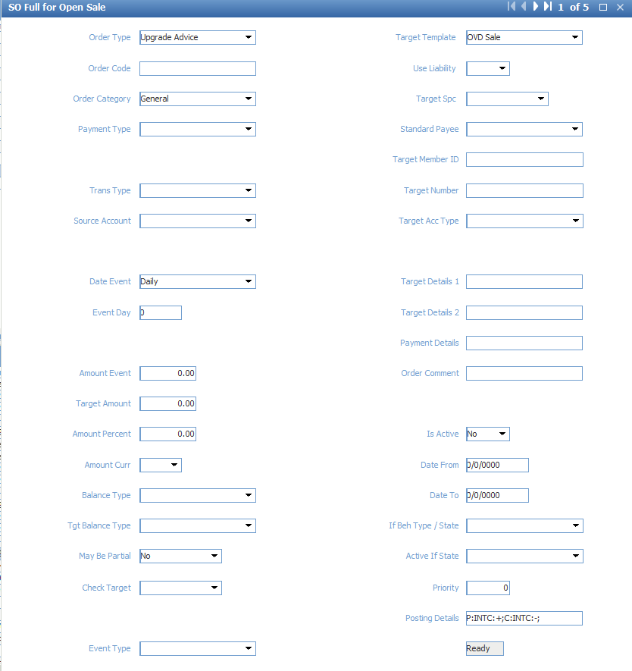

**Open Sale Fee (for late payment fee)**

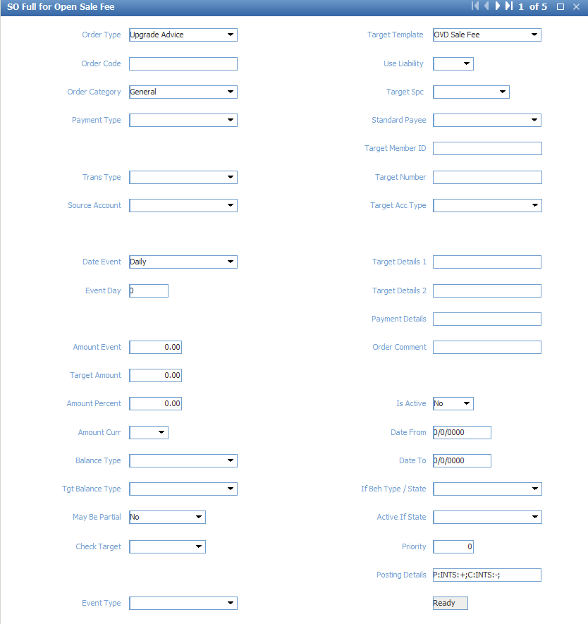

## Followed debt

Event Type:



Account Type:



Account Scheme:

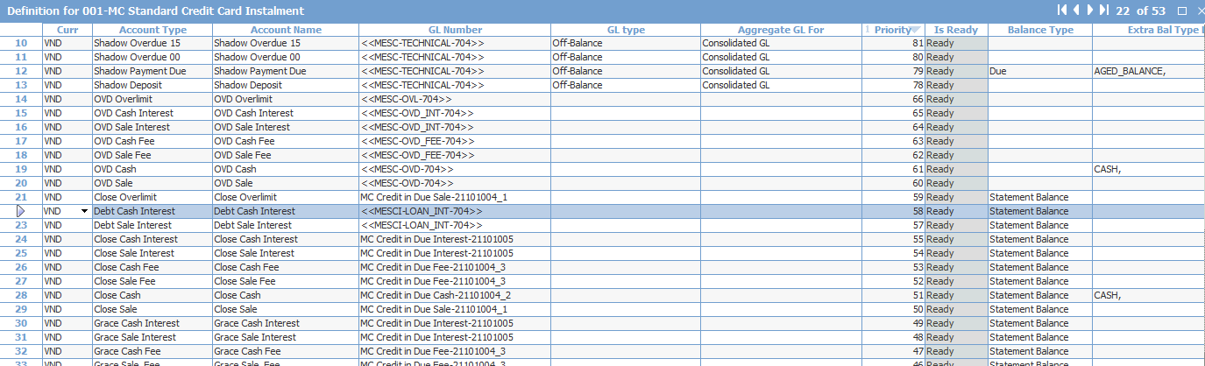

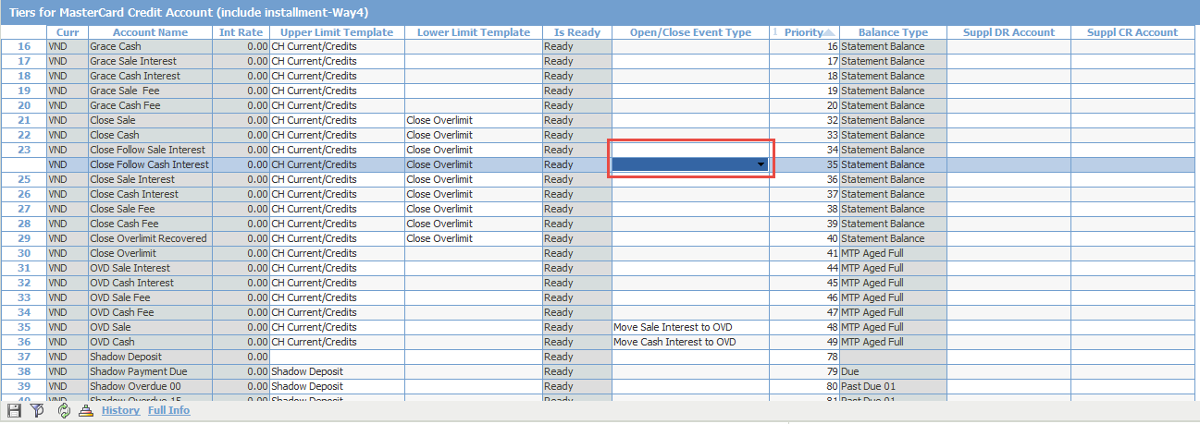

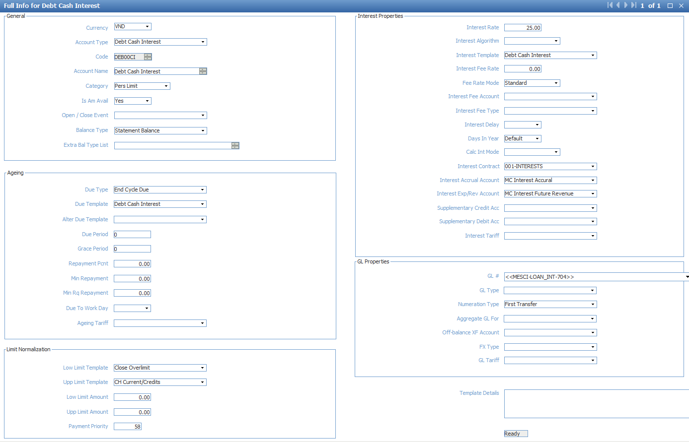

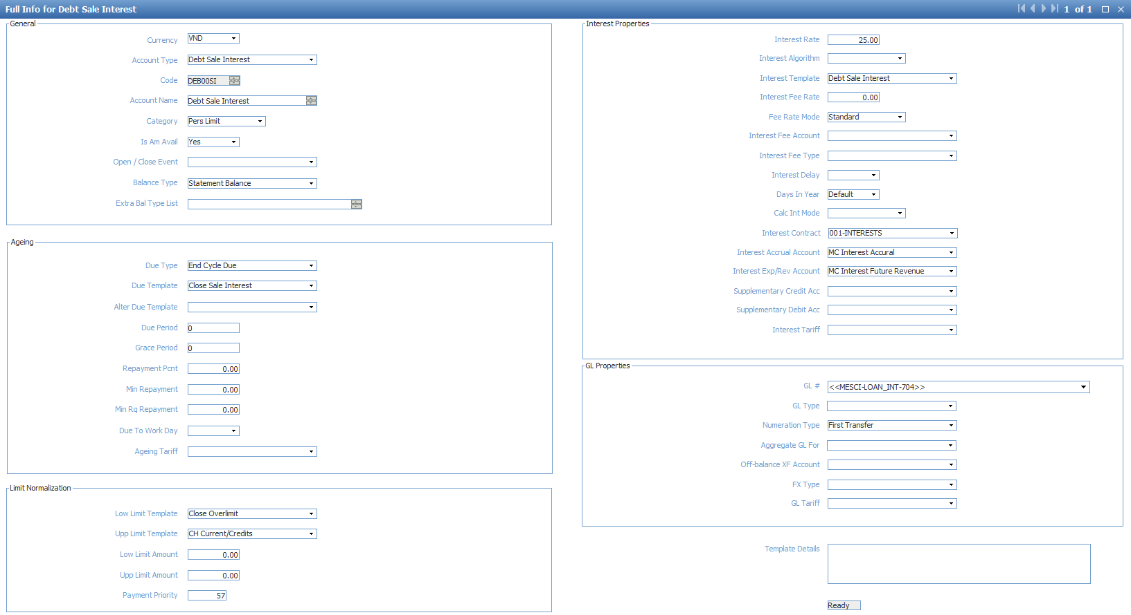

Menu: ROOT.OpenWay.Full.Configuration Setup.Products.Event Types

Purpose: Call event “Move Sale Interest to Follow” and “Move Cash Interest to Follow” when event   
“Follow Interest to Debt” is opened, and close these event when event “Follow Interest to Delinquency” is opened

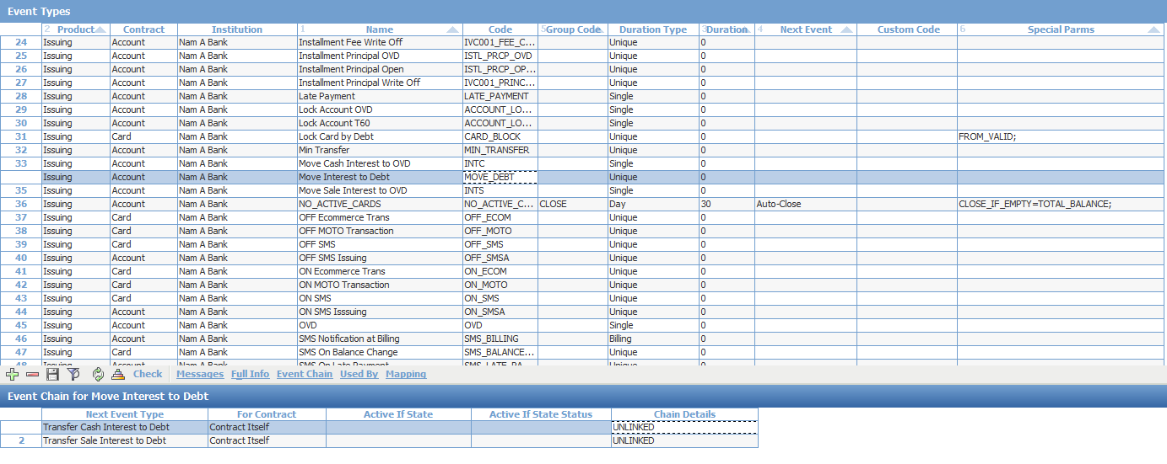

Open form Event Chain for event type Follow Interest to Debt

Add two events to event chain: Move Sale Interest to Follow and Move Cash Interest To Follow

Set value “UNLINKED” in the Chain Details field

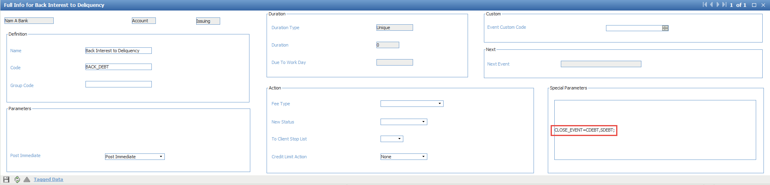

Open Full Info for event type Follow Interest to Delinquency

Add value “CLOSE_EVENT=CDEBT,SDEBT;” in the field Special Parameters

Standing Order:

**Debt Cash Interest**

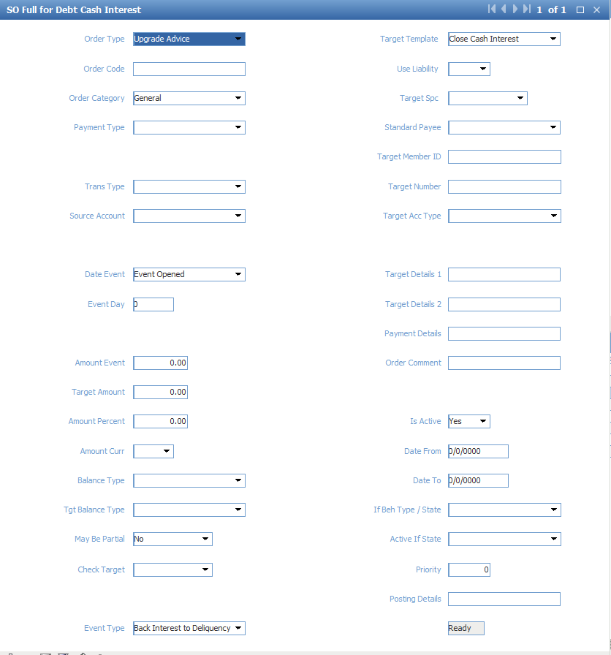

**Debt Sale Interest:**

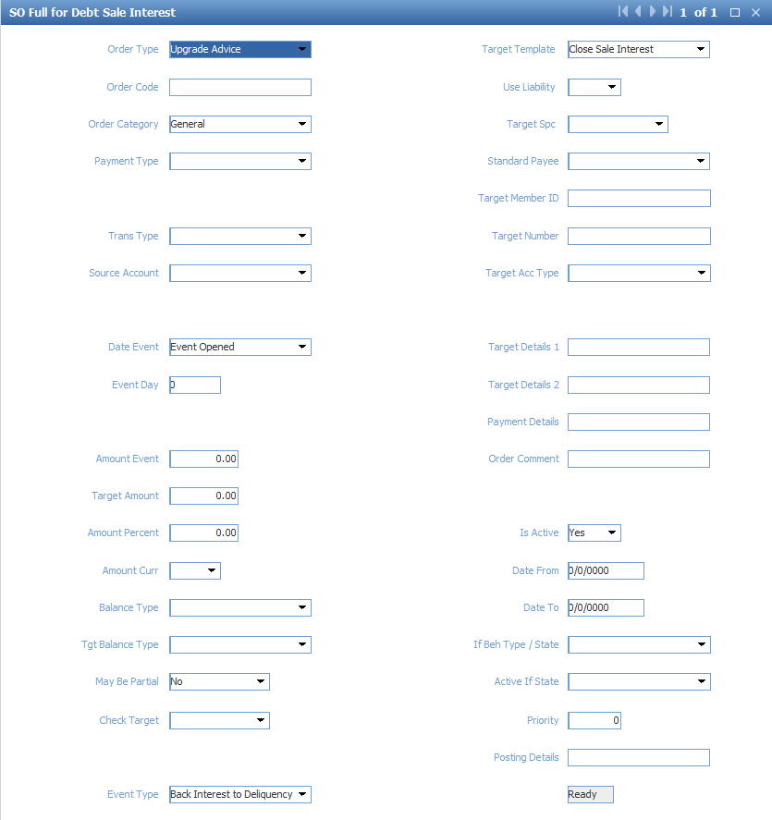

**Close Cash Interest:**

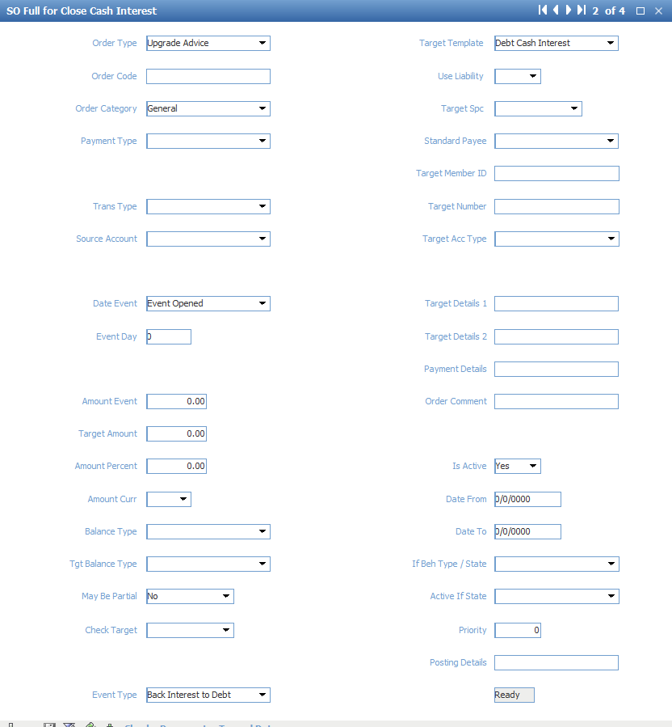

**Close Sale Interest**

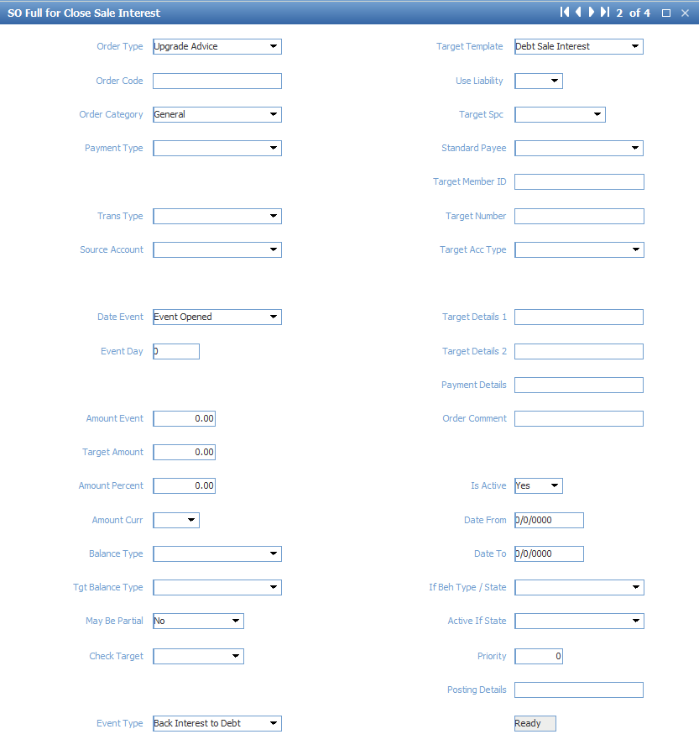

**Grace Cash Interest**

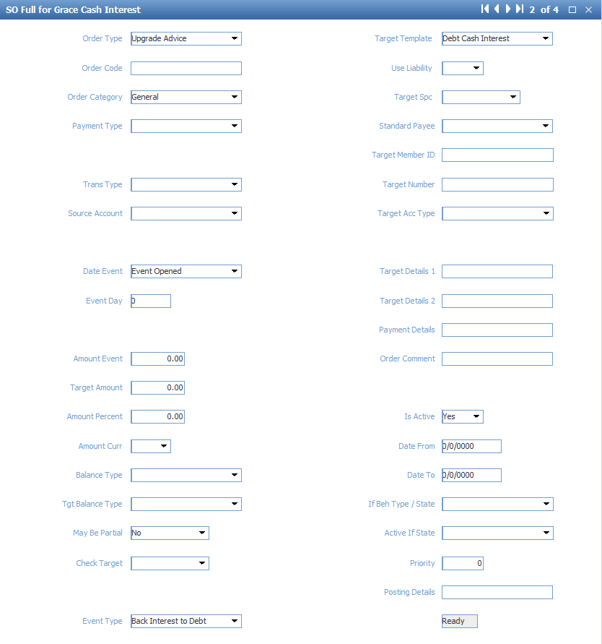

**Grace Sale Interest**

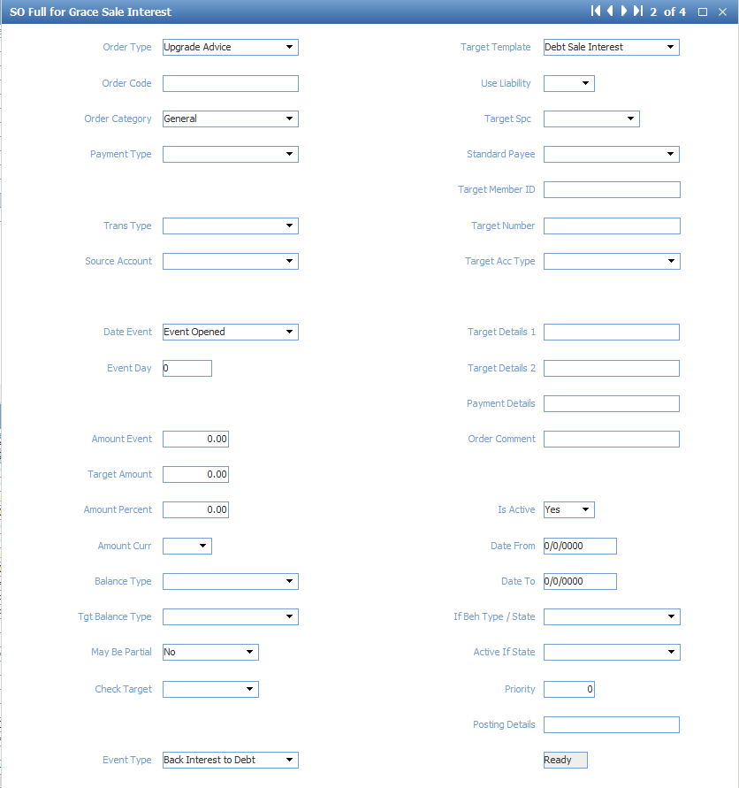

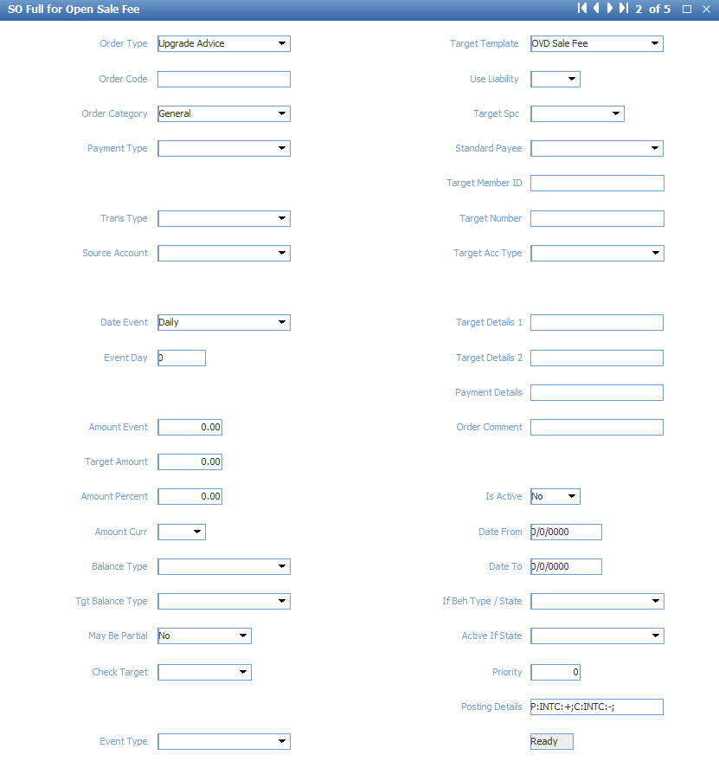

## Account T60 configuration

Menu: ROOT.OpenWay.Full.Configuration Setup.Products.Event Types

Purpose: Create new event “Call Lock Account T60”

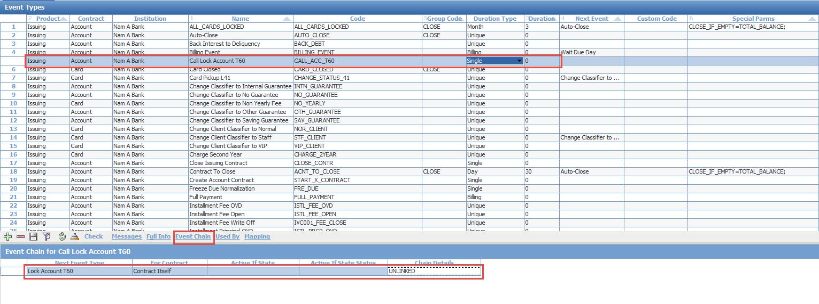

Create new event type “Call Lock Account T60”

Set Product = “Issuing”

Set Contract = “Account”

Set Code = “CALL_ACC_T60”

Set Duration Type = “Single”

Set Duration = “0”

Save and click “Check”

Click “Event Chain” to open Event Chain form

Add event type “Lock Account T60”

Set For Contract = “Contract Itself”

Set Chain Details = “UNLINKED”

Menu: ROOT.OpenWay.Full.Configuration Setup.Products.Issuing Private Products.Private Issuing Account Schemes

Purpose: Set event “Call Lock Account T6” in account scheme

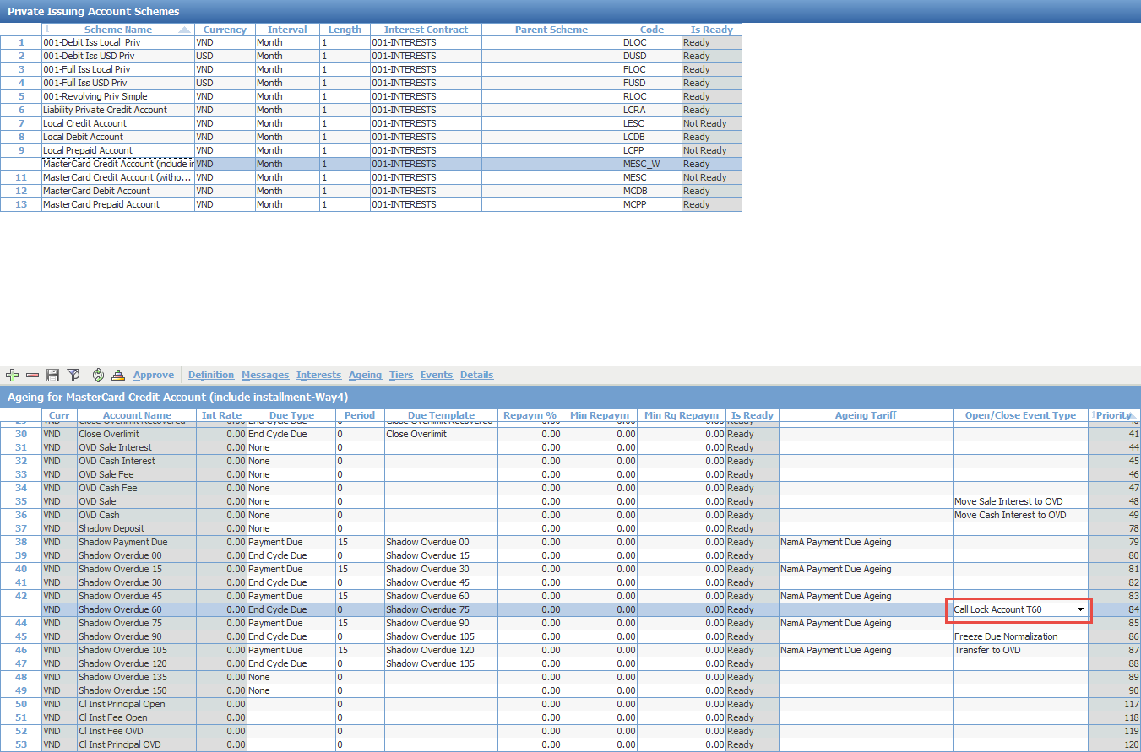

Open “Ageing” form

For account “Shadow Overdue 60”, set Open/Close Event Type = “Call Lock Account T60”

Save and approve Account Scheme

## Account T30 configuration

Menu: ROOT\OpenWay\Full\Configuration Setup\Contract Types\Contract Statuses

Add new Account status “Account T30”

Change PR tag for other status as below:

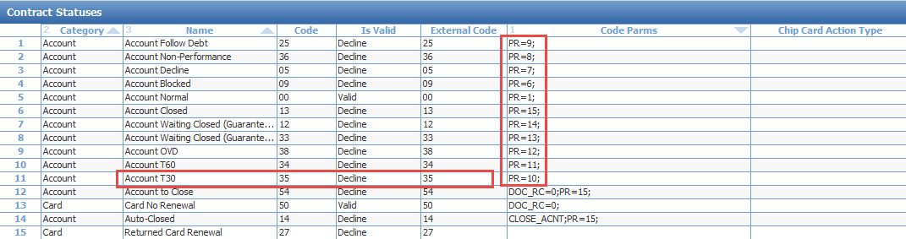

Menu: ROOT\OpenWay\Full\Configuration Setup\Products\Issuing Private Products\Issuing Event Types

Add new event “Lock Account T30”

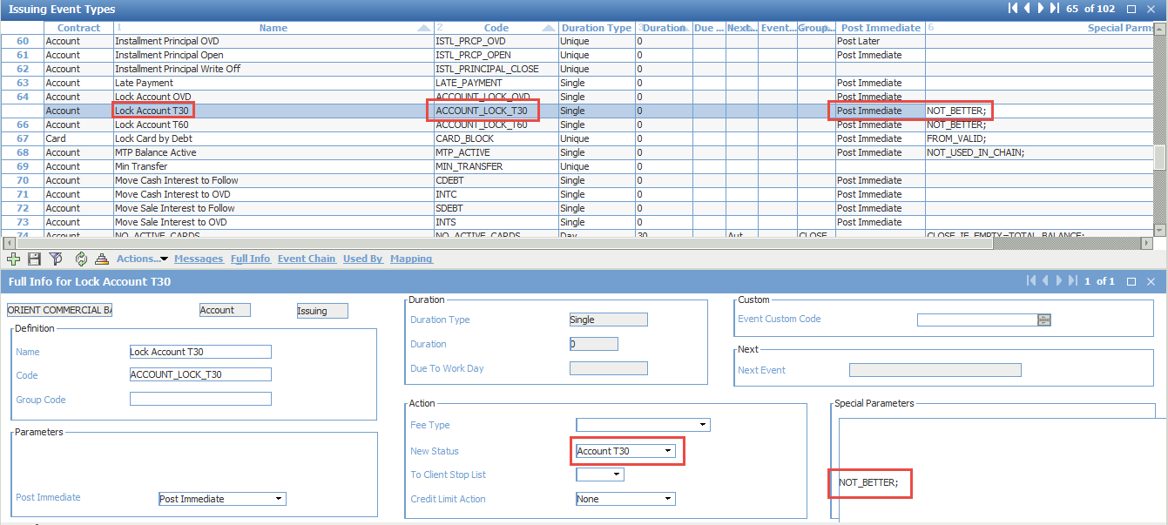

“Check” the newly created event

Menu: ROOT\OpenWay\Full\Configuration Setup\Products\Issuing Private Products\Private Issuing Account Schemes

Choose “Tiers” form

Add event “Lock Account T30” for account “Shadow Overdue 30” and “Shadow Overdue 45”

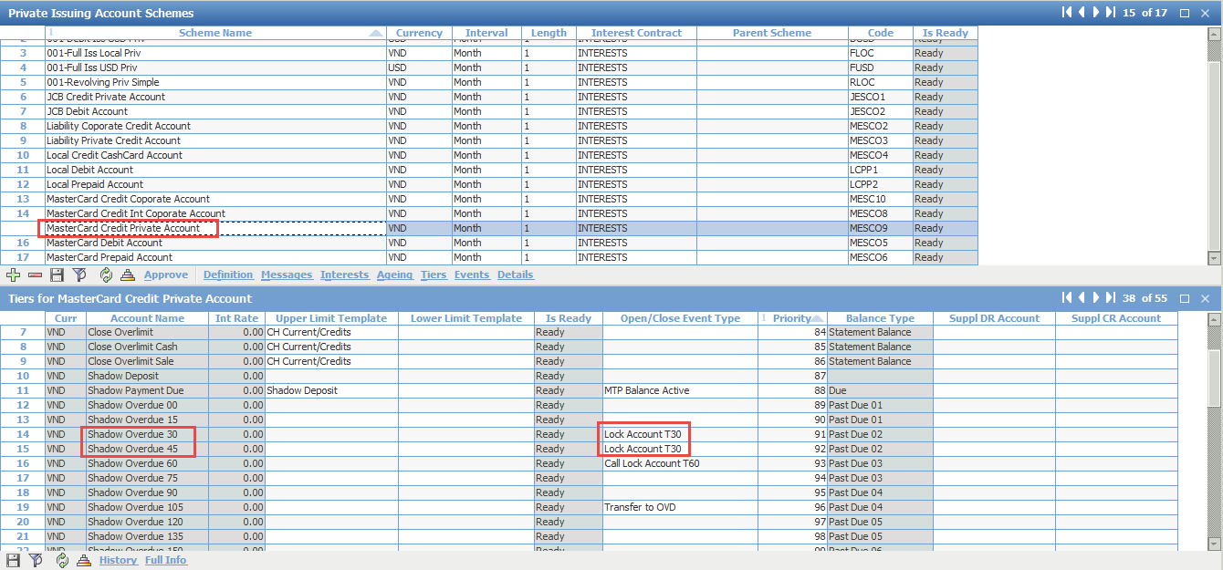

Approve the account schemes

## Balance type changes

Menu: ROOT.OpenWay.Full.Configuration Setup.Accounting Setup.Balance Types

Purpose: Remove “Statement Balance” and “Unbilled Balance” from sub-balance of “MTP Aged Partial” and remove “Unbilled Balance” from sub-balance of “Statement Balance”

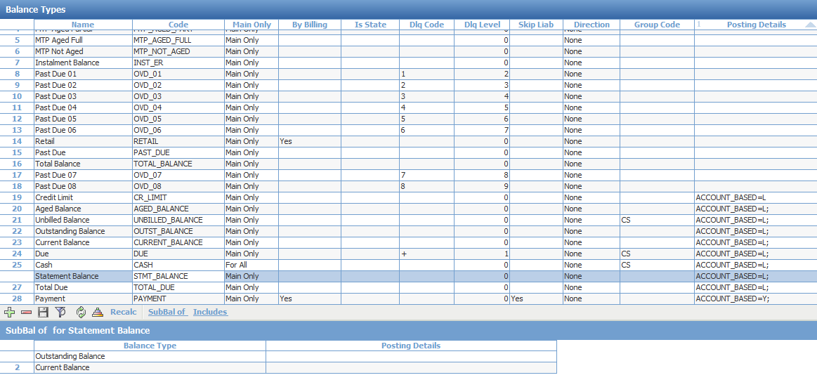

- Choose balance type “Statement Balance”

- Click on “SubBal of”

- Remove balance type “MTP Aged Partial”

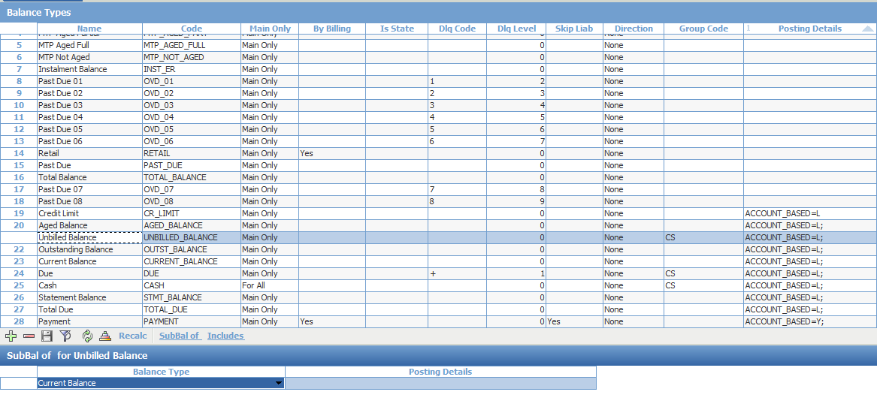

- Choose balance type “Unbilled Balance”

- Click on “SubBal of”

- Remove balance type “MTP Aged Partial”

- Remove balance type “Statement Balance”

Menu: ROOT.OpenWay.Full.Configuration Setup.Products.Issuing Private Products.Private Issuing Account Schemes

Purpose: Update balance type for accounts

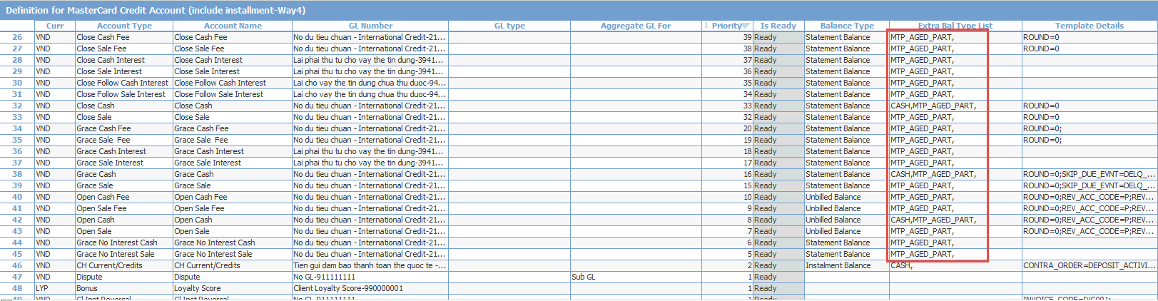

- Choose account scheme for credit card

- Click on “Definition”

- Add value “MTP_AGED_PART,” in the field “Extra Bal Type List” for the following accounts: Grace No Interest Cash, Grace No Interest Sale, Open Cash, Open Sale, Open Cash Fee, Open Sale Fee, Grace Cash, Grace Sale, Grace Cash Interest, Grace Fee Interest, Grace Cash Fee, Grace Sale Fee, Close Cash, Close Sale, Close Follow Cash Interest, Close Follow Sale Interest, Close Sale Interest, Close Cash Interest, Close Sale Fee, Close Cash Fee



- Add to field “Balance Type” value “Statement Balance” for accounts: Cl Inst Principal Open, Cl Inst Fee Open, Cl Inst Fee OVD, Cl Inst Principal OVD

- Add to field “Extra Bal Type List” value “MTP_AGED_FULL,” for accounts: Cl Inst Principal Open and Cl Inst Fee Open

## Country restrictions

### Restrict our cards in other country devices (e.g. devices in China)

* 1. Create restricted area

Menu: ROOT.OpenWay.Full.Configuration Setup.Main Tables.Country Area

Purpose: Create new Area



Add new country Area, then click [Normalize]

Menu: ROOT.OpenWay.Full.Configuration Setup.Main Tables.Country Table

Purpose: Add countries to restricted area

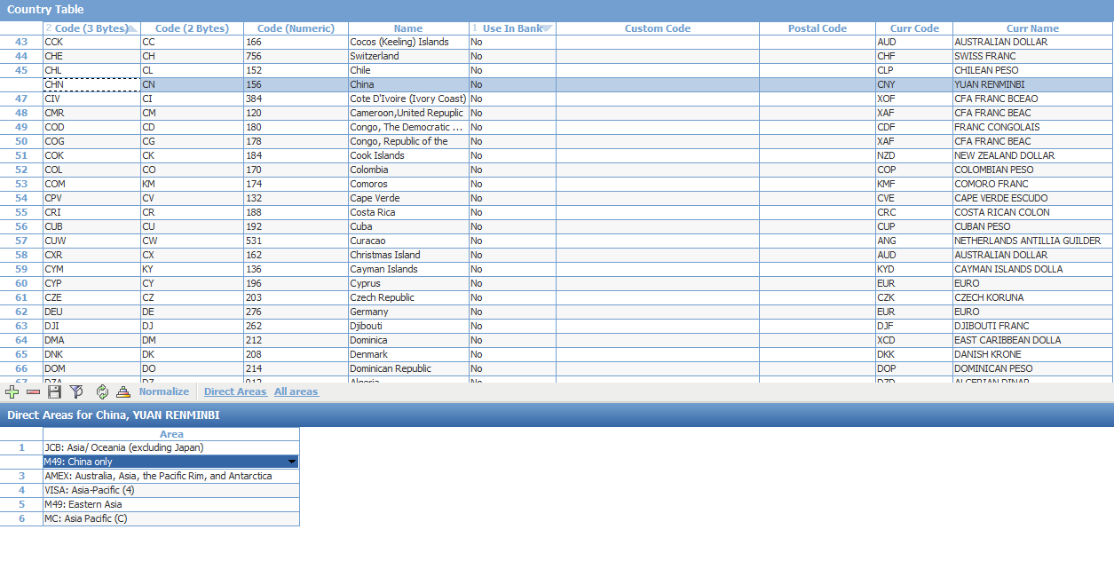

Choose the country then click [Direct Areas]

Add the area for this country, then click [Normalize]

As the result, the country is added to country area

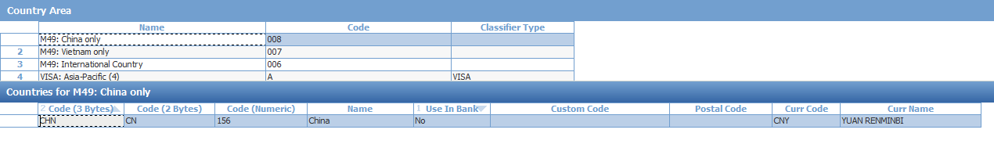

* 1. Card service pack

Menu: ROOT.OpenWay.Full.Configuration Setup.Products.Issuing Private Products.Private Card Service Packs

Purpose: Add usage to prevent transactions in restricted country

Create new additional service pack



Add usage limiter with Usage Event = “Response”

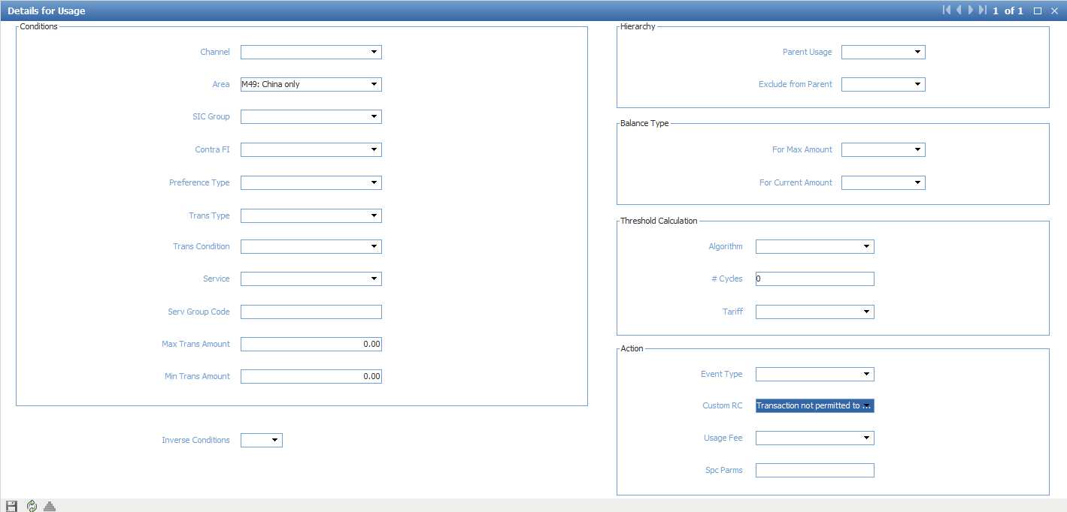

As the result, any transaction from area “M49: China only” will have response code “Transaction not permitted to card holder”

Add additional service pack to product service pack

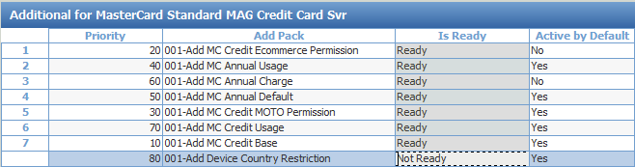

### Restrict foreign cards in our devices (e.g. cards from Canada)

* 1. Create new restricted area if necessary

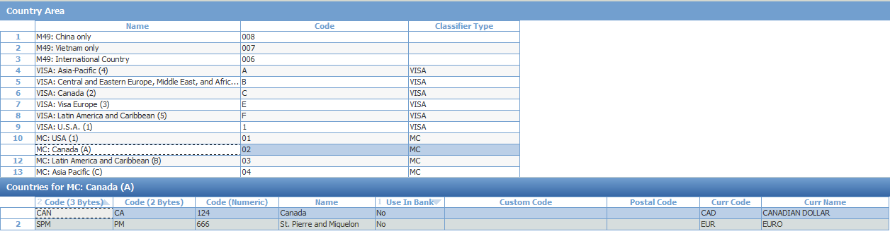

* 1. Create new preference type

Menu: ROOT.OpenWay.Full.Configuration Setup.Products.Product Definition.Preference Types

Purpose: Create new preference type

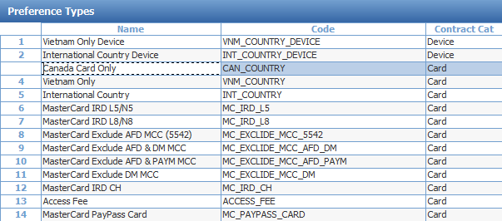

* 1. Device service pack

Menu: ROOT.OpenWay.Full.Configuration Setup.Products.Acquiring Products.Device Service Packs

Purpose: Add usage to prevent transactions from restricted country’s cards

Create new Additional service pack for POS and ATM



Add preference type to additional service pack

In the Area field, choose the country area that will be restricted

In the Contra Type, choose the card contract type that will be restricted



Create a usage limiter which will restrict the transaction from foreign cards



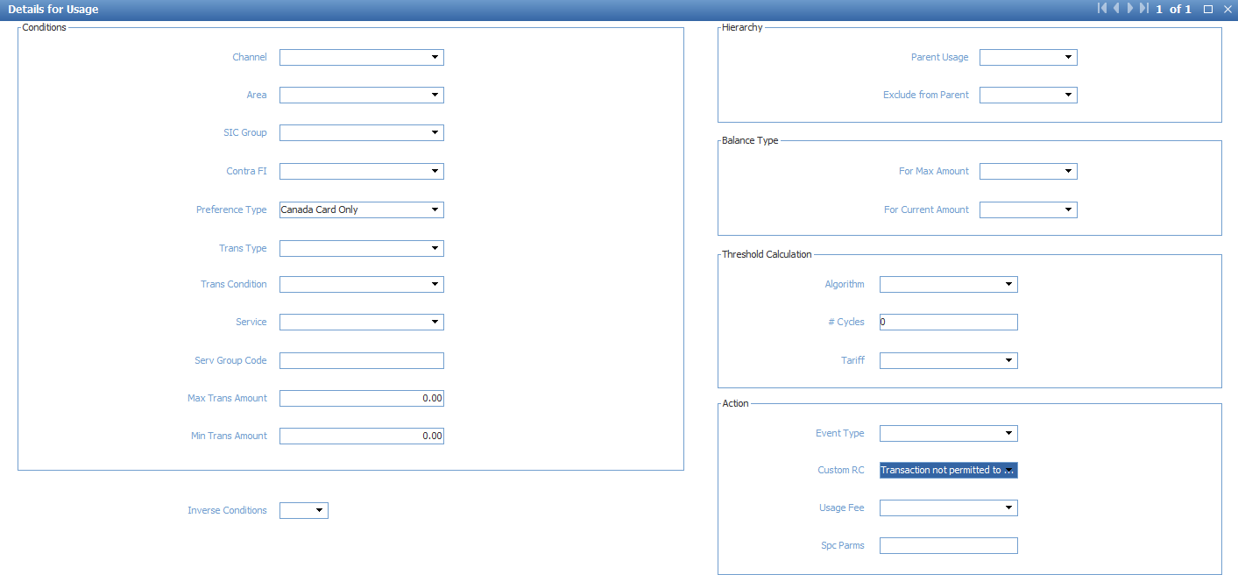

As the result, all the transactions which belong to preference type “Canada Card Only” will have response code “Transaction not permitted to cardholder”

Add additional service pack to product service pack

## Usage limiter without considering fee

Menu: ROOT.OpenWay.Full.Configuration Setup.Products.Issuing Private Products.Private Card Service Packs

Click menu [Usage]

Choose a usage limiter and click [Details]

Add to field Spc Params: BASE_AMOUNT_TYPE=RECONCILIATION;

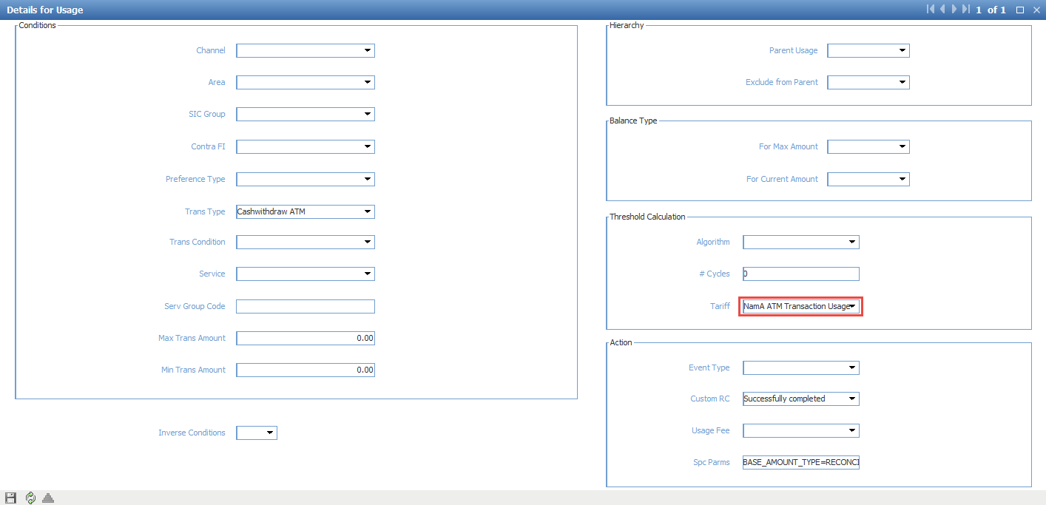

## Fee for Balance Inquiry

Menu: ROOT.OpenWay.Full.Configuration Setup.Transaction Types.Fee Types

Purpose: Add fee type for balance inquiry

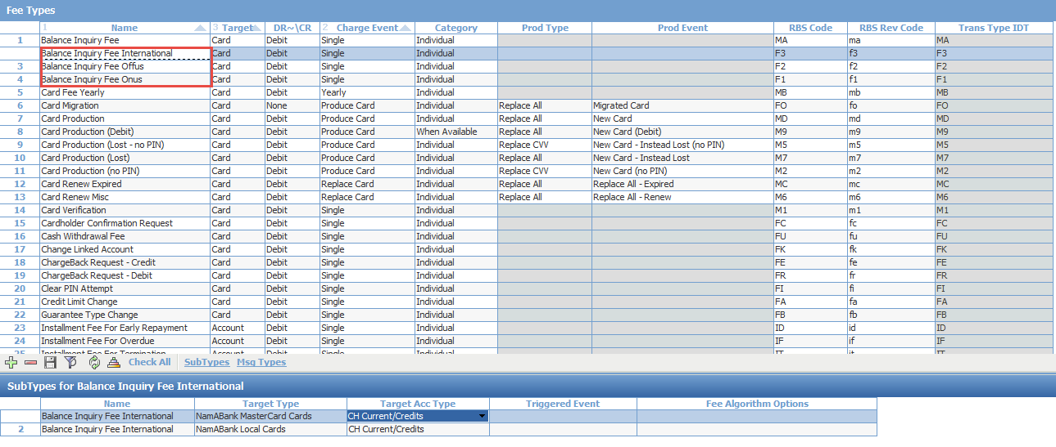

Menu: ROOT.OpenWay.Full.Configuration Setup.Products.Issuing Private Products.Private Card Service Packs

Purpose: Add balance inquiry Fee as Misc Fee

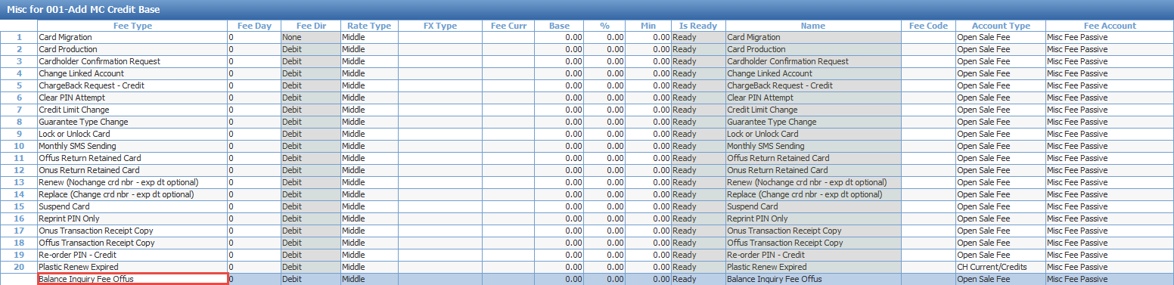

Menu: ROOT.OpenWay.Full.Configuration Setup.Products.Issuing Private Products.Private Card Service Packs

Choose [Target]

Choose service ‘Balance Inquiry’ for MasterCard Acquirer and click [Full Info]

Add value to field Service Details: GROUP_CODE=BAL_INQ_OFFUS;

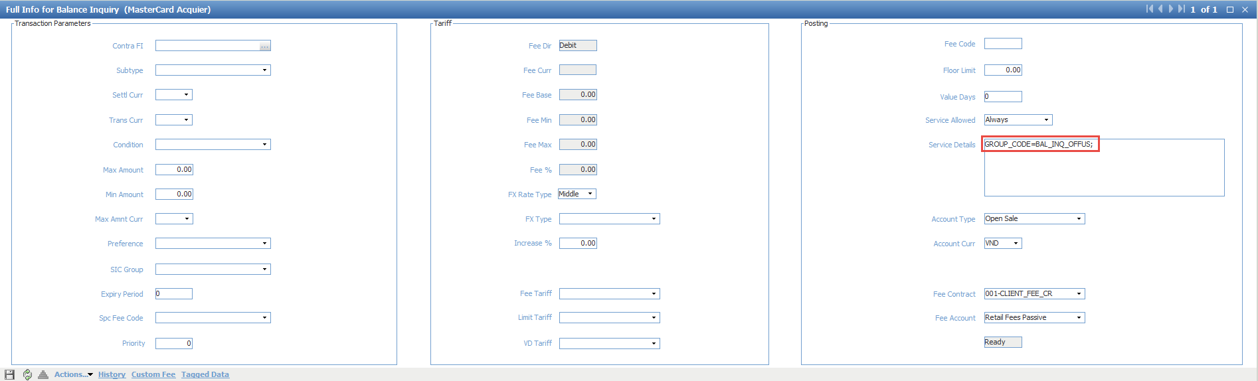

In the service pack, choose [USAGE]

Add new Usage to charge Balance Inquiry Fee Offus

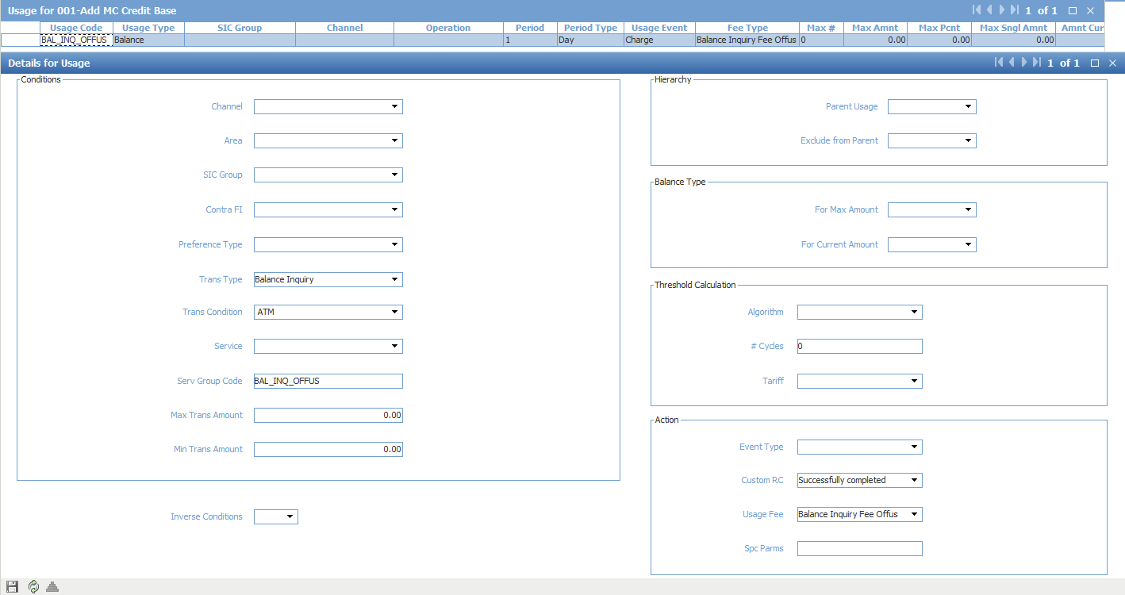

## Cash limit

Menu: ROOT.OpenWay.Full.Configuration Setup.Products.Issuing Private Products.Private Issuing Account Schemes

Purpose: Add balance type ‘Cash’ to accounts: Open Cash, Grace Cash, Close Cash, OVD Cash

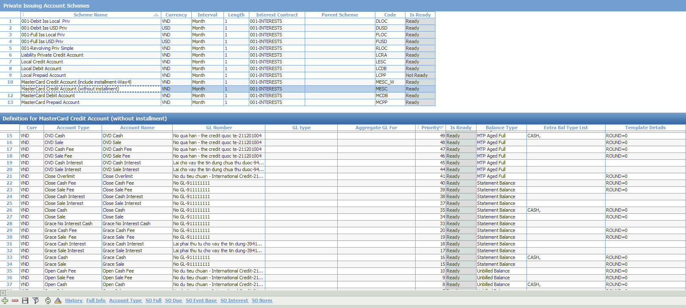

Menu: ROOT.OpenWay.Full.Configuration Setup.Products.Issuing Private Products.Private Account Service Packs

Purpose: Create Usage Limiter to limit Cash Transaction = 80% Credit limit

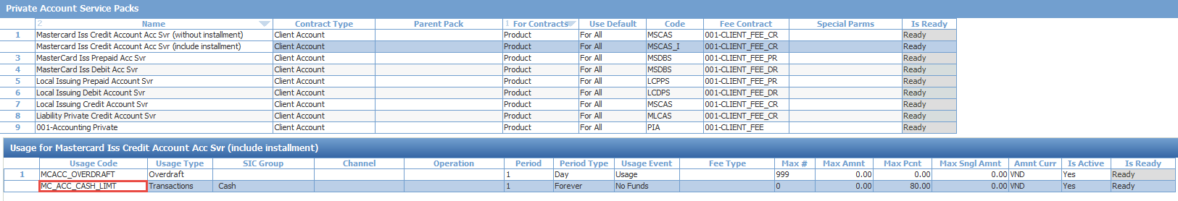

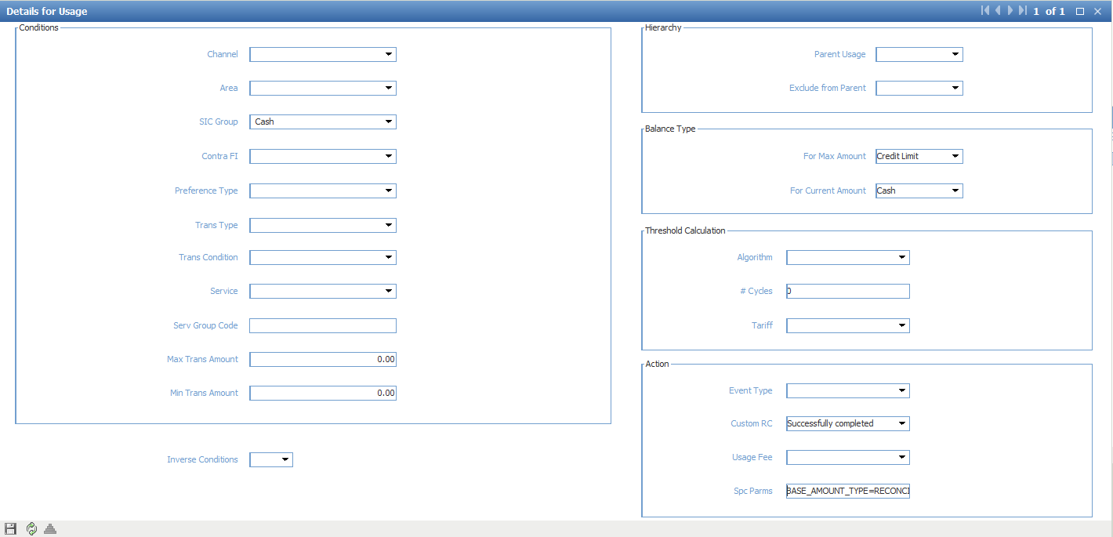

Set value

SIC Group: Cash

For Max Amount: Credit Limit

For Current Amount: Cash

Spc Parms: BASE_AMOUNT_TYPE=RECONCILIATION;

## Additional Hold

Create new tariff for additional hold

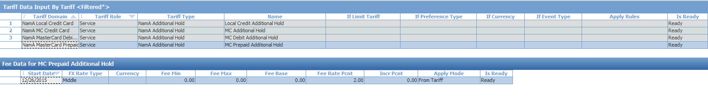

Create new Custom Fee in every service which uses foreign currency



Add tag <AUTH>; to Service Details so that this fee is considered (blocked) only in authorization

## Limitation of Off us card at Our devices

Menu: ROOT.OpenWay.Full.Configuration Setup.Products.Acquiring Products.Device Service Packs

In the ATM Cashwitdraw for off us card services, add value Service Details = [GROUP_CODE=OFF_US_CARDS;]

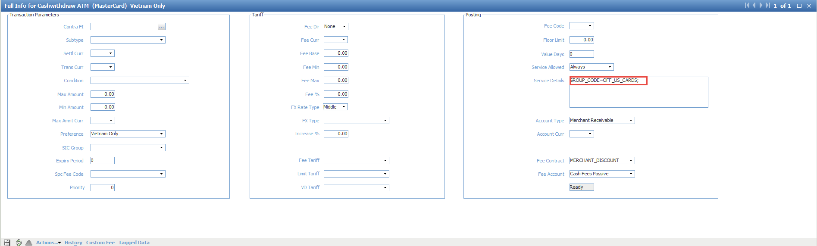

Create new usage limiter to limit transaction from off us card



In the details of usage limiter, set value Serv Group Code = OFF_US_CARDS

Spc Parms: BASE_AMOUNT_TYPE=RECONCILIATION;

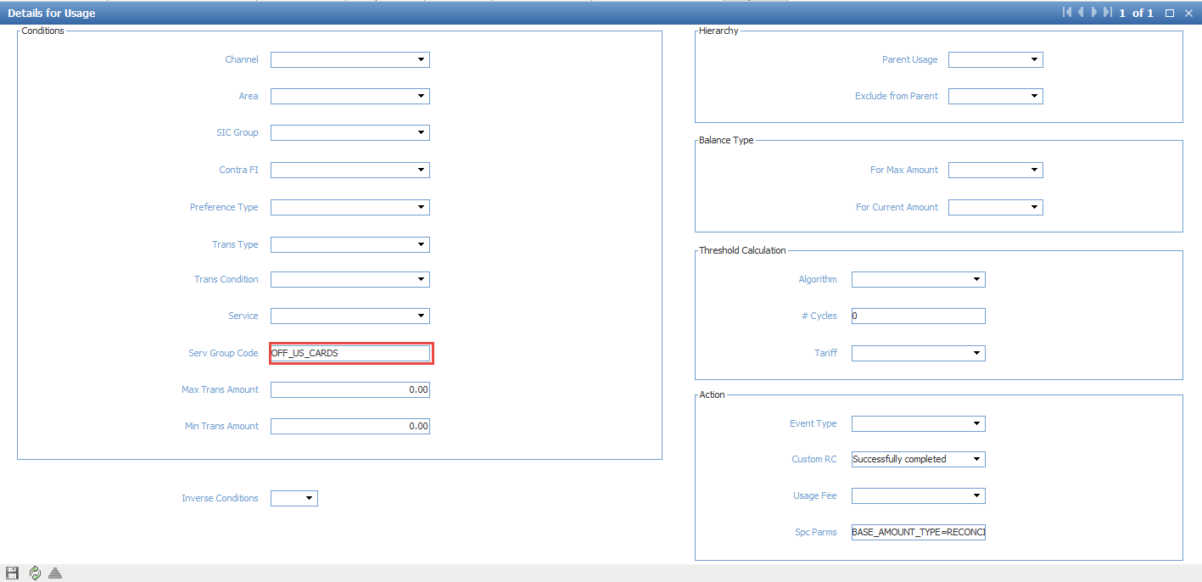

## Change Instalment scheme effective date and due date

Menu: ROOT.OpenWay.Instalments.Instalment Configuration.Instalment Schemes

Purpose: Change effective date for instalment schemes to billing date

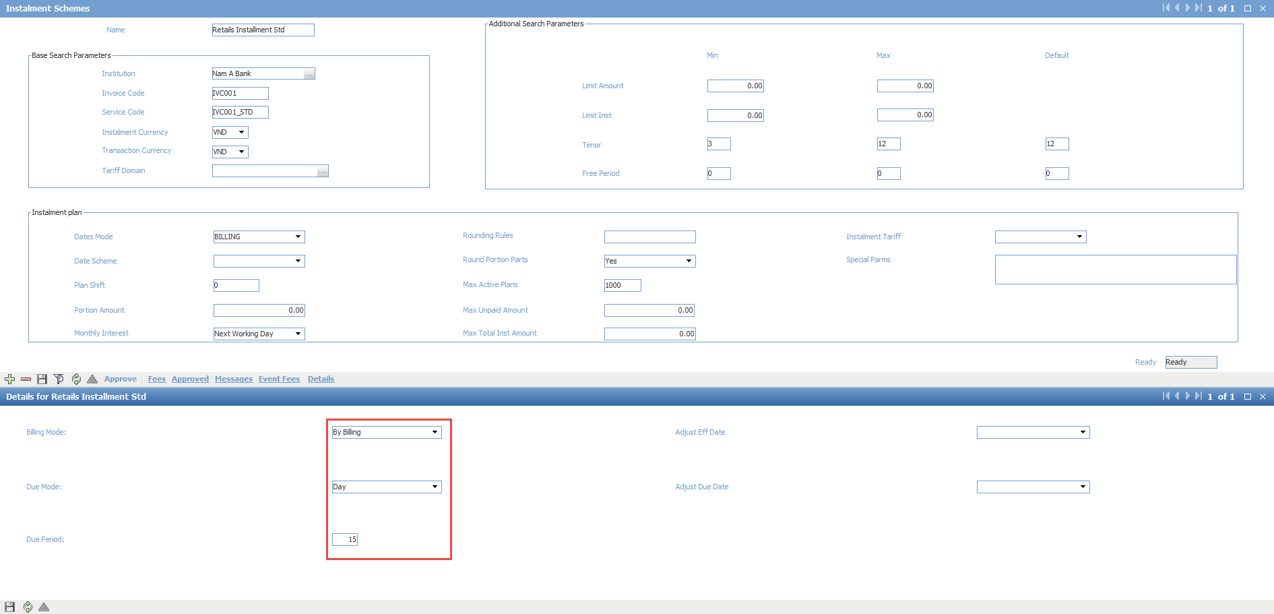

Open form Details in the instalment scheme

Set Billing Mode = “Billing”

Set Due Mode = “Day”

Set Due Period = “15”

## Disable Expire Check for Local Cards

Menu: ROOT\OpenWay\Full\Configuration Setup\Main Tables\Additional Global Parameters

Add parameter **AUTH_ENABLE_EXPIRED**, value “O”

When the value is "O", a check of a card's expiry date can be disabled for several card contract subtypes. To do so, specify the ENABLE_EXPIRED; tag in the subtype's Add Parms field.

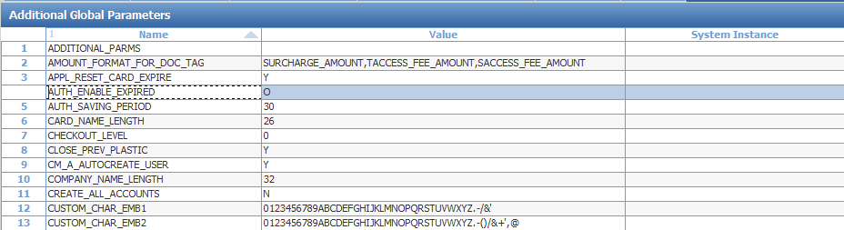

Menu: ROOT\OpenWay\Full\Configuration Setup\Contract Types\Card Contract Types

Add tag “ENABLE_EXPIRED;” for local contract subtypes

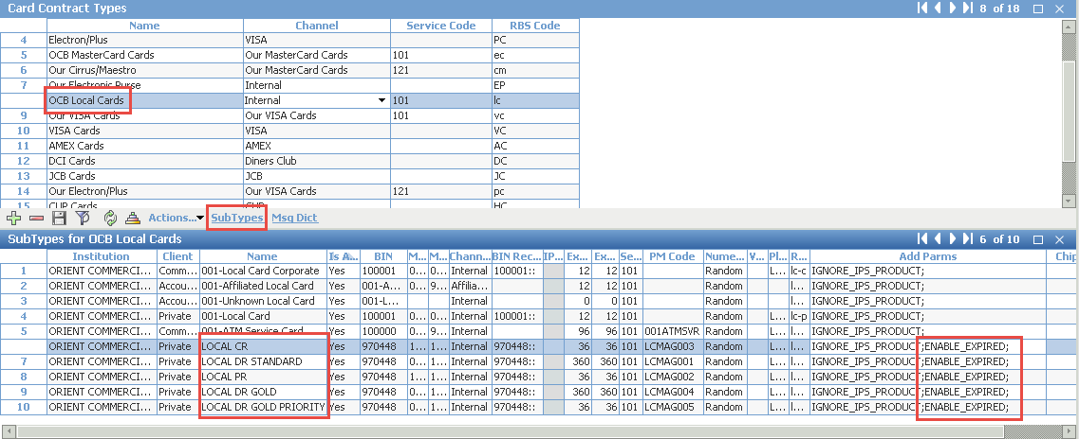

Validate the contract subtype

## Notification Event Configuration

Menu: ROOT\OpenWay\Full\Configuration Setup\Products\Issuing Private Products\Issuing Event Types

Purpose: Create new events for sms/email notification.

1. Credit Card Produced Notification

Add new event with the following parameter:

* Name: *SMS When Produced Credit Card*
* Code: *SMS_PRODUCED_CARD*
* Sepcial Parameters: *AVAILABILITY=R;*

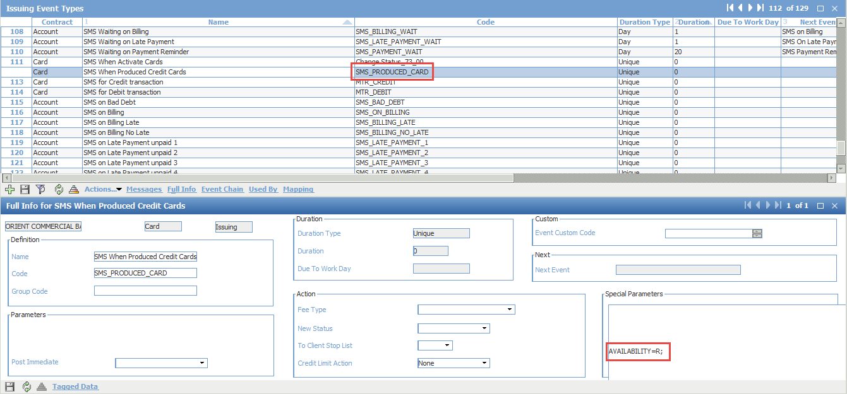

Click [Messages]

Add new message with following parameters:

* Code: *SMS_PRODUCED_CARD*
* Delivery Channel: *SMS*
* Address Type: *Current Address*
* Address Data: *%ADDR_PHONE_M%*

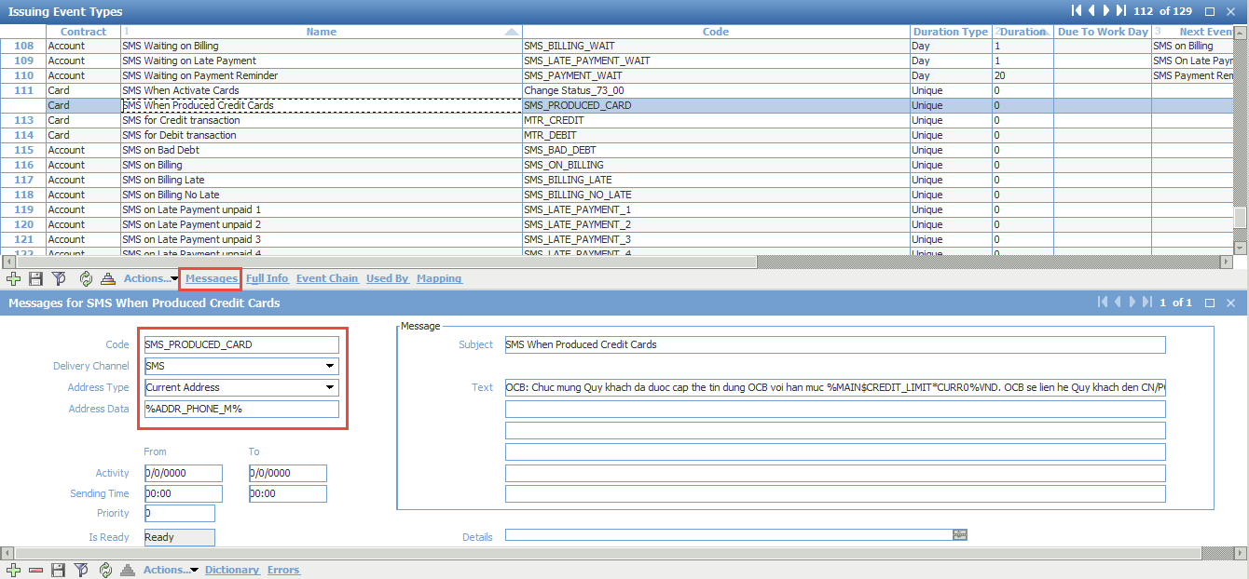

Choose event “Inactive When Produced Cards”

Add to Event Chain event “SMS When Produced Credit Cards”

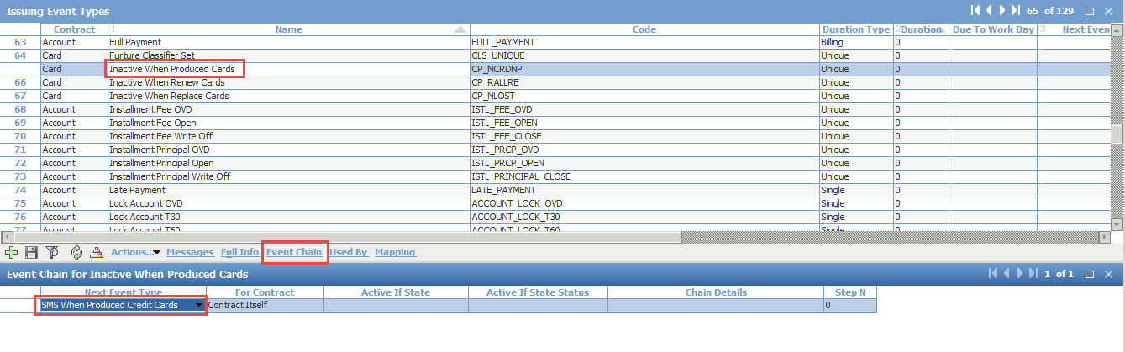

As the result, the event “SMS When Produced Credit Cards” will be called after card is produced

1. Credit Card Activation Notification

Add new event with the following parameter:

* Name: *SMS When Activate Cards*
* Code: *Change Status_73_00*
* Sepcial Parameters: *AVAILABILITY=R;*

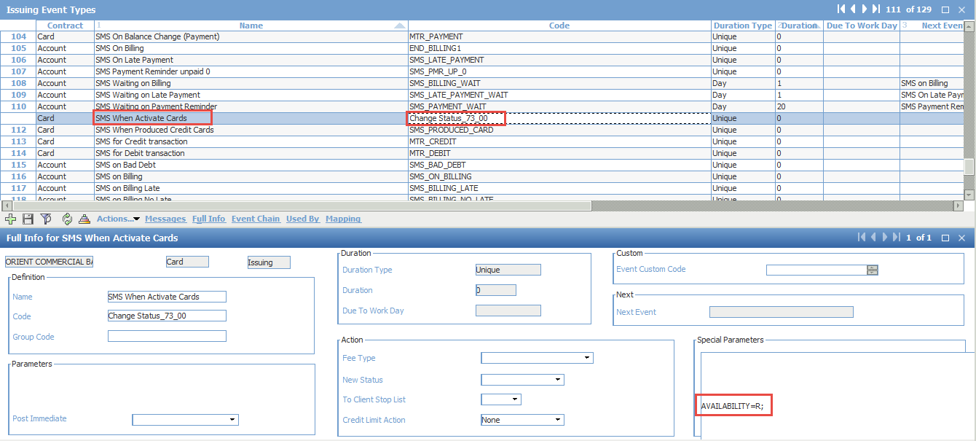

This event will open when card status change from 73 (Card Inactive) to 00 (Card OK)

Configure message:

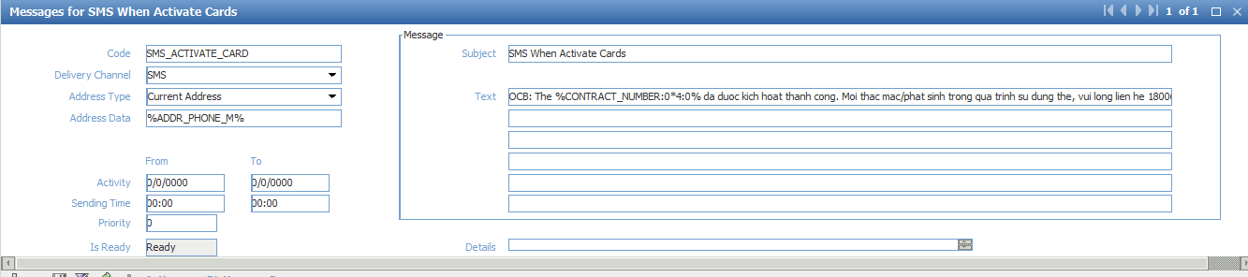

1. SMS On Balance Change (Auth Req)

Add new event with the following parameter:

* Name: *SMS On Balance Change (Auth Req)*
* Code: *AUTH_T_Q*
* Sepcial Parameters: *AVAILABILITY=R;*

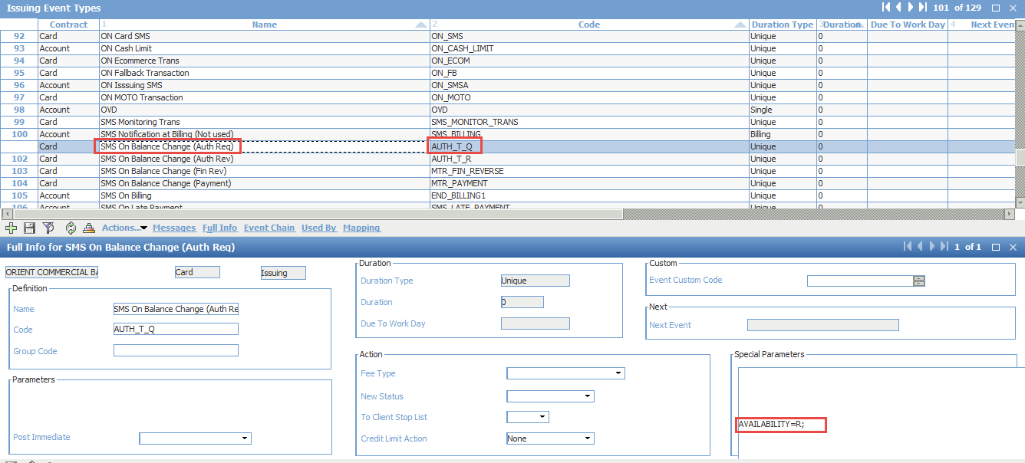

Configure Message:

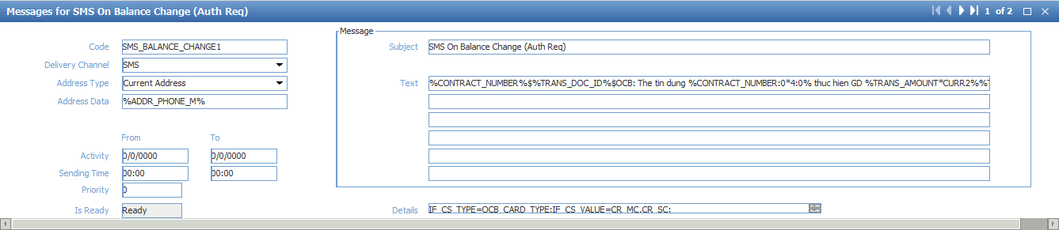

1. SMS On Balance Change (Auth Rev)

Add new event with the following parameter:

* Name: *SMS On Balance Change (Auth Rev)*
* Code: *AUTH_T_R*
* Sepcial Parameters: *AVAILABILITY=R;*

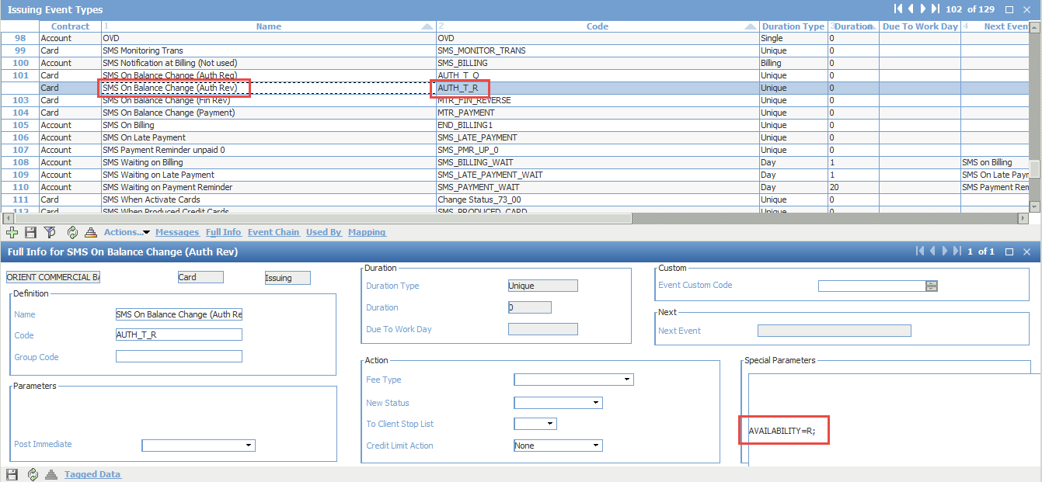

Configure Message:

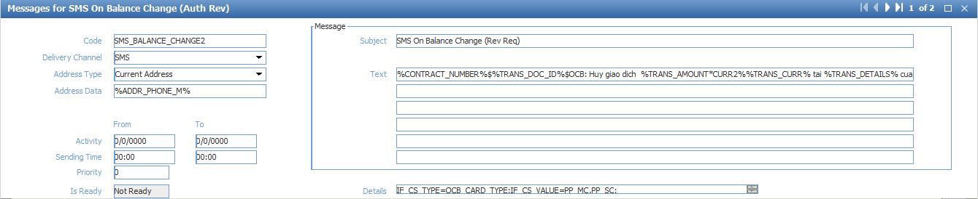

1. SMS On Balance Change (Fin Rev)

Add new event with the following parameter:

* Name: *SMS On Balance Change (Fin Rev)*
* Code: *MTR_FIN_REVERSE*
* Sepcial Parameters: *AVAILABILITY=R;*

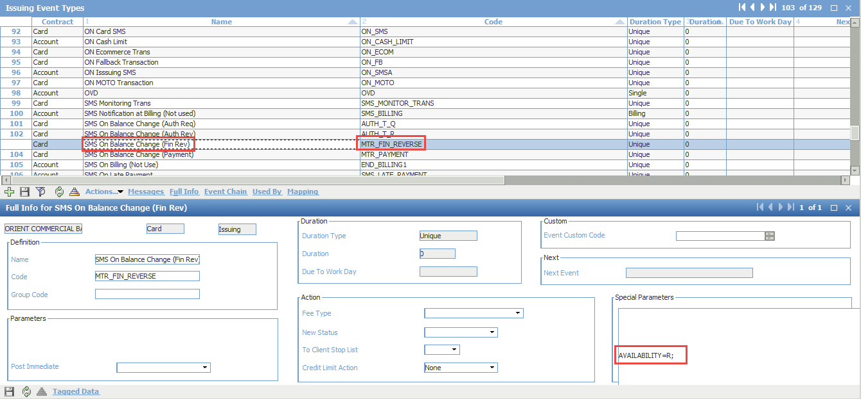

Configure Message:

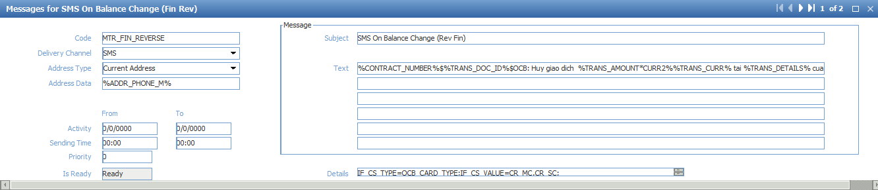

1. SMS On Balance Change (Payment)

Add new event with the following parameter:

* Name: *SMS On Balance Change (Payment)*
* Code: *MTR_PAYMENT*
* Sepcial Parameters: *AVAILABILITY=R;*

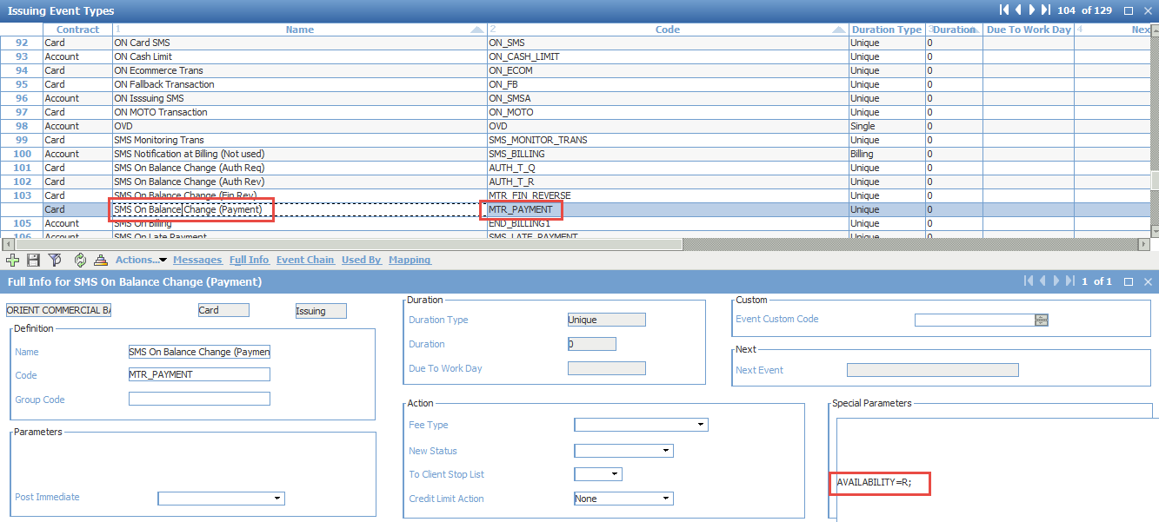

Configure Message:

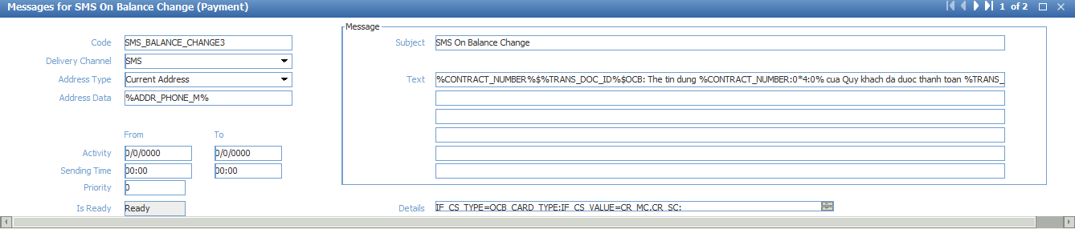

1. SMS for Credit transaction

Add new event with the following parameter:

* Name: *SMS for Credit transaction*
* Code: *MTR_CREDIT*
* Sepcial Parameters: *AVAILABILITY=R;*

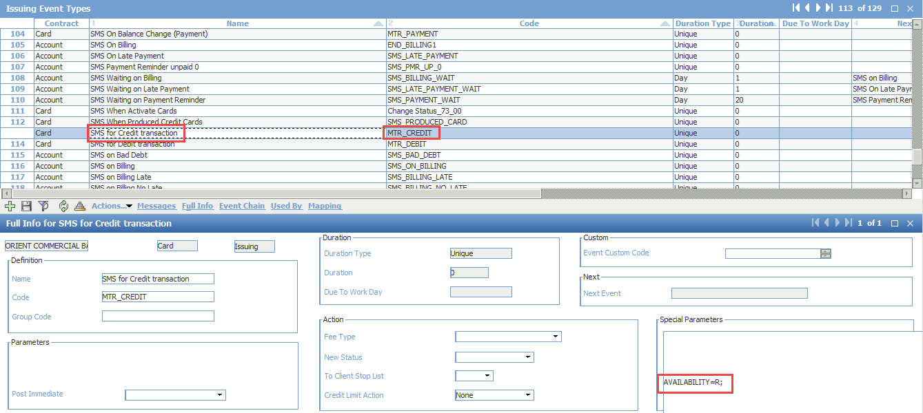

Configure Message:

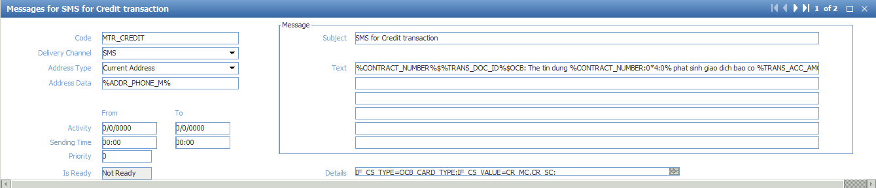

1. SMS for Debit transaction

Add new event with the following parameter:

* Name: *SMS for Credit transaction*
* Code: *MTR_DEBIT*
* Sepcial Parameters: *AVAILABILITY=R;*

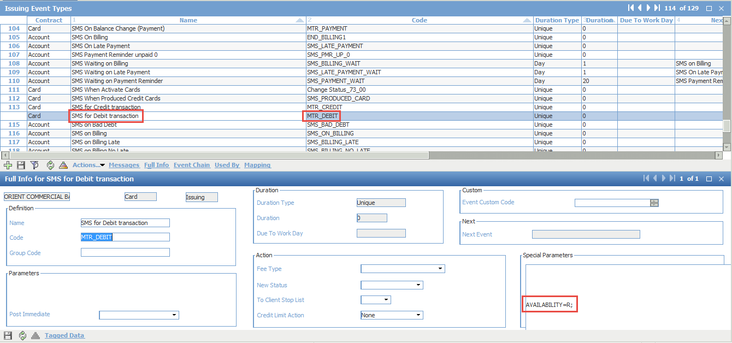

Configure Message:

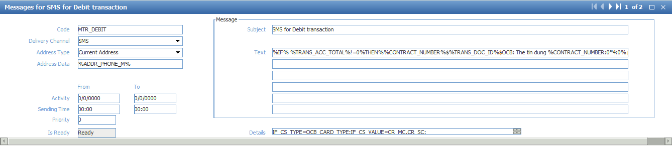

1. SMS on Billing Late

Add new event with the following parameter:

* Name: *SMS on Billing Late*
* Code: *SMS_BILLING_LATE*
* Sepcial Parameters: *IF_CS_TYPE=DLQ_LEVEL;IF_NOT_CS_VALUE=0,1;*

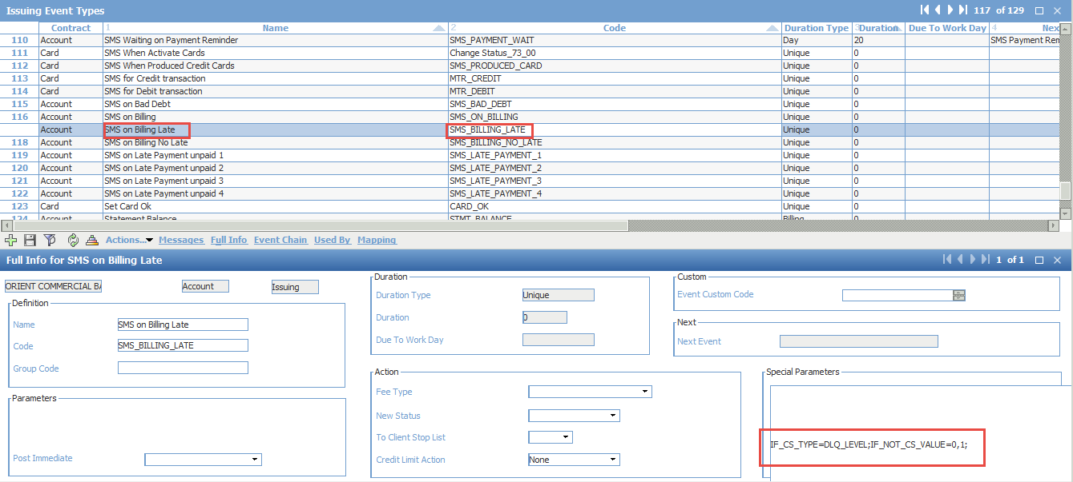

Configure Message:

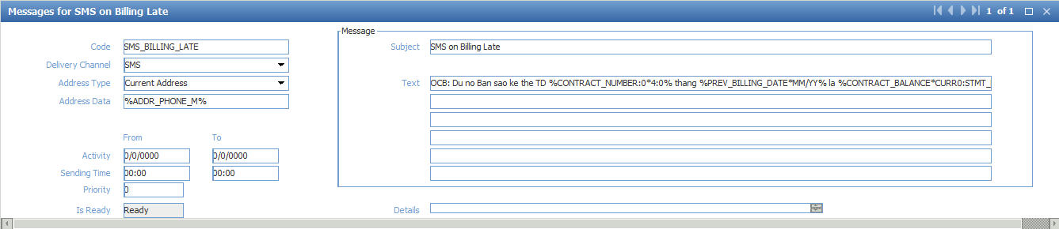

1. SMS on Billing No Late

Add new event with the following parameter:

* Name: *SMS on Billing No Late*
* Code: *SMS_BILLING_NO_LATE*
* Sepcial Parameters: *IF_CS_TYPE=DLQ_LEVEL;IF_CS_VALUE=0,1;*

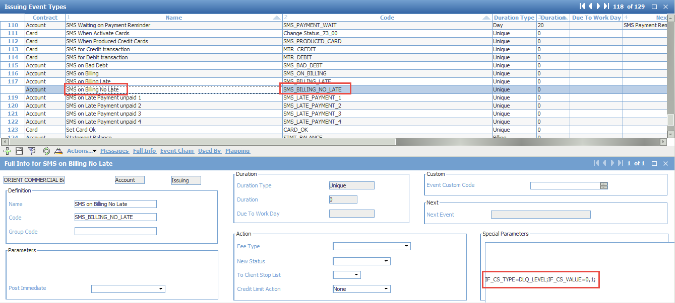

Configure Message:

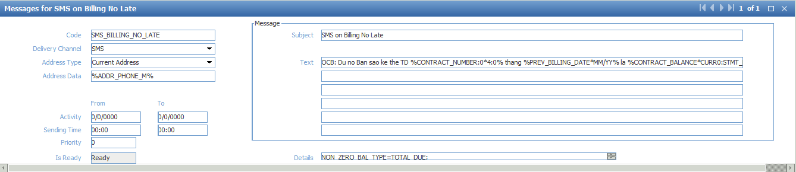

1. SMS on Late Payment unpaid 1

Add new event with the following parameter:

* Name: *SMS on Late Payment unpaid 1*
* Code: *SMS_LATE_PAYMENT_1*
* Sepcial Parameters: *IF_CS_TYPE=DLQ_LEVEL;IF_CS_VALUE=2;*

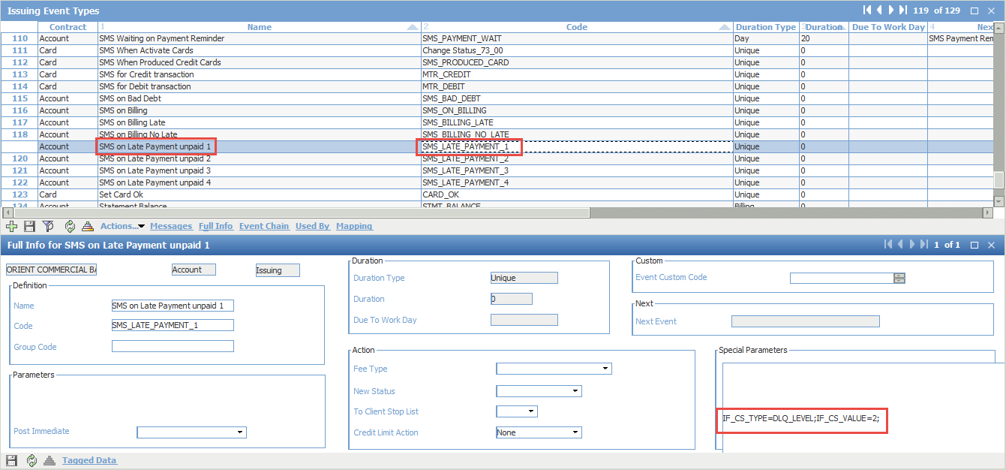

Configure Message:

Email

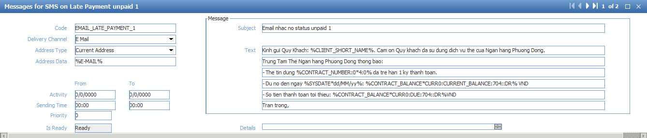

SMS

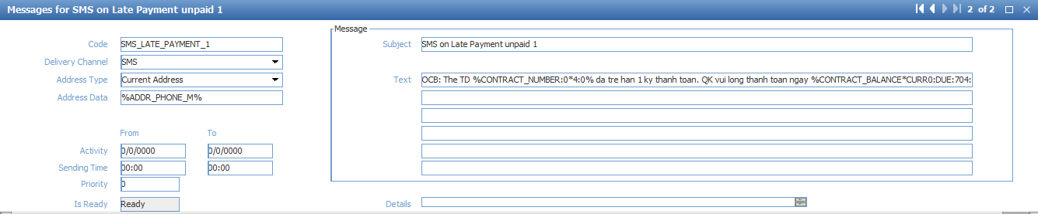

1. SMS on Bad Debt

Add new event with the following parameter:

* Name: *SMS on Bad Debt*
* Code: *SMS_BAD_DEBT*

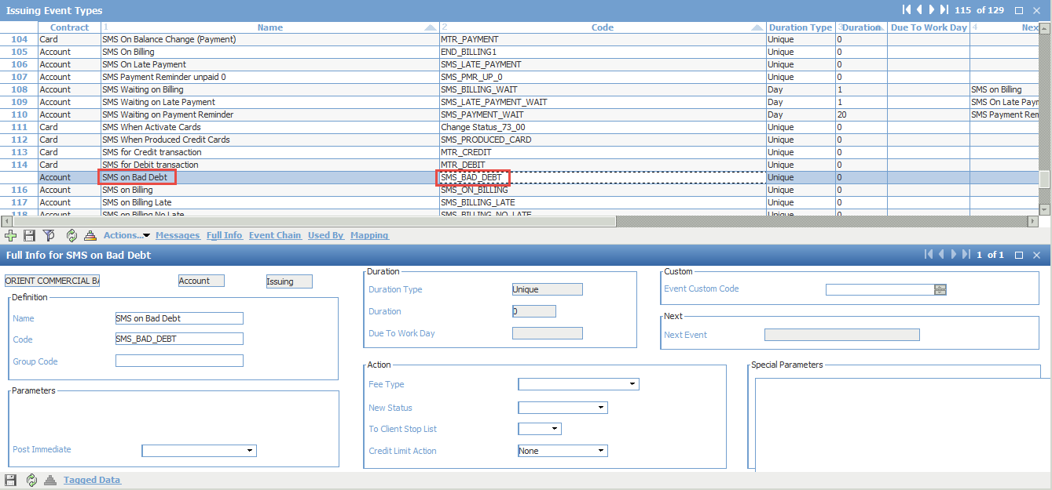

Configure Message:

Email

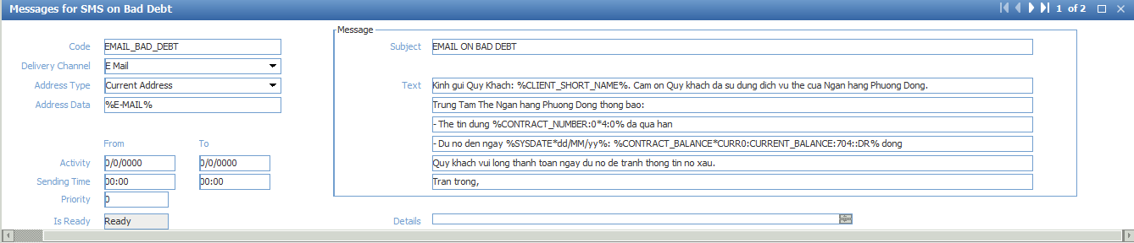

SMS

